Condylar fractures
It is the most controversial area in the maxillofacial skeleton in terms of fracture management . The still going debate is whether to treat condylar fractures surgically or conservatively .This is due to the great capacity of the condylar area to remodel ( auto-correction ) specially in young patients , as the condyle is the primary growth site of the mandible .
While in other areas of the body , there is consensus on the management ( taking many factors into consideration such as age of the patient , type of fracture .. ) .
Condylar fractures are either the most common mandibular fractures , or the second most common , differing from one region to the other .
In general , subcondylar fracture is the most common to occur in the condylar area , followed by the condylar neck . The least common area to be affected is the head of the condyle . This also depends on the age .

ANATOMY OF THE TMJ
The condyle articulates with the glenoid fossa . The articular disc is situated between them , separating the joint space into upper and lower compartments .
The condyle is attached to the lateral pterygoid anteriorly . That is why most fractured condyles are displaced anteriorly and medially , under the action of this muscle .
Posteriorly , it is attached to the posterior discal tissue which is innervated and with many blood vessels supplying the area .

Injury to the condylar area should be suspected when there is injury to the symphesial area or even the angle if the mandible . The direction and velocity of the force determine whether there would be unilateral or bilateral involvement .
For example , in assault injuries , unilateral and contralateral injuries are suspected due to the indirect force transmitted to the contalateral condyle . Whereas in road traffic injuries , bilateral condylar fractures should be suspected , as the velocity of the force is very high .
NOTE : as a high force is directed towards the mandible , the primary site of impact is subjected to compression force , whereas other sites such as the condyle suffer tension . So it is not the compression forces that are responsible for injuring the condyle , the tension that is generated medially or lingually is the responsible factor .
The previous discussion leads us to emphasize the importance of inquiring about the mechanism of injury as it would help us speculate the type of fracture , if present .
Note : a favorable fracture is that where the fracture line does not encourage displacement of the condyle , as it resists the muscle action .
Whereas an unfavorable fracture is that where the fracture line does not resist muscle action causing the condyle to move . The most common direction along which the condyle displaces is the anterior medial direction , under the action of the lateral pterygoid .

Classification of condylar fractures
Many classifications have been proposed .
Wassmund’s classification is one . It describes five types of fractures :
Note : please note that our professor didn’t discuss this classification thoroughly . He only mentioned that it is based on certain angles between the head of the condyle and the ramus .
Type 1 : a condylar fracture producing an angle between the head and the axis of the ramus between 10 and 45 degrees ( minimal displacement )
Type 11: a condylar fracture producing an angle from 45 and 90 degrees . This type of fracture results in tearing of the medial portion of the joint capsule .
Type 111 : a condylar fracture where the fragments are not at all in contact . The head is displaced due to non favorable muscle pulling of the fragment . the fragments are confined for the most part in the area of the glenoid fossa . The capsule is torn and the head is outside the capsule .
Type 1V : a condylar fracture of the condylar head articulates on or forward to the articular eminence .
Type V : severe involving vertical or oblique fractures through the head of the condyle .

Another classification is Lindahl’s classification
Discusses six types of fractures :
Type 1 :non displaced
Type 11 : simple angulation / deviation
Type 111 :displaced with medial overlap
Type 1V : displaced with lateral overlap
Type V : displaced with anterior or posterior overlap .
Type V1 :no contact between segments ( dislocation ) . The condyle is no longer articulating with the glenoid fossa . The dislocation is most commonly anterior to the articular eminence .

Maclennan’s classification
The simplest and most commonly used when interpreting radiographs .
Type 1 : non-dispslaced .
Type 11 : deviation of the fractured segment ( minimal displacement )
Type 111 : displacement is present , but the condyle is still in the fossa .
Type 1V :Dislocation outside the glenoid fossa .
This classification is of higher clinical significance , as it is easier to communicate through it , while other ones describe angles for example , which is not very practical , but non the less of value . The bigger the angle , the more justifiable a surgical approach becomes .

Another important classification is the one according to the location of the fracture line . It is also important in terms of communication .
The line that contacts the most inferior aspect of the segmoid notch , and perpendicular to the most posterior aspect of the ramus is called the “ A line” . The position of the fracture line in relation to the A line determines the location of the fracture .
- Intracapsular fracture : if the A line passes through the head of the Condyle . This type of fracture has a poorer prognosis than subcondylar or condylar neck fracture .
- Condylar neck fracture : if more than 1\2 of the fracture line is located above the A line .
- Subcondylar neck fracture : if more than 1\2 the fracture line is located below the A line .
Management
1. Primary survey : Assess the ABCD of the patient . Even if the Injury seems simple , it could indicate more alarming underlying injuries such as base of skull fracture , or displacement of the condyle into the middle cranial fossa .
Always assess the ABCD yourself , don’t rely on others' evaluation . Once the patient is stable , proceed to the next step .
2 . Secondary survey : which involves history and examination .
Ask and investigate about everything , especially regarding the mechanism of injury . Look for any sign of condylar fracture in the facial skeleton. Many signs could point to condylar fracture such as 1) laceration or bruising under the chin
2) facial asymmetry : usually indicative of unilateral condylar fracture
3) swelling , bleeding , tenderness or pain around the area of the TMJ . These could indicate a fracture injury or a blunt injury ( effusion) , which is usually of more serious complications than a frank fracture .
A Similar example is when an incisor suffers a trauma injury , in most cases the tooth to receive the direct force sustains the vitality of the pulp , whereas neighboring teeth develop periapical lesions some time later.
4) Deviation of the mandible to the same side of the fracture . As the patient unconsciously shifts his mandible to the side of injury to avoid pain stimulation at that side
5) spasms leading to limitation of mouth opening
6) bleeding from the ear ( otorrhagia ): an alarming sign that requires further investigation .
7) inability to palpate the TMJ during movement .
8) abnormal function of the TMJ . Limitation of mouth opening ,deviation of the mandible , open bite . Note that an open bite occurs on the contralateral side of the fracture . An anterior open bite is associated with bilateral fractures .
During your examination look for any signs that can be alarming such as bleeding from the ear .This sign could indicate 3 possibilities 1. Base of skull fracture , usually associated with the battle sign .
2. Laceration of the external auditory meatus .
3. Displacement of the condyle into the middle cranial fossa .
After asserting that the patient isn’t suffering any spinal injury , tilt the head and look for any dripping fluids . If a clear fluid is dripping , CSF leakage is suspected. This can be confirmed by performing a simple test using a filter paper . Double ring sign is what we look for in this case . Which is a halo of clear fluid around the central blood clot . If this test was positive , further tests are due . In this case beta 2 transferrin test . Which is an immunoflorescence test to confirm the presence of CSF .
Positive beta 2 transferrin test does not exclusively indicate CSF leakage , it could also indicate lymphatic leakage . Whereas nasal leakage indicates CSF leakage only .
Treatment can be controversial with CSF leakage . Some clinicians prescribe antibiotics ( clindamycin ) as the dura is torn, while others report no benefit of antibiotics in such cases as they don’t cross the blood brain barrier .
The best management would be to reduce the fracture while placing the patient in an upright position and wait for 10 days . If the leakage hadn’t ceased by then , refer to a neurosurgeon .
3. Imaging techniques
If you suspect a fracture , confirm your suspicion by ordering the proper radiograph . Look for areas of direct and indirect forces .
Plain radiographs are sufficient for simple displaced fractures resulting from simple mechanism of injury . Such as PA skull .
More specific images such as reverse Town reveal medial displacement or subcondylar fracture . Lateral oblique could be used but it is not very specific .
In more severe injuries , a CT is warranted . Another indication for a CT is when surgery is intended .
MRI is indicated in cases of rupture or injury to the disc .

4. Establishing a definitive diagnosis
Specify the type of fracture you’re dealing with , in terms of location , direction of displacement , whether it’s comminuted or not …. Etc .

5. Development of a treatment plan
Taking into consideration all the proceeding factors a treatment plan is developed.
Treating condylar fractures has pretty much the same aims as treating fractures at other sites .

Goals of condylar fracture repair :
- Pain free mouth opening
- Good jaw motion in all excursive movements
- Restoration of pre-injury occlusion
- Stable TMJs
- Good facial and jaw symmetry .
The condyle is a very sensitive area . 5-20% of cases of facial asymmetry are attributed to condylar trauma , as it could lead to condylar hypoplasia .
Auto-correction is suspected in the condyle , but not necessarily ideally to restore the proper function of the joint , as it could be in the form of ankylosis .

Types of treatment
- Conservative management : soft diet and analgesia .
- Closed reduction + IMF : to fix the two jaws together in the pre-injury occlusion . The period of IMF is dependent on the age and degree of displacement .
- Open reduction and internal fixation .
Each of these methods has its own indications , advantages and disadvantages .
The condylar area is viewed as a sensitive area , therefore the protocol of treatment is debatable . However , the Royal college of surgeons initiated a clinical guideline in 1997 regarding the treatment of condylar fractures . The main factors considered are the age , degree of displacement and derangement of occlusion .

Some general rules or facts were considered :
- A patient less than 12 years of age has a high potential for remodeling and occlusal development . Therefore , a more conservative approach is considered regardless of the degree of displacement .
- A patient aged from 12-20 years is within a gray area .They have some capacity for remodeling but it is not highly predictable . Making the degree of displacement a factor to be considered during treatment planning .
- In a patient more than 20 years of age , the remodeling is not predictable at all , so we might consider surgical treatment . Certain factors should be considered though .
So the main factors to determine a treatment plan are the age , degree of displacement and derangement of occlusion .
- Age < 12 years
A high potential for remodeling .
The degree of displacement is not very important in terms of treatment .
Next , assess the occlusion . If there was no occlusal alteration , conservative approach is followed ( soft diet and analgesia ) . Should there be occlusal alteration , then reduce the fracture progressively by elastic traction using guiding or functional elastics ( functional IMF ) . They guide the mandible into pre-injury occlusion and the TMJs remain in function to enhance healthy remodeling (the patient is able to open and close his mouth) .
Functional IMF is the most commonly used means of fixation in such cases . However , rigid IMF (using wires ) may be indicated in certain cases , such as bilateral condylar fracture , or when elastics are not sufficient to guide the mandible correctly to the pre-injury occlusion .
If no improvement is observed after one month , surgery might be considered.
Surgery at this young age is very unpredictable , it could induce ankylosis and lead to unpleasant consequences such as interference in the facial skeleton growth on that side of the face . 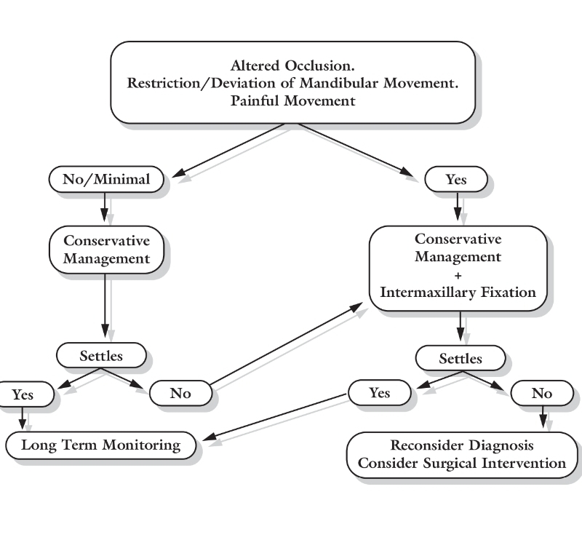
- 12-20 years of age
Here the degree of displacement has to be considered , however it is not as important as occlusal derangement , as there is still some potential capacity for remodeling ( but not highly predictable ) therefore the degree of displacement has to be considered when planning a treatment at this age .
- Open reduction and surgery is indicated in severe occlusal derangement and severe displacement of the condyle .
- if the occlusion was minimally altered but with severe displacement , conservative treatment is considered with or without IMF . IMF could lead to ankylosis . Therefore , if it was absolutely necessary , it has to be applied for 1-2 weeks only ( 10 days in average ) . 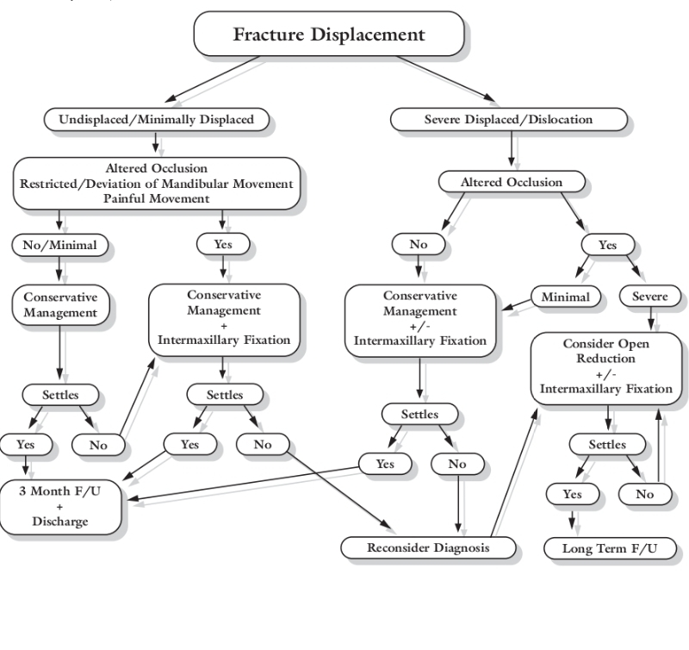

- Age > 20 years .
The degree of displacement is as important as the occlusal status .
- If the occlusion was altered with minimal displacement of the condyle , conservative approach is followed WITH IMF . 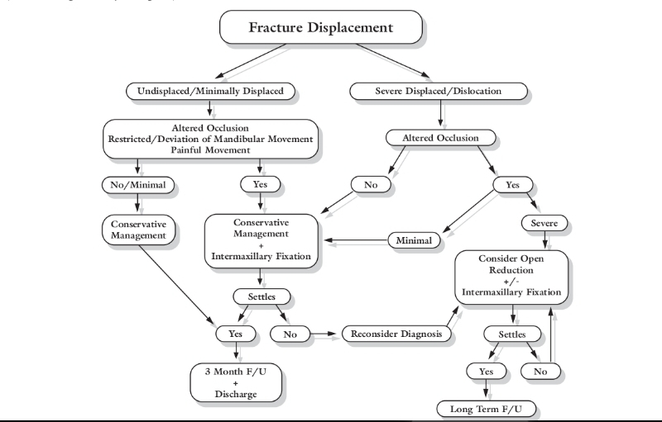

Follow up of condylar fracture patients is usually for 3 months , but it is life long when surgery is performed , or if the patient is less than 12 years of age .
Conservative treatment has better reported results in the literature .

Case discussion
A 25 year old patient presented with a shot wound where the bullet penetrated the left TMJ and settled subcutaneously on the other side near the angle of the mandible .
Diagnosis
Subcondylar fracture on the left side with severe medial and anterior displacement ( telescopic overlapping ) . Disruption of the upper border of the mandible on the other side .
Note : disruption is when the continuity of one border is disturbed . Whereas a fracture is when it includes both borders . The management of both cases is totally different .
The occlusion is minimally altered . ( the patient was able to achieve pre- injury occlusion with minimal assistance - assisted occlusion .)
Treatment
Conservative approach and IMF for the broken condyle . ( if the patient was 15 years old conservative approach with or without IMF ) .
So the patient was treated with IMF screws and guiding elastics to guide the mandible into its appropriate special position . Heavy ones were used in the first week and on the contralateral side as the patient deviates the mandible to the epsilateral side of the fracture .
Note : Class 3 elastic has a class 2 effect .
IMF for condylar fracture for children is for 1-2 weeks to reduce the risk of ankylosis , while in adults it is 3-4 weeks as the risk of ankylosis decreases .
On the other hand , IMF for mandibular fractures is double the period for condylar fractures . One month for children , and 2 months for adults .

Some cases of condylar fracture have consensus in terms of treatment . These are called Zide’s absolute indications for surgery . Which are :
- Middle cranial fossa involvement .
- Inability to achieve occlusion with closed reduction . As the interference between the ramus and zygomatic arch is preventing the mandible from being guided to its proper position .
- Invasion of the joint space by a foreign body . Open reduction and internal fixation is performed in this case , but it is not the main indication for the surgery . The main indication is to prevent any complications resulting from having a foreign body within .

When surgery is indicated , many choices for access incisions are available :
- preauricular incision : The layers observed through a preauricular incision :
Skin , subcutaneous tissue, superficial fascia, deep fascia , parotid gland .
- access through the external auditory meatus
- The most commonly used incision is the transparotid or the retromandibular incision , done 1 cm below the ear lobe.It gives access to the subcondylar area where there is subcondylar fracture .
- Submandibular incision with very low subcondylar fractures

Done by : Dina taimeh

