Management of facial trauma
Introduction
- Trauma to the facial region frequently results in injuries to soft tissue ,teeth , and major skeletal components of the face , including the mandible , maxilla , zygoma , naso-orbital-ethmoid (NOE) complex , and supra-orbital structures . in addition , these injuries frequently occur in combination with injuries to other areas of the body .

- Almost 50 % of facial trauma are accompanied with other types of injury ; because the most common causes of facial trauma are road traffic accident , violence , falls down and sport injuries . as the trauma is more sever then facial trauma is accompanied with other types of injuries . so our primary assessment must be directed to protect patient life by assessing the whole patient then go to assess the facial injury .
- In most of cases the stabilization of patient life come in the top of treatment priority , then the maxillo-facial surgeons intervene to treat the facial trauma . but when life threatening situation due to air way obstruction or bleeding – which is in our region – maxillo-facial surgeon intervention become in priority .
Causes of facial fracture :
- The major causes of facial fracture include :
- Motor vehicle accident : more common in developing country . because of not wearing the seat belt at the time of accident .
- Falls down
- Sport related incident
- Work-related accident
- Violence ; more common in Europe countries at weekends .

Evaluation of patient with facial trauma :
- Immediate assessment :
Before completing a detailed history and physical evaluation of the facial area , critical injuries that may be a life threatening must be addressed .
- The first step in evaluation a trauma patient is to check the ABC’s ( the new recommendation is CAB ):
- assess the patient’s cardiopulmonary stability by ensuring that the patient has patent air way and that the lungs are adequately ventilated .
- vital signs , including respiratory and pulse rate and blood pressure , should be taken and recorded . during this initial assessment , other potentially life threatening problems such as excessive bleeding should also be addressed and immediate measures such as pressure dressing , packing , and clamping of briskly bleeding vessel should be accomplished as quickly as possible .
Note :
Treatment of head and neck injuries generally should be deferred until a thorough evaluation , assessment and stabilization of the patient has been accomplished . however , some initial treatment is often necessary to stabilize the patient .
- management of the patient air way is of vital importance . frequently , fractures of the facial bones severely compromise the patient ability to maintain the air way , particularly when the patient is unconscious or completely supine . severe mandible fractures , especially bilateral or comminuted fracture , could cause posterior displacement of the mandible and the tongue ,which results in obstruction of the upper airway .

- simply grasping , repositioning , and stabilizing the mandible into a more anterior position may alleviate this obstruction . placement of a nasopharyngeal or an oropharyngeal airway ( 10 cm plastic device ) may also be sufficient to temporarily maintain a patient’s airway . in some cases , endotracheal intubation may be necessary . any prosthetic devices ,avulsed teeth , pieces of completely avulsed bone , or other debris may also contribute to air way occlusion and must be removed immediately . any areas of bleeding should be quickly examined and with packing , pressure dressing , or clamping . all excess saliva and blood must be suctioned from the pharynx to avoid aspiration and laryngospasm .
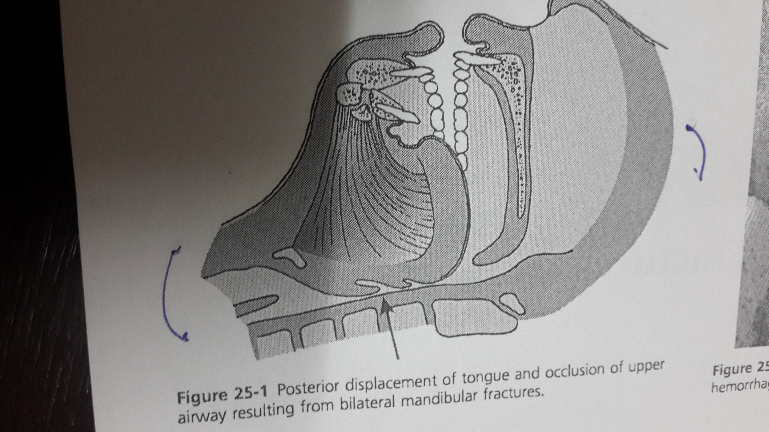

- The next step is to assess the patient’s neurological status and evaluation of cervical spine . forces severe enough to cause fracture of the facial skeleton are often transmitted to the cervical spine . the neck should be temporarily immobilize until neck injuries have been ruled out . careful palpation of the neck to assess possible areas of tenderness and a cervical spine radiographic series should be completed as soon as possible .
- Then thorough examination , assessment and stabilization should be accomplished .
- Once the patient is stabilized , the maxilla-facial surgeon intervene to assess head and neck injuries – and this occur within one or two days , not after months of injury . maxillofacial surgeon recommend to extend CT scan to facial area instead of having two separate CT scan one for the injured area and the other for the facial area .

- history and physical examination :
Notes
- Facial trauma include soft tissue laceration , teeth fracture , fracture of mandible , maxilla , mid face , zygomatic complex , orbital and supra-orbital rim . so our field extend from soft tissue laceration to pan facial trauma – trauma affecting the face in general .
- Overlapping disciplines :
maxillofacial surgeons have to work with other surgeons ; as our field of trauma is extend from supra-orbital rim which has frontal sinuses in the cranium make us In need to neurosurgeon . in the other hand trauma to the orbital bone also make us in need to ophthalmic surgeon .

- Patient Stabilization
The first thing to do as maxillofacial surgeon – even after patient stabilization by other disciplines – is to ensure the safety of the airway . BUT what are the things that if traumatized in the oral cavity may affect the air way ?????
- Tooth avulsion : if the traumatize tooth still present in oral cavity which may obstruct the larynx .
- Bilateral mandibular fracture especially in the body of mandible“ para-symphesial area “. the muscular attachment of the tongue become loose and the action of these muscles will be reversed , so instead of having the tongue in the ant. Segment it will become in the post. Segment of the mand. and cause airway obstruction . in this situation early intervention is very important before doing the surgery , so you have to pull the tongue forward by stitching the tongue with thick zero silk suture .
- Bilateral mandibular fracture may cause tooth mobility , so use wires to stabilize the teeth .
- If u can’t control the tongue and the airway is compromised , then emergency access to the airway is needed through the following :
- Tracheostomy : need long time . it is either hazal or elective tracheostomy .
Hazal tracheostomy : vertical incision to have quick dissection to the trachea , elective tracheostomy : horizontal incision .
- Intubation : either nasal or oral intubation according to the easiest access . however, it needs experience and special setup . if a patient came with pan facial trauma especially in the mid face Dura has been teared and there is CSF leakage - then nasal intubation must be avoided to prevent the intrusion of the tube to the brain . so here we prefer to use oral intubation .
- Cricothyrotomy :very rapid method without the need a lot of experience , just hold a pen or blade above the cartilage and penetrate the Trachothyroid membrane, once you are in you create an airway for breathing for few hours . we use it in the top emergency with airway obstruction .
- Mid face fracture with posterior disimpaction of maxilla :fracture that cause disimpaction of the maxilla pushing the soft palate downward causing airway obstruction .
- Sever bleeding in oral cavity that may obstruct airway . surgeon has to control the bleeding either by ligation or cuatery to the vessels , pressure dressing and stitching for big laceration .
- Trauma to the orbit that may cause compression to the optic nerve and artery which will cause necrosis then blindness will occur .

- History taking :
After the patient has been initially stabilized , complete history should be obtained . this history should be obtained from the patient . however , because of loss of consciousness or impaired neurological status , information must often be obtained from witnesses or accompanying family members .
- The important questions to be considered in history taking :
- Where did the accident occur ? if it occurred in dirty place then you had to consider Ab and tetanus .
- How did the accident occur ? and determine the direction of the hit to predict the site of injury .
- Medical history of the patient ; if the patient has allergy to medication or has a virus so you have to take care of cross infection control .
- When the accident occur ?
- Did loss of consciousness occur ?
- What symptoms are now being experienced by the patient , including pain , altered sensation , visual changes and malocclusion ?

- Physical examination :
Evaluation of the facial area should be perform in an organized and sequential fashion ; by doing the assessment for supra-orbital rim , zygoma , upper jaw , lower jaw and the oral cavity .
- Inspection : the face and cranium should be carefully inspected for evidence of trauma , examples :
- Inspect Bruises and laceration of the face .
- inspect the orbits : for sub-conjunctival hemorrhage and Periorbital hematoma (swelling or edema around the eyes ) which indicate trauma to infra-orbital rim , supra-orbital rim or zygomatic complex .
- Inspect eye movement : any resection in eye movement means fracture in orbital floor by which extra-ocular muscles and nerves are affected . visual acuity or papillary changes may suggest an intracranial bleed ( cranial nerve ∥ or ∥∣ dysfunction ) or direct orbital trauma . diplopia , enophthalmous ( intrusion of the eye ball , which mean fracture of the medial wall of the orbital floor ) , uneven pupils ( anisocoria ) in a lethargic patient suggest an intracranial bleeding ( subdural , epidural hematoma or intraparenchymal bleeding ) .
- Inspect the nose : deviation , swelling and bleeding indicate trauma directed to the nose .the white fluid from the nose is an alarming sign ; which mean that the trauma is directed toward the mid face and ethmoidal sinus causing tear of dura and CSF leakage occur from the nose (rhinorrhea ) . Ab coverage and neurosurgeon intervention is very important because any contamination or infection may cause meningitis .
- Inspect the ear : bruises or hematoma behind the ear and the mastoid is swollen ( battle sign ) suggest CSF leakage and mastoid fracture . CSF leakage from the ear (otorrhea ) indicate basilar skull fracture
- Inspect the zygoma : the fracture either occur to the zygomatic arch alone or to the zygomatic complex which include infra-orbital rim , z-f suture and zygomatic arch . in order to examine it , palpate infra-orbital rim , supra-orbital rim , zf and the zygoma for stiffness , pain or cheek numbness ( because any movement of the zygoma may compress the infra-orbital nerve causes cheek numbness )
- Inspect the upper jaw :
- How to inspect maxillary fracture : stabilize the nose by one hand , and grasp the maxilla from the centrals by the thumb and the forefinger in the other hand then try to mobilize the maxilla . if mild movement of maxilla occur then lefort 1 , but if the mid face move then it is either lefort 2 or 3 .
- Laceration of the soft palate also indicate maxillary fracture .
- Inspect the lower jaw :
- signs of mandibular fracture are :
- any change in occlusion, open-bite , dis-occlusion , mand. Deviation and limited mouth opening .
- mobility of the teeth and the underlying structure is indicator for dentoalveolar fracture
- hematoma of buccal and lingual sulcus
- numbness in the lip ; the fracture in the mandible affects the nerve .
- ecchymosis in the floor of the mouth usually indicate an anterior mandibular fracture .

- examination :upon examining the mandibular movement ,,, if you notice any limitation then depressed zygomatic fracture is occurred which compress the coronoid process that limit the movement of the mandible .

- radiographic evaluation :
- as the severity of trauma increase and directed toward the mid-face and the orbit then we go for CT scan . in severe facial trauma , cervical spine injuries should be ruled out with a complete cervical spine series ( i.e , cross-table , odontoid and oplique views ) before any manipulation of the neck .
- CT scanning is used to rule out neurological injury in many patient with facial trauma .
- each structure in the face has it’s own types of radiographs ; radiographic evaluation of the mandible require two or more of the following four radiographs : panoramic view , open mouth towne view , posteroanterior view , lateral oblique view . occasionally , these radiographs are not enough. Therefore , supplemental radiograph is taken includes occlusal and periapical radiograph .
- evaluation of mid face fracture historically has been supplemented with standard radiographic views , including water view , lateral skull view , posteroanterior view and submental vertex view. However because of the difficulty of interpreting plain radiographs of mid face , CT scan is the most commonly used radiograph for evaluation of mid face trauma .

Special thanks to Tawba
Haneen Qandil

