Salivary Glands Disorders
Dr.Shayyab
25/3/15

The anatomy of salivary glands:
Salivary glands are developed as invasionations of the oral mucosa in the underlying structures to form 3 major salivary glands and numerous ( >400) minor salivary glands distributed over the oral cavity.
The 6 major salivary glands are 2 parotid, 2 submandibular and 2 sublingual. While the minor salivary glands lay all over the oral cavity, esp. in the inner side of the lower lip, cheeks, floor of the mouth, retromolar pad area and orodigestive tract, and they contribute in 10% of the total volume of saliva.
The Surgical Anatomy:
Sublingual Salivary Gland:
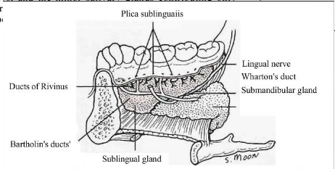
- it is the smallest major salivary gland
- highly related to some important anatomic structures, which are the submandibular gland duct and the lingual nerve.
- located over the myelohiod muscle.
- bounded laterally by the medial side of the body of the mandible, medialy by the genioglossus muscle, superfacially by the oral mucosa, inf. by the myelohyoid muscle and post. related to the deep loop of the submandibular gland.
- the gland is placed sub-mucosaly ( under the mucosa).
- opens and drains its own saliva into the ant. floor of the mouth by 10 small ducts ( Ducts of Rivinus).
- contains mucinus cells and secretes viscous thick saliva.
Submandibular Salivary Glands:
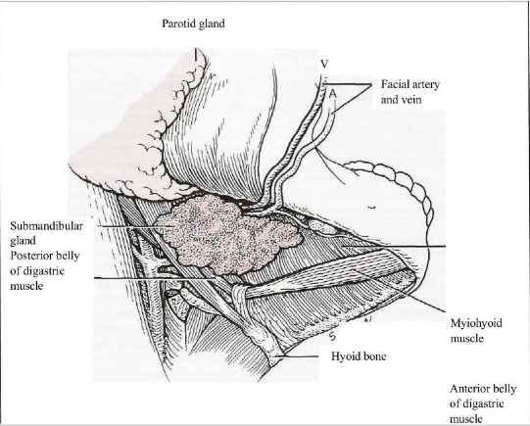
- it is a C-shaped gland that lies over the boarder of the myelohyoid muscle.
- has superficial loop and deep loop.
- from the most ant.sup. part of the gland, the duct runs forward and curves medially to open at the floor of the mouth at Warton's Duct.
- it receives its parasympatahtic secretomotor fibers from the lingual nerve that carries the post. ganglionic parasympathatic fibers that are originated from the superior salibary gland neuclus carried by chorda tympani which is abranch from the facial n.
- the gland is located in the submandibular triangle, bounded anteriorly by the ant. belly of digastric, posteriorly by the posterior belly of digastric and superiorly by the lower border of the mandible.
- you can feel the gland intra-orally ( the deep loop) and extra-orally ( the superfacial loop).
- when you examine the submandibular gland bidigitally, you will feel the gland between your fingers, while when you examine the sublingual gland, you only can touch it by your internal finger.
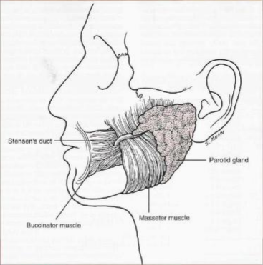
Parotid Salivary Gland:
- it's related to the facial nerve that divides into 5 branches within the gland.
- from the most ant. sup. part of the gland you can find the gland duct “ Stensen’s duct” that runs forward and perforates the buccinator muscle to open in the oral cavity against the upper 2nd molar.
- it receives its post ganglionic parasympathatic fibers originally from the inf. Salivary nucleus, carried by the glossopharyngeal n. through its branch the tympanic then the greater petrosal n., the lesser petrosal n. then it will synaps with the post ganglionic parasympathetic fibers carried by the auriculotemporal nerve.
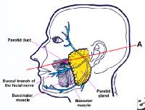
- the clinical location is very important in cases of facial trauma and lacerations. To decide whether the gland is traumatized or not we have some specific landmarks to locate the duct. If you draw a line from the tragus and a midpoint between the ala base and the upper part of the lip, the mid 1/3 of the line is occupied by the stensen’s duct which is highly related to the bucca branch of the facial n. and 1.5 cm bellow the zygomatic arch.
-if any laceration occurred at this area, you have to double check the parotid gland. If involved you have to repair it otherwise you will deal with salivary fistula.
- Predominant cells are serous cells, that’s why its secretion is watery or thin.
Diagnostic Approaches: “ the pt. work up”
Ideally the diagnosis is reached by history, examination and investigation, but the diagnosis in some specific diseases is dependent only on few approaches. Salivary glands diseases, for example, depend solely on history and examination while oral cancer diagnosis depends on the histopathological results.
In about 80% of the cases, history and examination will provide you with a professional differential diagnosis. While some cases need further investigations such as :
- Evaluation of dry mouth
- Past/present medical history
- Clinical examination
- Saliva collection
- Salivary gland imaging
- Biopsy + FNA
- Serological evaluation
Starting with Clinical History:
You should ask the pt. different questions that would indicate the type of the disease you are dealing with, whether obstructive, inflammatory or neoplastic. Some questions are considered as” Key Questions” ,as when you ask if the lesion is unilateral or bilateral. If it is bilateral , you should establish a professional differential diagnosis before even examining the pt. that you are dealing with a non-neoplastic lesion. Many other questions are important and might contribute to your differential diagnosis such as asking about the swelling, change in size, trismus, pain, variations between meals, dry mouth, dry eyes, sick contact (mumps), history of radiation (might cause sialadinitis) and current medications (as using Chlorhexidiene for a long period of time might cause bilateral enlargement).
It is extremely important to ask about the history of any scalp or ear cancer, because any malignancy in the parotid gland is most probably secondary metastasis from ear or scalp as the parotid lymph nodes are the first nodes where they drain their lymph.
Examination:
Clinical examination has many skills, the first is Inspection, and the most important part of it is to determine whether you are dealing with a discrete or diffuse lesion.
- Diffused = non-neoplastic
- Discrete = well-defined boarder, Neoplastic
- involvement of the skin = ulceration, laceration, malignant
-facial palsy = invasion of the facial n. , malignant
- size of the lesion
- pressure or erythema ( indicate bacterial infection)
80% of Salivary Glands neoplasms are benign tumors and 80% of these benign tumors are Pleomorphic Adenoma. It should always be your 1st differential diagnosis.
The second important skill is Palpation intra and extra orally. You should detect the consistency and the texture as this might lead you directly to a professional differential diagnosis.
In the floor of the mouth -submandibular area – you should check the submandibular and sublingual glands. Bi-digital palpation in this area will differentiate between 3 structures: submandibular gland, sublingual gland and submanibular lymph nodes( that are not part of the gland’s capsule, while the parotid nodes are part of the gland’s capsule).
If you feel it by finger extra orally, they are most probably the lymph nodes. While if you can feel it bi-digitally (intra+ extra orally) this is the gland.

Investigation:
It is the third part to confirm you diagnosis as we have many different tests and methods:
- Plain film radiography: required in most of the cases. Their main use is to determine obstructive disorders(stones).
The radiograph of choice for submandibular gland and duct stones that are located in the ant. part is the vertex-occlusal view. The location of the stone has an important clinical significance as the anteriorly positioned stones can be retrieved easily intra orally. But post. stones hardly retrieved and in some cases you should surgically remove the whole gland.
- CT
- Sialography:
It can be used to diagnose almost all types of salivary glands disorders. It shouldn’t be used in acute infection cases because the duct is friable and you might perforate it. As a rule, surgical procedures are contraindicated in acute infection cases unless they are life threatening situations.
Sialography is more invasive that CT’s. it works by injecting 0.5 – 1 ml of contrast material ( mostly iodine or water based material) in the duct till the pt. feels pain. In the first 1 min. the contrast material will be within the duct (ductal phase), you take a radiograph. After the 1st min you expect to see the contrast material within the parenchyma of the gland (after the 1st min. up to 5 mins.).During this phase, in a normal gland you should detect the Tree in winter appearance, while if there is any abnormality you will see other patterns depending on the disorder. After 5 mins. No contrast should be detected in the gland (emptying phase) or there is a problem within the gland.
The Sialography will show “sausage linked appearance” if there is any obstruction in the gland (sialadinitis). Dilation of the proximal part and atrophy of the gland itself, because when there is an obstruction the saliva will cause atrophic pressure and atrophic fibrosis. (proximal: near the salivary gland, distal : away from it).
In chronic inflammatory/ granulamatous disease ( sjogren or sarcoidosis) no fibrosis will be seen in the gland but destruction of the acinus structures and terminal ducts. After injecting the contrast material, you will find it leaking outside the duct, Punctuate appearance or Snow Storm.( there are 3 other diseases that have the same appearance you should look for them)
If there is a benign tumor within the gland, the structure will be normal but push by the mass, it will appear as a Ball in Hand. ( normal acinus structure, normal tree in winter appearance).

- Ultra-sound:
It is the simplest and minimally invasive investigation but it is difficult in interpretation.
- Nuclear medicine:
Non-specific, technetium 99m radioactive isotope is injected intravenously because it is favored by the salivary glands. High spot/ uptake indicates higher activity of the gland.
- FNA:
There is a huge debate on this type of investigation, people who are against it believe that salivary glands tumors have high seeding tendency and high recurrent rate, moreover they think what is the benefit of the diagnosis when the treatment at the end is the same ? while other surgeons think that it is very important to differentiate between benign and malignant tumors and secondary metastasis, and by FNA you might determine non-surgical treatment.
- Biopsy:
Wither incisional or exisional, there is a consensus that minor salivary gland biopsy is better than major as they are representative of what is happening in major glands.

Sialography might be therapeutic when after injecting the contrast the stone moved and the obstruction is revealed.
There are many diseases and disorders might affect the Salivary gland :
- Inflammatory and reactive lesions.
- Sialolithiasis.
- Immune and Systemic diseases
- Tumors
- Mucoceles and Ranulas

Sialadinitis:
Salivary glands infections can be either:
- Bacterial: acute, chronic, and recurrent with unknown etiology. It is usually unilateral and diffused, associated with errythema and puss from the gland. No incision and drainage needed unless there is a closed abscess.
- Viral : acute ( mumps, cytomegalovirus), chronic ( sarcoidosis), can be associated with some systematic features such as malaise, fever, pain, swelling, anorexia but no puss or errythema.
The main aim of our treatment is to prevent complications ( meningitis, hearing loss, …). The main treatment is supportive, anti-inflammatory and analgesics.
Acute sialadinitis: acute submandibular or parotid gland infection, most common in depilated or dehydrated pts. with xerostomia. This is an indication for hospital admission to administer IV anti-biotics (floxicillin for staph. areus) as those infections are very rapid and may compromise the airways.

Sialolithiasis:
Salivary glands stones, occur mostly in the submandibular gland duct because it secretes mucus saliva and due to the gravity. 90% of stones in the stensen’s duct are radiolucent while in the submandibular gland they are commonly radiopaque due to high levels of minerals ( esp. calcium). There is no relation between renal and salivary glands stones.
Plain films are the main diagnostic tool for these stones and if they are not clear we might go for a sialography or CT scan. The treatment can be either :
- Conservative: AB, anti-inflammatory, spontaneous stone passage, rehydration and mouth wash.
- Excision: * lethiotripsy: if there are less than 3 stones in number, and less than 3 cm. fragmentation of the stone will ease its removal.
* if you find the stone in the gland itself you have to excise it surgically. Start with a submandibular incision at the neck crease, 2 fingers from the lower boarder of the mandible. If you went higher you will damage the marginal mandibular branch from the facial n. causing weakness in the lower lip. During the surgery you will be encountered by several layers: skin, subcutaneous, platysma fibers, deep facsia and the capsule then the gland . after that search for the facial n., artery and vein and ligate them.

Sjogren’s Syndrome:
Auto-immune disease, progressive degradation of salivary and lacrimal gland, connective tissue disorder, associated with rheumatoid arthritis.
The criteria of diagnosis : ( 4 out of 6 )
1- oral signs.
2- oral symptoms.
3- ocular signs.
4 – ocular symptoms.
5- serology.
6- histopathology

Mucoceles / Ranula:
Mucus extravasation, retention cysts. Soft bluish fluid filled swelling affecting major or minor salivary glands. The main phenomena is called Mucocele, when it affects major glands ( esp. sublingual) it is called ranula.
The most common location of the mucocele is the lower lip, or the most common cause of the of swelling in the lower lip of this type ( bluish cystic swelling ) is mucocele. While in the upper lip the most common cause of swelling is canalecular adenoma which is a type of pleomorphic adenoma.

With regards, Haneen O. Kharoub

