DISTRACTION OSTEOGENESIS (DO)

History of DO :
The concept of distraction is not new
- Hippocrates , the first one who talked about it , he used an external device to apply traction to a fractured and shortened leg .
- Gavril lizarov , a Russian surgeon, developed the concept of correcting bone deficiencies in 1950’s , the result of his work was not widely disseminated to the rest of the world until the late 1970’s and early 1980’s . since that time the application of these principles has extended to all forms of orthopedic correction (موضة).
He did osteotomy (cut) in the bones and apply external distractor on both ends, move them by a key in a slow rate, and he discovered that this slow motion will stimulate bone formation between the two ends

Principle of DO :
Cutting an osteotomy to separate bone through an appliance in a slow rate produces Gradual tension placed on the distracting bones >> blood clot and granulation tissue will form >> produces continuous bone formation .
And EVEN the surrounding tissues appears to adapt to this gradual tension, producing adaptive changes in all surrounding tissues ( skin,muscles,nerves,cartilage,tendon …etc) and this is the KEY ELEMENT why it is useful .

Advantages of DO :
- Produce large skeletal movements (in Centimeters) which sometimes cannot be achieved by one stage surgery .
- Eliminate the need for bone graft & associated secondary surgical site .
- Better long term stability & changes of relapse become minimal.
- Less trauma to TMJ , because when you do a gradual movements you allow the adjacent structures to adapt to these movements
- Decrease neurosensory loss >> distraction for weeks will allow the nerve to grow and adapt

Disadvantages OF DO:
- Placement & positioning of appliance to produce the desired vector of bone movement is technique sensitive .
- Sometimes less than ideal occlusal positioning resulting in discrepancies such as : small open bite & asymmetry
- Increased the cost “ distractor is very expensive “ and longer treatment time
- the need for two procedure ( placement & removal )

when to use a distractor in craniofacial region ?!
when you have BIG bones & BIG movements >> the BEST option is to use a distractor

STAGES Of DO:
- osteotomy & placement of appliance .
- latency period of 7 days .
To allow granulation tissue to take place , during this time the appliance is not activated

- distraction phase , within a rate & rythym of 1 mm per day completed by activation of the appliance 0.5 mm twice daily ,
* rate of distraction : the amount of activation per day
*rhythm : the timing of appliance activation each day
- consolidation phase ,once distraction is completed , the appliance is left for the Consolidation phase which is usually 2 or 3 times the amount of time required , allowing for mineralization of the regenerate bone .

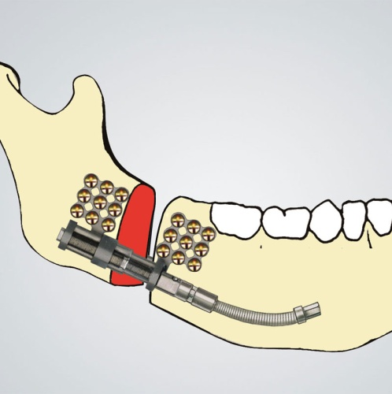
- Two types of distractors :
- intraoral distractor

- Extraoral distractor

The Dr talked about (Hyrax) APPLIANCE , which is a maxillary expansion appliance
In case the patient has severe constriction of maxilla , and it’s impossible to correct with ortho trt , the use of surgical- assisted palatal expansion ,incorporating the concept of DO ,
In such a case the expansion device is secured and a surgical procedure is then completed by performing LE FORT 1 OSTEOTOMY and create a separation between central incisors , after the latency period the device is activated 1 mm per day until the desired expansion takes place.

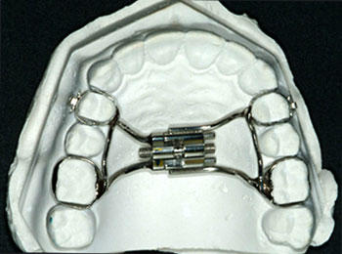
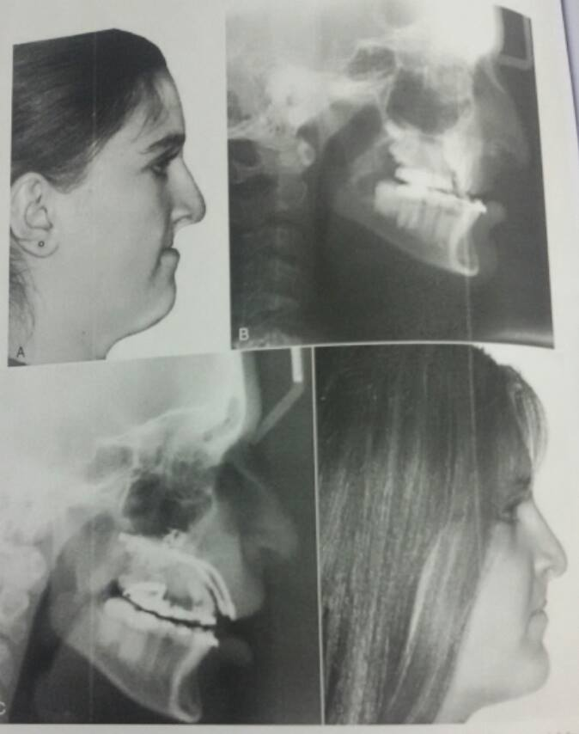
- Distraction appliance are also available for maxillary & midface advancement
In patients with cleft lip and palate, substantial scarring often occurs from multiple previous surgical procedures , this scarring combined with significant growth abnormalities creates soft tissue limitations that may prevent single stage correction with orthognathic surgical technique , DO can be effective by gradually stretching the soft tissues and eliminate the need for graft harvest and providing long term stability .

Pre operative care for orthognathic surgical patient :
- Admission
The patient should be admitted as IN patient on the day of surgery or the day before according to hospital system.

- pre opretive assessment : medical history taking and complete physical examination
clinical , laboratory ( full blood count, kidney function test, clot screen , liver function test ) , radiograph ( OPG & lateral ceph )
& anesthesiologist consultation.

- Post operative / after surgery
- Recovery room ( until the pt is oriented , alert ,comfortable, and has stable vital signs)
- Hospital room , the nurse should continuously monitor postoperative progress , usually stay for (1-4 days)
- Radiograph (OPG & Lateral ceph) as soon as is feasible, radiographs are obtained to ensure that the predictable bone changes have taken place & that stabilization device is in proper position.
- Medications (prophylactic Antibiotics , Analgesics “the pt experienced mild to moderate pain” )
- Discharge & mobility , when he is feeling comfortable , urinating without assistance ,taking food and fluid without difficulty , and oral hygiene is very important.
- home instructions : nutrition , the patient require a nutritional support and to learn how to obtain adequate nutrition during the period of IMF because the neurosensory balance between the jaws are changed and the proprioception might be confused after the surgery , so you have to put guided elastics to over-ride proprioceptive impulses from teeth, which otherwise would cause the patient to seek a new position of maximum intercuspation .
- Recall

Postsurgical treatment phase

- Completion of orthodontics :
When a satisfactory range of jaw motion and stability of osteotomy sites are achieved, the orthodontic treatment can be ended.
The settling process proceeds rapidly & rarely takes longer than 6 to 10 months.

Complications of orthognathic surgery

Intra operative :
  - Bleeding
Pterygoid plexus of veins
Maxillary artery
Descending palatine artery
ID artery
>> The first line of managing bleeding is ( pressure)
- Bad split
>> you need to fix it and this will take a longer time in surgery

post operative complications :
- relapse ( could happen immediately after or years later ) esp in cases of Anterior open bite , or in big movements , or due to poor planning
- fixation problems
- neurosensory deficient , might be permanent
- Generalized complications:
- vomiting
- DVT(deep vein thrombosis ) its un common , but you have to be sure that you have a DVT Prophylactic program / make sure that the pt is well hydrated, do exercises for the legs and encourage mobility , or sometimes use anticoagulant drugs
- Emotional & psychiatric ( which is the most important thing )
Most of orthognathic surgeries are elective, but if the pt want to change his profile and his expectations are too high that cannot be achieved by the surgeon this can cause a psychological problem for him and ended with a medico legal problem .
So You should have proper assessment and proper treatment plane

Finally ,,
Done By : Ruba Aqel
Sorry for any mistake !
Good luck with your exams
And May the odds be ever in your favor :P

