Preprosthetic surgery
22/10/2014
Lec. #6
Dr.Shayab

It is the surgery that is needed before the placement of the final prosthesis or to prepare the mouth (hard and soft tissues) to receive the final prosthesis. As you know the ridge (either the lower or the upper) is subjected to the physiological process of resorption, and this resorption is dependent on many local and systemic factors ( such as diabetes and metabolic disorders that affect the pattern of resorption, for example we know that a pt. with diabetes has an accelerated pattern of bone resorption). And for this reason we have to know the ideal requirements of the oral hard and soft tissues before receiving the final prosthesis.
Before any preprosthetic surgery you have to work and plan effectively with the prosthodontist to reach the best treatment plan and decide which type of surgeries is needed.
The ideal requirements for the oral hard and soft tissues are:
1) no evidence of intra- or extra-oral pathologies.
2) Proper inter-arch relation (in ant-post, vertical and transverse relation)
3) the ideal shape of the arch ( uniform U shape with the vertical components parallel to each others)
4) adequate palatal vault form
5) proper post-tuberosity notching
6) no bony or soft tissues undercuts
7) adequate attached keratinized mucosa in the primary denture bearing areas
8) adequate vestibular depth
9) added strength when mand. Fracture may occur
10) protection of the neurovascular bundle
11) adequate bone support and attached soft tissue covering
If any of the previous points was deficient, the prosthodontist would decide to plan for a preprosthetic surgery, and the surgeon might have his input in the plan.
The most important step in the preprosthetic surgery isn’t how to perform the technique of the surgery but treatment planning and choosing the most suitable surgery and technique as each one has its own indications and contraindications.
We have to start evaluating the pt. from the c/c, and then we have to see the pt’s expectations, motivation and attitude. After that, it’s important to evaluate the pt’s medical condition (as if you have a diabetic pt. you have to explain him the fact that he has a higher resorption rate than competent pts. or a higher ratio of implant failure). This is followed by intra- and extra-oral examination and inspecting any problem that might affect your final prosthetic design.

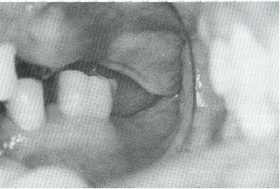
Excess growth of the tuberosity:
It might be caused by excess soft tissue or bony growth and diagnosed by x-rays. This overgrowth might reduce the interarch space resulting in interferences in the final prosthesis.

Flappy Ridge:
Very high thickness of the gingiva that might reduce the stability and retention of the final prosthesis. This appears most obvious in pts. with teeth in the lower jaw and edentulous upper jaw for a long period, and due to rapid trauma severe resorption and redundant tissue might appear.
We can’t directly decide that this pt. needs excision of the excess soft tissues because in some cases the remaining bone height isn’t enough to receive the final prosthesis, so here we should plan for bone grafting.
We may use a lat. Ceph. for detecting the relation between the max. and the mand. in dentate people. While in edentulous pts. we detect it clinically by constructing base plates and wax rims.
CTs and CBCTs have recently helped in assessing the quality and the quantity of bone before any preprosthetic surgery. And all these methods of examination (history, clinical examinations, radiographs,..) are important to determine your definite diagnosis and decide the final treatment plan and the surgery needed.

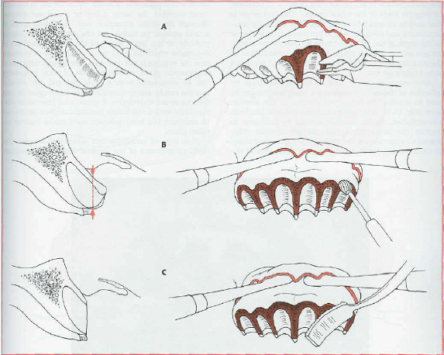
Simple Alveoplasty:
In this surgery we aim to recontour the bone and remove any irregularities that affect the ridge, because they might cause frequent lacerations and excessive bone resorption when the final prosthesis is placed and compressed against the soft tissues. This also might cause instability and poor adaptation of the final prosthesis.
The alveoplasty could be performed either at the time of extraction or after the healing of the ridge.
It is about removing bone from the labiocortical surface of the ridge after the elevation of a flap to expose the bone either by a rongeur or a bur, then smoothen it with a bone file. After that we close the flap with a continuous locked suture that will insure good adaptation and healing of the flap.
By this type of surgeries you may achieve a “U” shaped ridge which is the ideal shape to get the maximum stability of the final prosthesis.
The flap incision should extend beyond the working area. If you expect tearing while making an envelope flap and applying pressure, you may do releasing incisions. No need to reach the basal bone with your releasing incisions, you only need good exposure and access to the working area.
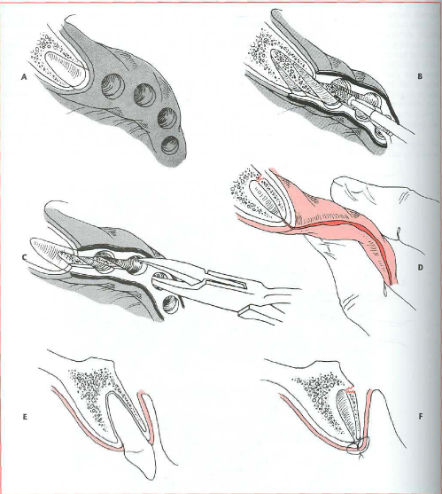
Interseptal Alveoplasty:
Applied at the time of alveoplasty, but in those cases which if you go for simple alveoplasty you are going to reduce the height of the ridge. So we remove the interseptal bone and squeeze the buccal ridge toward the palatal side. You may ease the fracture of the buccal bone by making a monocortical cut on each sides of the bone.
In this type of surgery, you are not removing much from the bone structure, furthermore, you are preserving the attachment of the labial structure and this will decrease the resorption. The height of the ridge is preserved but the width is reduced.
This alveoplasty is contraindicated in case of implants.

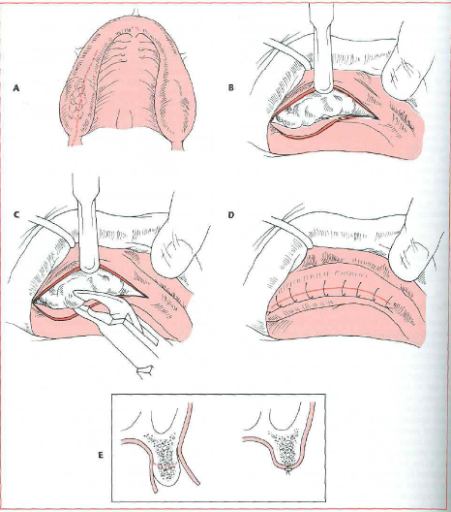
Boney Exostosis in the Tuberosity area:
If the interarch space is decreased, you have to remove those exostosis, while if it is increased you have to move toward bone graft.
In the case of excision, start with a cristal incision, and then remove the exostosis with a bur or a rongeur.
Before proceeding, you have to take x-rays to detect the level of the sinus and to prevent any communication. (the dr. asked about the management of the oroantral communication but didn’t answer!)
After any extraction, try to remove any bone irregularities to get a regular final healing ridge. Even if you are placing an implant you have to smoothen the ridge before the procedure, because if you leave any irregularity the threats will be exposed in some areas and covered in others.
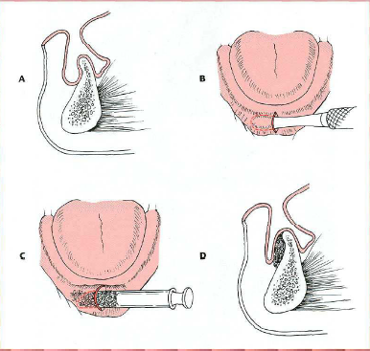
Always use continuous locked suture after any preprosthetic surgery, except for cases of dental extractions then make it simple interrupted to allow drainage.
In a knife edge ridge you will mainly find sever undercut, so if you remove bone you are decreasing the height and width of the ridge so the best solution here is to graft bone. But when you deal with bone graft – wither autogenous or synthetic- you have to pay attention for the exposure and retraction of the soft tissues. Try to make it as minimal as possible to prevent failure of the graft or increased resorption. Use the tunnel technique and open a midline incision then enter the periosteal elevator and place the bone graft. This technique will provide good placement of the graft, preserve the tissues and prevent failure.

Palatal Exostosis:
Start with a flap, but be aware of the greater palatine artery. If by mistake you injured the artery you first apply good pressure to stop the bleeding and then ligate distal to it.
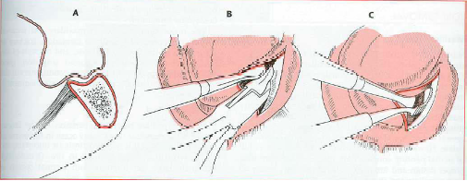
Prominent Mylohyoid ridge:
Excessive resorption in the mandible will cause prominent Mylohyoid ridge and external oblique ridge and depression in the middle of the ridge. So if the interarch space is increased you may go for bone grafting, but if reduced you have to lower the floor of the mouth and the myelohyoid ridge.
Do your crestal incision more buccally to avoid lingual n. injury but be careful from any hematoma in the floor of the mouth. Inform your pt. to attend the ER as soon as he feel any difficulties in breathing or swallowing or bleeding.

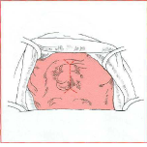
Torus Palatinus:
It varies in size and can be present in dentate or edentulous pts. in dentate pts. it is rarely indicated for removal unless interferes with speech, while in edentulous pts. if it’s presented in the post dam area it will interfere with the peripheral seal of the final prosthesis so it is usually indicated for removal.
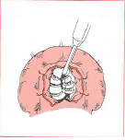
Start with a midline incision with releasing incisions ant. and post. But keep in mind that the soft tissue in the palate is very thin and easily lacerated. Retract the soft tissues with retraction sutures and divide the torus into small pieces to ease its removal without fracturing the bone and making communication with nasal cavity. Remove the pieces with a fine osteotome or a bur. To avoid hematoma and induce good adaptation you may add a solid liner or conditioner to the fitting surface of the denture over that area.
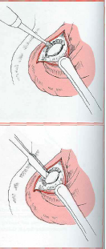
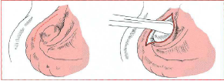
Torus Mandibularis:
It is indicated for removal whenever it interferes with speech or final prosthesis. Start with more buccal incision then direct exposure. If it’s large, don’t use a ronguer to remove it because you may fracture the mandible. So make a trough by a fissure bur between the tori and the lingual plate to separate it, then by an osteotome you van remove it. Finally smoothen the area with a bur or a file and close the incision.

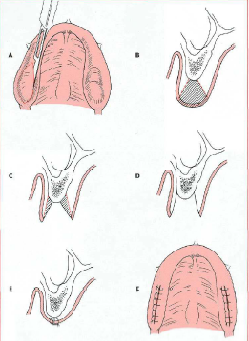
Excess unsupported soft tissues:
If present in the max. tuberosity area, Cristal or diamond incision is made, remove the soft tissue then it will heal with primary intention.

Excess fibrous tissue affecting the maxilla:
It can be excised if we have adequate bone support underneath it.

Inflammatory Fibrous Dysplasia :
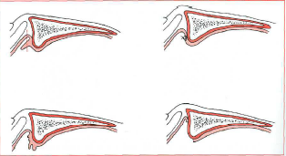
Also know as denture fibrosis or epulis fissurata. If it has a large size and we excised it and pull the mucosa to close it by primary intention we are losing the depth of the vestibule. So we just excise it and suture the edges of the incisions to the underlying periosteum and let it heal by secondary intention to preserve the depth of the sulcus.

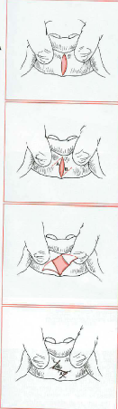
Frenectomy:
The frenal attachment is prominent fibrous attachment that could be with a narrow or wide base. If the base is narrow, make a diamond incision around it, remove the fibrous tissue with the periosteum and close it. This technique is called Simple or Z-plasty Frenectomy.
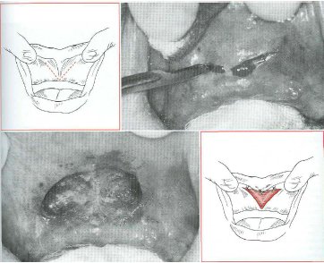
If the base is wide we can’t use the simple technique because it will reduce the depth of the sulcus. We use the Localized Vestibuloplasty with secondary epithelialization by making a ”V” shaped incision, then remove the fibrous tissue and the periosteum to prevent recurrence with a dissecting scissors, suture the mucosa with the underlying periosteum and leave it to heal by secondary intention.
We can use the CO2 laser to remove any excess fibrous tissues and the area will heal by secondary intention.
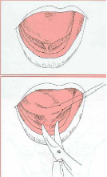
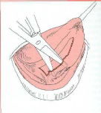
Lingual Frenectomy:
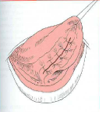
The lingual frenum attaches the tip of the tongue to the lingual surface of the mandible. It’s indicated for excision when it interferes with speech in children or breaks the seal of the final prosthesis.
Use the hemostat to compress the frenum for about 3 mins., this will compress the blood supply to that area and you will notice the blanching. Retract the tongue either by sutures or by hand and make a transverse incision till you reach the tip of hemostat, undermined the edges of the incision the close. Be aware of the sublingual vessels and the mandibular gland ducts.

Sinus Lifting Procedure:
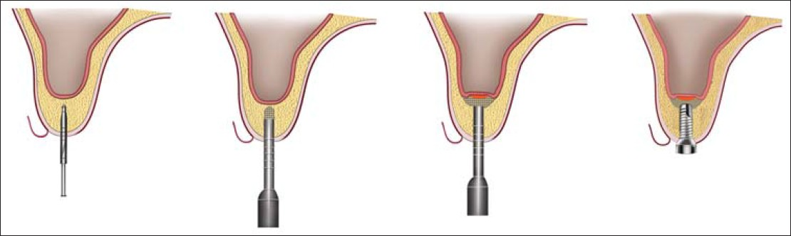
Used when there is no enough thickness of bone under the sinus for implant surgery. The minimum bone thickness needed for implant placement is 8mm (as the shortest implant length is 8mm). so when you have 4-8 mm of bone thickness left, this is an indication for indirect sinus lifting (without a direct exposure of the sinus), use the osteotome for raising the sinus membrane for 4 mm. If less than 4mm thickness of bone is left, direct sinus lifting is indicated. (4mm is the cut point because it is the minimum height needed for primary stability).

with regards,
Haneen O. Kharoub

