lecture one
Sunday 14-9-2014
dr. ahmad hamdan
periodontal suturing
- Requirements: 8 points
- Competencies:
Full mouth charting
Use of hand instruments on a specific sextant
Use of ultrasonic or machine driven instruments
Polishing
Maintenance case
ملاحظة: اللي ما بخلص ال Competenciesيعتبر غير مكتمل للمتطلبات
-our main object is to know when to refer a patient to periodontal surgery
Note: principles of surgery that we took last year will be included in the midterm exam" a question or two"
-the principles of perio. treatment are: removal of the cause, stabilization, regeneration and maintenance
-in surgery, incision placement, flap management and the outcome of the surgical procedure is very important, also flap adaptation and stabilization are equally important
-the surgeon must not relay on sutures to pull the flap
-any surgery with tensed flap margins will eventually open
-the aim of sutures is to stabilize the flap in its position and not to pull the flap beyond its passive position so that tension on the base of the flap doesn’t happen
-tension on flap margins will cause ischemia and necrosis
Goals of suturing:
1-Approximation of edges: Goal: “approximate, not strangulate”
-Healing is usually by: primary intention
Or secondary intention"ex: when there is gap on the ridge after teeth extraction"
2-Compression of blood vessels to stop bleeding"hemostasis" "ex: when taking grafts from the palate, you will be close to the greater palatine vessels, and the danger zone begins distal to the first molar"
Note: the safest area to take a palatal graft is from the mid. first molar
3- Suturing is performed to provide adequate tension of wound closure, to avoid creating a dead space; it should be loose enough to prevent ischemia and subsequent necrosis

4- Suturing to maintain clean spaces, because if the flap remains open especially with partial thickness flap bleeding will continue "ex: plastic surgery and soft tissue surgery"
5- It allows for primary intention healing
6- Suturing is performed to provide support for tissue margins until they have healed and support is no longer needed; during healing process blood clot will form, and this clot needs space at the expense of tissues
7-suturing helps to minimize the clot
Note: compression for 2-5 minutes also helps to minimize the clot
8-A key for success of any surgery is to maintain the clot to its minimal volume as much as possible, the bigger the volume of the clot will result in increasing the need for more tissues to replace the clot during tissue regeneration "with increased granulation tissue"
On the other hand when the clot is of minimal volume revascularization will happen faster and the space that is needed to regenerate tissues is minimal
9-reduce post operative pain
10-Prevent bone exposure
11-permit proper flap position
Advancement flap should not be placed beyond its limits; undermining incisions "periosteal releasing incisions" are performed so that we can advance the flap without creating any tension
Suturing materials:
Silk: the worst suturing material ever, but all the beginners begin using silk
Vicryl, Nylon, Gut….etc
Characteristics of suturing materials:
Biocompatible
Easy to handle
Prevent bacterial contamination and accumulation of plaque
Durable
Not slippery
Thin "to minimize trauma"
High tensile strength" low tensile strength creates a weak point on the knot area that is weaker than the material itself"
-wetability of the suturing material: ideal surgical field should be sterile and dry opposite to what we have in the oral cavity which is always contaminated and wet, and hydrophilcity decreases the tensile strength of the material "so we prefer it to be hydrophobic"
- knot security
- sterilized material
- Appropriate elasticity
- No reactivity "inert"
- Chemical biodegradable vs. foreign body breakdown:
Chemical biodegradable: the material itself will dissolve, and not affected by the host response; the byproducts of the dissolution are recognized by the body as basic components "carbohydrates, amino acids, proteins…"
Foreign body breakdown: Any host driven response including healing has inflammatory response in the first 2-3 days up to 7 days, and if the material depends on foreign body breakdown this will increase inflammation in a site that requires minimal inflammation and therefore increase morbidity
Note: PLGA or poly(lactic-co-glycolic acid) was thought to be a good suturing material, but as It consists of amino acids; the biodegradability actually decreases Ph which increases inflammation
Types of suturing materials:"size, color, absorbability, diameter, origin…"
– Absorbable vs. non-absorbable
– Natural vs. synthetic
– Monofilament vs. multifilament

-Absorbable: plain gut, chromic gut, vicryl
-Non absorbable: silk, nylon, ptfe, polyester
Note: vicryl needs 2-3 months to be resorbed

- Monofilament
-Braded" multifilament"

-biologic"natural"
-Synthetic: poly glycolic acid, vicryl, Polyglycan,monocryl, polyglycolate

-we mainly use silk, nylon and vicryl
- ptfe is not available in Jordan but it is used mainly in bone grafting and guided tissue regeneration, because of its high tensile strength, liability and high resistance

You choose the right material depending on:
-The type of surgery and procedure
-Biocompatibility of the material
-The clinical experience and preference
-Quality and thickness of tissues
-Rate of absorbtion vs. time for tissue rebuild: we don’t want a material to be absorbed after 7 days, meanwhile the gingival needs 14 days to heal, tissues are not yet stable and needs sutures to remain for 14 days not 7 days

Knots and knotting:
Suture security: is the ability of the knot and the material to maintain tissue approximation during healing process
-the knot strength is always less than the tensile strength of the material, when force is applied the site of disruption is always the knot
- The knot security depends on:
The coefficient of friction within the knot: This depends on:
-The nature of the material: braded sutures have better coefficient of friction
-Suture diameter: smaller diameter is better
- Tie of the knot

Silk vs. vicryl:
-silk is the most user friendly material, next in line is vicryl, but silk is inferior to other materials in terms of strength with high degree of tissue
reaction...why??Because it gets wet pretty easily and organisms can easily colonize on it, vicryl is not so much different in terms of plaque accumulation but the wetability is less than silk
Summary:
vicryl | Silk
more | less | strength
less | more | Tissue reaction
less | more | wetability

Knot anatomy: three parts:
-Loop
-Knot
-Ears: the cut ends of the suture "2-3 mm" why??Because the tensile strength on the knot is smaller than the material itself and if any disruption happen it will occur on the knot
If more than 2-3 mm: will decrease the resistance on the knot but will annoy the patient
If less than 2-3 mm: the knot will disrupt

Principles of suturing:
-the completed knot must be firm, flat and tied in away so slippage will not occur
- To avoid wicking bacteria, knots shouldn’t be placed on incision lines
- Knots should be small and the ends cut short 2-3 mm
- avoid excessive tension of fine gauge materials because breakage may occur, we use 5-0 and 6-0, in microsurgery we use 7-0 and 8-0
If it did not break, micro fractures or weaknesses may happen
-Avoid using a jerking motion which may break the suture
Note: taking two bites at the same time can cause: tension on the buccal and multiple punctures or partial bites lingually, weakening the needle and suture
-avoid crushing of suturing material by not using needle holders on them except
on the free end for tying
-do not tie sutures too tightly because tissue necrosis may occur
-avoid tissue damage
-maintain adequate traction on one end by trying to avoid loosening the first loop
Suture removal:
-swapping the area with H2O2 "3%" to clean the area, why?? Because the sutures are covered with bacteria and plaque, and when we remove the sutures holes in tissues will occur, as a result bacteria will enter the tissues through theses holes if we do not clean the area with H2O2"in addition this will help in removing the necrotic tissue"
-sharp suture scissors should be used to cut the loops of the suture rather than blades
-cotton plier is used to remove the sutures
Surgical needles: three parts:
-Eye "swage": where the thread is attached to the needle
-Body: widest point of the needle called the grasping area
-point: it runs From the Tip to the maximum cross sectional area of the body "Conventional cutting, reverse cutting, side cutting, taper cut"
-Chord length: Straight line distance between the point of curved needle and swage
-Radius: the distance that is measured from the center of the circle to the needle
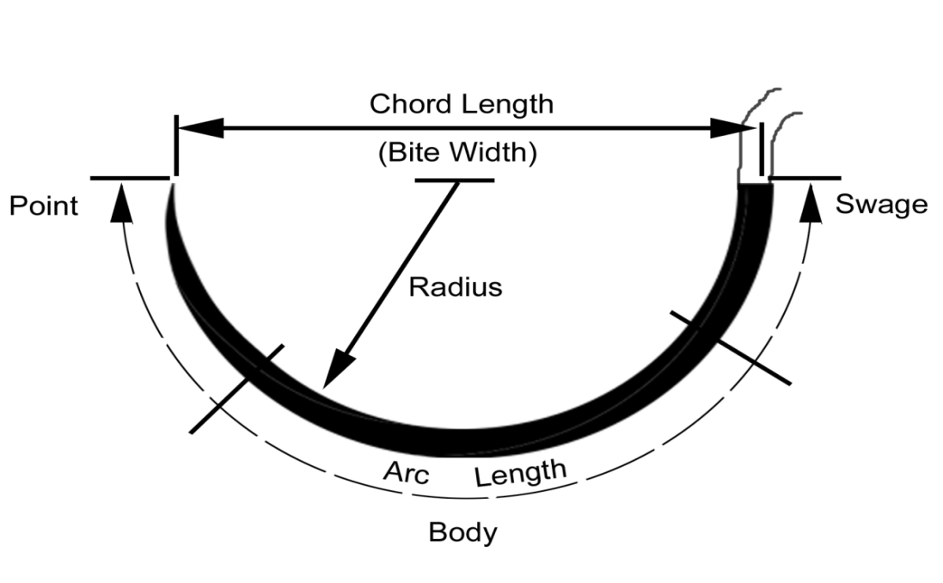
ملاحظة: ما رح يجي اسئلة على parts of the needle
But you should know them!!!
-hold the needle two thirds the distance from the tip, why?? To ensure a good bite with no bending in the needle
-Sometimes we might need to change how we hold the needle to ensure a good bite without creating tension
Needle holder selection:
-Approximate size for a given needle; a small needle needs a small holder and vice versa
-needles should be grasped one fourth to one half the distance from the swage area to the point
-the tips of the jaws of the needle holder should meet
-needle should be placed securely in the tips of the jaws without poking, twisting or turning
- avoid whole closure of the needle holder to avoid damaging the needle
-needle holder should be directed by the thumb not the index or the middle
Placement of needle in tissues:
- Force should be applied in the direction following the curvature of the needle, and the tip perpendicular to the tissues
- Suturing is done from movable to non movable tissues
- Avoid excessive tissue bites with small needles
-Sharp needles should be used with minimal force. Replace plunt needles
-Do not hold the swaged area or the pointed area
-Needle should penetrate the tissues at right angels
- Avoid retrieving the needle from the tissue from the tip.
- An adequate tissue bite is required from the tissue margins to avoid tissue tearing

Suturing techniques:
"You should know the differences between the steps not the actual sequence of steps"
-periosteal : we include the periosteum
-non periosteal
- interrupted
-continuous
- The choice of the technique depends on the choice of individual , operator preferences, educational background, skill level and surgery requirements

Periosteal sutures:
Permits precise flap placement and stabilization mostly in apically positioned flaps "partial thickness"
Sequence: Penetration, rotation, gliding "Gliding on bone", rotation then exit
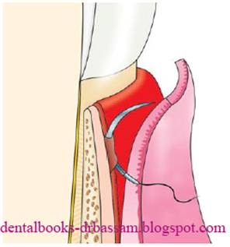
Interrupted sutures:
For vertical incisions, tuberosity and retromolar areas, bony regeneration procedures and GTR "GIUDED TISSUE REGENERATION" Why??Because these sutures are Single stitches and individually knotted, if a suture breaks, all sutures will not break
….51: 13 also used for apical positioning flaps, in edentulous areas partial osteotic flaps and dental surgery
Types:
Circumferential
Direct
Loop
Figure of eight
Vertical mattress
Horizontal mattress
Intrapapillary placement

Direct suture:
Outside..inside…inside…outside
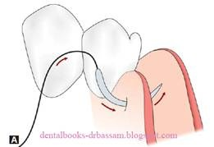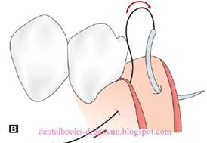

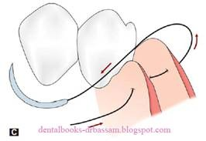
Figure of eight suture:
In crown lengthening
Outside…inside.. outside..inside
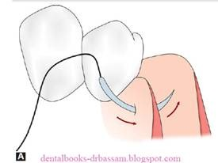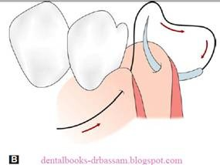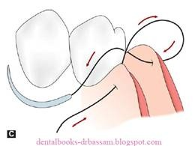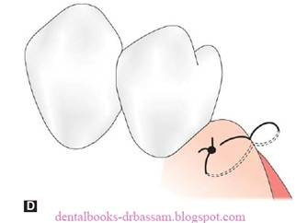

– Mattress sutures:
Greater flap security and control, more precise flap placement, good papillay stabilization and placement
Vertical mattress:
In bony regeneration, Soft tissue surgery and plastic surgery
Outside...inside..outside…inside …
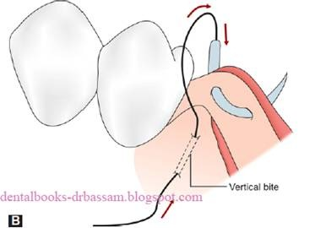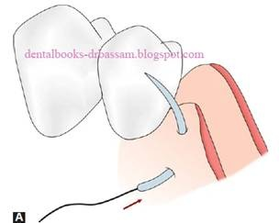

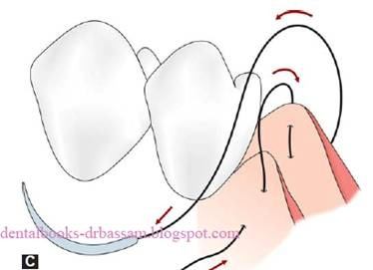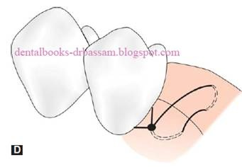

Horizontal mattress:
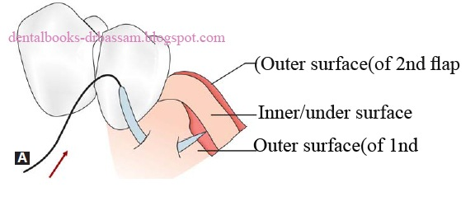
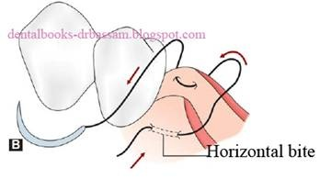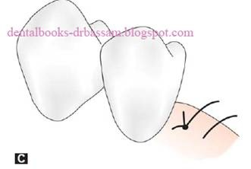

Sling suture:
The flap is raised only on one side of a tooth involving one to two inches of papillae
Coronally Advanced flaps and laterally positioned flaps

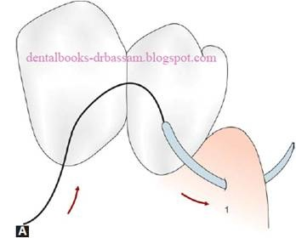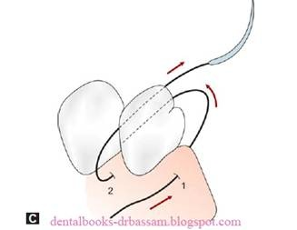

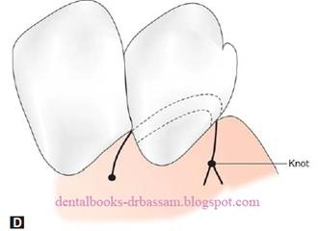

-Continuous sutures:
Advantages:
- They can include as many teeth as required
- Minimize the need for multiple knots
- Simplicity
- Teeth are used to anchor the flap
- Permits precise flap placement
- Avoids the need for periosteal sutures
- Allows indefinite placement and tension of buccal and lingual or palatal flaps
- Distribution of forces of flaps
Disadvantages:
- If a suture breaks ,all sutures will break as well
Types:
- independent sling
- mattress sutures
- Continuous locking sutures

Sorry for any mistakes
Done by: ruba rayyan

