Periodontology
Lecture 4
Sunday 12/10/2014
Dr. Nicola
Periodontal Flaps
- Last lecture we talked about “Resective surgery” which is the category that includes Gingevectomy and Gingivoplasty.
- It was so-called “Resesctive surgery” because we are resecting (cutting) something. The Gingevectomy procedure is indicated to eliminate the suprabony pockets.
- So far, we have learned how to treat gingivitis and how to treat periodontitis simply by root planing, scaling and polishing along with oral hygiene instructions.
- We also learned how to eliminate the ginigival pockets or any gingival enlargement and coronal migration of the gingiva irrespective of their cause (whether it was inflammation, plaque induced or idiopathic causes).
- Today we are going to learn about a new surgical modality which is “Periodontal Flaps”.
- Flaps by definition are a section of the gingiva, mucosa or both that is surgically separated from the underlying tissues to provide visibility and access to the bone and roots surfaces.
  - The section in the gingiva is only within few teeth; because we can’t do a surgery for the whole gingiva, it is very hectic, time consuming and the patient can’t bear the pain.
  - The flap also aids in providing access and visibility for the root surfaces; this is another function of the flap
- Why do we need access and visibility? For many reasons:-
- To allow us to do a proper root planing
- Once we insert the probe inside the sulcus; this is called “Closed technique root planing”; because we are using our tactile sensation to plane the root surfaces without seeing them.
- When we rise or reflect a flap and do root planing this is called “Open technique root planing”.
- To access the area in order to perform respective surgery (Gingivectomy/Gingivoplasty) to reduce the level of the bone or to add bone in the place of the lost bone or to change the place of the gingiva (ie: to cover denude roots in any direction whether Coronal (upwards), Apical (downwards) or Lateral (on the sides)).

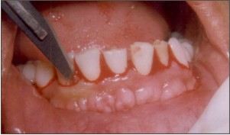
This is a picture showing how to raise a flap using scalpel blade.

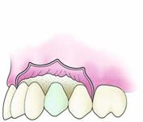
- Here I simply took the blade and put it in the sulcus, I am moving sulcular and I am further detaching the already detached tissues; usually this procedure is done when we have periodontitis. So by this procedure I am increasing the detachment of the tissues to access the area, although I didn’t raise a flap this procedure is still called a flap (we made a flap without elevating it from the periosteum).
- When I want to reach deeper structures I have to do incisions (one side/two side); it is similar to envelope opening. {We will talk about incisions shortly in this sheet}
- After I elevate the flap and finish my procedure I have to return it back to its place; there are two ways to return the flap:-
- Return the flap to its original exact position (Replaced Flap) or (Non-displaced Flap).
- Return the flap to a new position (EX: Apically positioned flap; the flap is put apical to its original position)
- In some cases of gingival recession we have to reach deeper in our cutting which is beyond the mucogingival line; we all know that the mucogingival line is a loose area; it is loose to allow the periodontal tissues to move freely during eating; if this area is not loose enough it will tear during eating and moving.
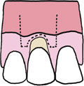
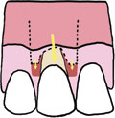
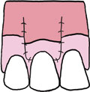
- So in this area (Gingival recession) we access the flap beyond the mucogingival line in order to get a completely flexible flap and move it in any desired direction. In our case of gingival recession we made a coronally repositioned flap
- Then we sutured it using interrupted sutures, the sutures are left for 7 days then removed.
- All our work will be a failure if the patient did not reach a high standard oral hygiene; actually we did the and all that surgical work because of lack of good oral hygiene.
- So the main etiological factor was plaque mainly.
- Also, aggressive periodontitis is mainly caused by plaque.
- Thus, all the prognosis of the cases depends on the patient’s oral hygiene.

- Objectives of Oral surgical procedures (why do we perform it) :-
- Improvement of the prognosis of teeth and their replacement
- Ex: I have a patient with grade 2 mobility, which means there is resorption and bone loss; some people will say that it has a poor prognosis and will recommend extraction and implants; however other more experienced people may say that the prognosis is problematic but still treatable and they do a surgery to improve the prognosis of the tooth.
- Improvement of aesthetics:-
- Ex: patient having gingival recession on a single tooth that is denuded due to high frenum, inflammation or excessive brushing
- The surgical phase consists of various techniques that can be used for pocket therapy and for the correction of related morphological and mucogingival defects (morphological defects like bone resorption, Mucogingival defects such as gingival recession)

- After we have known the objectives we have to know the goals (which are the results after the surgery)

- Goals of Oral surgical procedures:-
- To expose root surfaces that are not accessible such as those associated with deep pockets or furcations; especially if it is more than grade 2 or 3 or 4 where the interseptal bone is resorbed.
- The surgical reduction or elimination of periodontal pocket (Resective pocket surgery)
- The induction of adaptation, new attachment and bone regeneration(periodontal pocket/Regenerative pocket surgery).

(So we have cutting, root planing and regenerative procedures)

- The correction of gingival and mucogingival defects and deficiencies (Dehiscence, fenestrations, recession…etc)

How do we achieve regeneration (coronal migration of the junctional epithelium) after root planing?
- As we know, the pocket was caused by the apically migrating junctional epithelium.
- There are 2 concepts of healing, healing by Reattachment and Healing by New attachement.
- The difference between Reattachment and New attachment:-
- In Reattachment, the tissues repair itself and nothing is lost (no bone loss), the cells repopulate and attach themselves again, this is associated with shallow pockets 2 mm or less (remember we have the sulcus that is 3mm and a pocket that is only 2 mm below the sulcus (ie: probing depth is 5 mm).
- However, if the pocket is greater than 5 or 6 mm, we have bone loss, which is associated with connective tissue loss (periodontal ligament loss), as a result of the bone loss there is no place for the epithelial and PDL cells to reattach when they repopulate, so we have to do what is so-called “New attachment” that is directed by us by putting new bone or membrane or by guided tissue regeneration and bone grafts.
So what we have taken is summarized in 2 points
Pocket reduction surgery is either:-
- Resective
- Regenerative

- Resective:-
- It includes gingivectomy, gingivoplasty and apically positioned flap.
- The flap can be done with or without osseous surgery.
- Regenerative:-
- It includes flaps with grafts
- We take the grafts from different sites such as the palate.
- It also include Guided Tissue Regeneration:-
- Once the PDL is lost and we have bone resorption, we open a flap and bring a membrane that could be GTR (guided tissue regeneration or PTFE (poly-tetra-fluoro-ethylene) and many other substances; the chosen substance is put between the pocket wall and the bone and it is resorbable.
Note: Before, they used non-resorbable membranes, they were put between the pocket wall and bone, and they wait for a while and open a flap again to remove it, this was painful and costy and success rate was only 50% depending on the operator’s skills.

- Which tissues will have repopulation after flap closure?
- Epithelial cells and periodontal ligament cells (PDL).
- Usually epithelial cells repopulate much faster than the PDL, when the flap is closed we will have long junctional epithelium which is not acceptable to us; we don’t do the surgery to have long junctional epithelium, we have to guide the tissue regeneration, so we bring the guiders which are going to retard the repopulation of the fast epithelial cells and allow the periodontal ligament to build up first, then let the epithelial cells to repopulate ; by this we have equal proportions of junctional epithelium and periodontal ligament, and hence there will be no pocketing (we eliminated the pocket)
Note: PTFE has many applications in real life (used in kitchens, shoes and dentistry) and the difference between these uses is in the porosity of the materials, which gives the material its quality for dental use and make it worth 200 JDs. (this is for your own info only)

Continue talking about the goals of flap surgery:-

- Plastic surgery techniques to widen the attached gingiva.
- Aesthetic surgery, root coverage and recreation of gingival papillae.
- Pre-prosthetic techniques
Ex: Crown lengthening by flap surgery, gingevectomy or electrosurgery.
- Ridge Augmentation and Vestibular Deepening.
Ridge Augmentation is for resorbed ridges to prepare them for prosthetic replacement.
Vestibular Deepening is required in the construction of complete denture borders (We widen the vestibule to increase the height of the ridge).

- Basic Principles of Flap surgery:-
- Periodontal flaps can be classified on the basis of the following:-
- Bone exposure after flap reflection (Thickness of the Flap)
And the flaps are further classified into:-
- Full thickness (mucoperiosteal) flap
- Partial thickness (mucosal) flap
- Placement of flap after surgery
And the flaps are further classified into:-
- Non-displaced Flaps
- Displaced Flaps
- Management of the papilla
And the flaps are further classified into:-
- Conventional Flaps
- Papilla preservation flaps
Now in Details:-
- For bone exposure after flap reflection (thickness of the flap):-
- Full thickness Flap:-
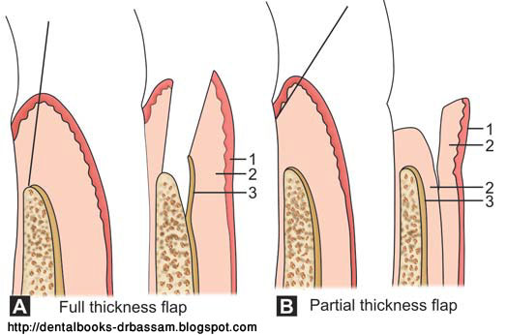
  - In this flap all of the soft tissue including the periosteum is reflected to expose the underlying bone.
  - It is indicated when respective osseous surgery is done.
- Partial thickness flap:-
- In this flap the epithelium and a layer of the underlying connective tissue are included, the bone is not exposed and is remained covered by the periosteum.
- This flap can be also called “Split-thickness flap”.
- It is indicated when the flap is to be positioned apically or when the operator does not want to expose bone.
- Note: in the diagram (1)= Epithelium, (2)=Connective tissue, (3)=Periosteum
- According to the placement of the flap:-
- Non-displaced flaps (Access Flaps):-
- The flap is returned and sutured in its original position.
- They provide access to the roots.
- Displaced Flaps:-
- Includes flaps that are placed apically, coronally or laterally to their original position.
- Both full thickness and partial thickness flaps can also be displaced or Non-displaced.
- Palatal flaps cannot be displaced due to the absence of keratinized tissue (unattached gingiva)

Note: The operator should decide where he is going to place his flap before starting the surgery (not haphazard)
We will continue talking about the third classification after revising the incisions.

- Revision on Incisions:-
The periodontal flaps involve the use of:-
- Horizontal Incisions (Mesial-distal)
- Vertical Incisions (Occlusal-Apical)

- Horizontal Incisions:-
- These incisions are directed along the margins of the gingiva in a mesial or distal direction.
- There are 3 types of horizontal incisions:-
- Internal Bevel incision:-
  - In this incision we are cutting from inside the gingiva.
  - It is used in most periodontal flap procedures.
  - It is the incision from which the flap is reflected to expose the underlying bone and root (ie: used with full thickness flaps) it also can be used with partial thickness flaps.
  - It can also be called reverse bevel incision
- Crevicular (Sulcular) incision:-
This incision is made in the pocket; we are cutting in the base of the sulcus.
- It starts at the bottom of the pocket and it is directed to the bone margin.
- Interdental Incision:-
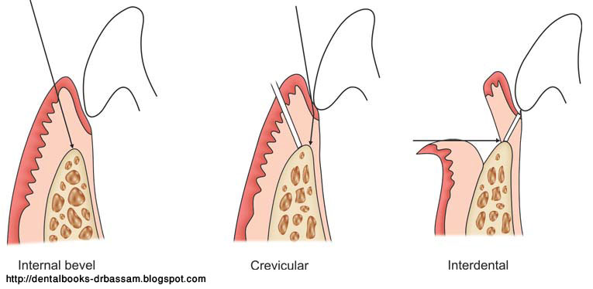
- It is performed after the elevation of the flap to remove the interdental tissue that remained after making the first two incisions.

- Vertical Incisions:-
- They are also called Oblique releasing incisons.
- They can be used on one or both ends of the horizontal incisions depending on the flap design and purpose.
  - When the flap has no vertical releasing incisions it is called “Envelope Flap”.
  - When two vertical releasing incisions are included in the flap design it is called “Pedicle Flap”.
  - When one vertical releasing incision is included in the flap design it is called “Triangular Flap”.
- Vertical incisions are generally used with displaced flaps.
- In apically displaced flap, the incision should be done at both ends.
- They should extend beyond the mucogingival line to reach the alveolar mucosa.
- These incisions are avoided in lingual and palatal areas.

Now we will continue talking about the last classification
- According to the management of the interdental papilla
- Conventional:-
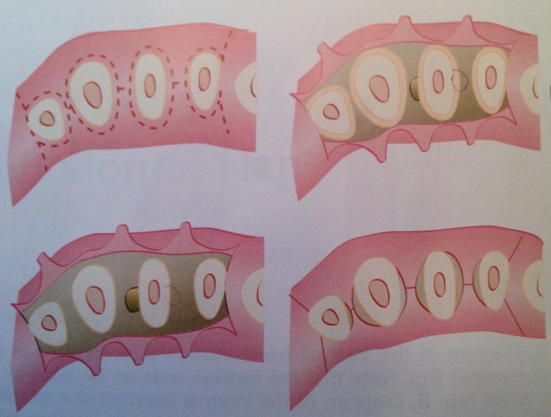
- As you know, the papilla should be removed completely in the flap.
- In the conventional flap, the papilla is splitted into facial and lingual/palatal halves.
- The incision is usually scalloped to retain the gingival morphology and to retain the papilla in the flap as much as possible.
- It is usually used when:-
        - The interdental spaces are narrow
        - When the flap is to be displaced
- The conventional flap include:-
- The modified Widman flap
- The undisplaced flap
- The apically displaced flap
- Flap for reconstructive procedures
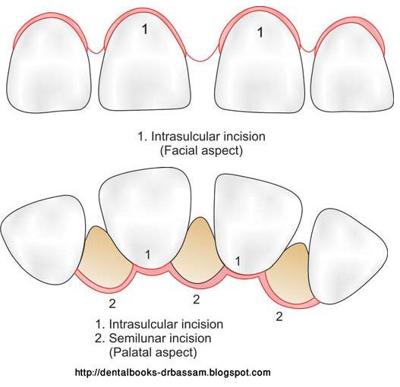
(These will be discussed later on the next lecture)
- Papilla preservation flap:-
- It incorporates the entire papilla in one of the flaps by means of crevicular interdental incisions (it includes the whole papilla)
- It is used in spaced teeth.

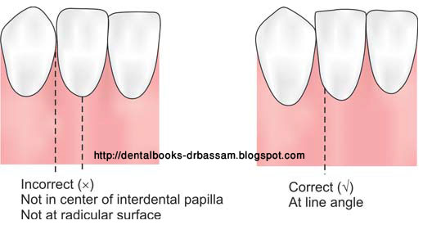
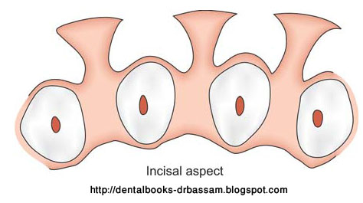

- When making the vertical (Oblique releasing incision) we should not put the knife at the middle of the interdental papilla, as this will bisect the papilla and it will not heal and it will be difficult to suture it and it easily tears off.
- The papilla is preserved as it is and should be cut lateral to the tooth (see figure above on the left).
- Avoid touching the crown at all.
(Sorry for Any Mistakes)

Done by: Khaldoon AlQaddumi

