lec # 5 Dr.Nicola

flaps for pocket therapy
last lecture we have studied the classification and the types of flap, How to raise up a flap , type of incisions , goals and objectives according to the classification . those are hints were given by the doctor that might be asked in the exam , questions we will about outlines we will not be asked to discuss a procedure in details ( la tet3ama8o kther belmo7a'6 alas2la r7 tkon sa67ya ) .
flaps for pocket therapy are dividing into two categories :
- flaps to treat pockets, here we rise flap only for gaining access , to remove calculus by root planning we also remove the diseased epithelial layer and granulation tissue by curettages to enhance healing and reattachment will occur then pocket will shrink.
remember : the purpose of the flap here is only having access not to reduce the pocket by excising part of gingiva.
so after we rise the flap we gained the access to perform the treatment we close the flap , pocket will shrink by itself not by cutting part of gingiva , hence no more pocket .

- flaps to eliminate or reduce the depth of the pocket by cutting part of gingiva ( pocket wall ).
steps for flap technique :
- incisions
we can't rise any flap without incisions ,we start with a certain incision and end up with final incision . for example :
- we start with inverse bevel ( also known as internal bevel )→1st incision .
- then crevicular ( also known as sulcular incision) →2nd incision
- then interdental or horizontal → 3rd incision ( to release the attachment of interdental papilla ).
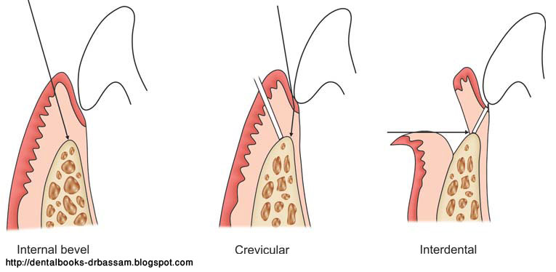
2) elevation of flap and doing the recommended procedure .
3) expose the area of the bone ( regenerative methods)
what is the deference between regenerative and reattachment ?
reattachment → tissues were attached before it diseased, after healing reattachment of those cells well return again .
new attachment → cells that have no attachment before but after treatment it will gain attachment ( dr. didn't mention this point in the lecture ) .
regenerative → we induce material ( either guided tissue regeneration , membranes, collagens , synthetic or natural <human> bone) to regenerate both new periodontal ligaments and new bone to gain attachment , actually we can't regenerate bone without periodontal ligaments and vise versa they are hand to hand .

4) closing flap by suturing whether interrupted suture , continuous suture ,... ) depend on the type of flap .
note : both full thickness flap and partial thickness of flap can be used either to eliminate / reduce or only treat pocket .
- classification of pocket therapy flaps ( exam question ) :
- conventional flaps ( done by the three incisions internal bevel crevicular and interdental ) include :
- modified widman flap ( very important ) → reattachment will occur( healing process ) .
- undisplaced flap → new attachment will occur.
- apically displaced flap → new attachment will occur .

- flap by regenerative process ( done only by one incision <crevicular incision >) include:
- conventional flap for regenerative technique with only crevicular incision, it's most simplest flap we can do after we rise the flap we put some material inside to trigger regeneration of bone and periodontal ligaments then we close flap .
we don't expose bone her to not be infected and resorbed.
we do this type of flap when teeth are so close and tight .
- papillary preservation flap.

modified widman flap ( No. 1 in the figure )
- also called gingival flap or open curettage technique .
- Ramfjord do a modification on the original widman flap to make it more accessible and easier even for general practitioner .
we do this flap by the three incisions as discussed earlier,
- internal bevel
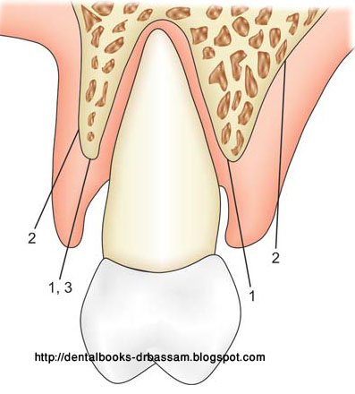
internal bevel in modified wedman start no more than 1-2 mm apical ( away ) from gingival margin ( enough to remove diseased epithelial lining ),it's subjective according to operator decision if there is no enough height of attached gingiva or not , sometimes it reachs 0.5 apical to gingival margin if there is no enough attached gingiva but if there is we can start incision up to 2 apical to gingival margin tell we touch alveolar bone crest , by that we separate the epithelial layer from pocket wall .
note : if we remove more than 2mm this mean we include the pocket wall that why we don't remove more than 2 mm .
b)cervicular incision .
c)interdental incision by urban knife( to release interdental papilla ) .
we will rise the flap for meticulous root planning and curettage then we close the flap by interrupted suture , suture will be removed after one weak , don't measure depth of pocket for the first 12 weeks because insertion of probe before that time will disturb the healing process and destroy epithelial attachment .
indication of modified widman flap is to treat pocket not to eliminate it because we didn't cut gingival wall
purpose of modified widman flap :
- to expose root surface for root planing.
- to remove pocket epithelial lining .
dr will give us paper has two paragraphs related to modified widman flap we should know them by heart( for the exam) .

undisplaced flap
- we excise apically to bone crest ( No. 2in the figure above )
- we remove epithelial lining + pocket wall
- here we eliminate / reduce pocket ( not treating )
- flap reposition back to its original place , that why it named undicplaced
- here new attachment will occur

apical displaced flap
- can be both to eliminate / reduce or treat pocket depending on pocket depth.
- to do this type of flap we should have :
- sufficient attached gingiva left , to be able to place flap apically
- mild to moderate periodontitis up to 6 mm pocket
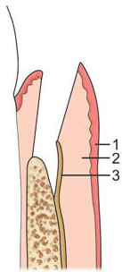
- here we reposition muscles of muccogingiva apically this allow the un keratinized tissues to become keratinized which great new attached gingiva .

mucoperiosteal flap without vertical incision
- here we are rising periosteum too.
this type of flap called repositioned flap because it can be repositioned ( coronaly , apically or laterally ).
note :apically / coronaly regarding to the level of original gingival margin.

- indication : we have pocket depth up to 9 mm .
( in the book it says '' this flap for mild to moderate periodontitis for pockets up to 6 mm ).
- we start with inverted bevel then the other two incisions
dr. didn't mention them but I guess they are crevicular and
interdental incisions .
- we raise the flap then we use a bur to recontour bone .
note: we are not reducing bone level here ,we only redesign the miss architecture bone(osteoplasty).
if you repositioned flap on well leveled bone i.e. bone not thick in one area and thin in other area so tissues will follow same architecture of bone which enhance attachment and we will have new biological zone .
biological zone composed of three parts :
1. sulcus
2. junctional epithelium
3. attachment
biological zone is 1.96 mm , in cons they say it's 3 mm .
while if we reposition the flap on non-will leveled bone healing will be by long juctional epithelium .

flaps by regenerative methods :-

papillary preserved flap

- from the name we preserve the interpapillary .How ?
In previous flaps we used to split inter dental papilla into labial side and lingual / palatal side then we suture it back , But her we circumference papilla by blade rather than splitting it , then we return it as one peace .
- advantages ( objectives ) of doing that is we are not losing tissues , bone or attachment.
- we add regenerative material

conventional flap for regenerative technique
- as mentioned above we just doing crevicular incision .
- we add regenerative material .

note : palatal flaps can't be displaced because they are keratinized .

sorry for any mistakes
Done by : Fahad Al-aswad

