Management of osseous defects
Osseous Surgery

Definition of osseous resective surgery:
- Removal of unsupported or undermined bone.
Osseous defect: is a concavity or deformity in the alveolar bone involving one or more teeth.
- Concavity: it means that the shape of the bony defect is concave (it has a uniform shape).
- Deformity: it means that the shape of the bony defect is abnormal and irregular.
Note: the normal contour of the alveolar bone is to be parallel to the CEJ so any change in this contour could be concavity or deformity.
Another definition for the osseous surgery:
- Re-contouring and eradication of angular bony defects and craters.
Note: crater is a bony defect located between two teeth mesially or distally.
Note: When we do probing for one side and the reading was 7 mms for example, it’s not necessary to be 7 mms on the other sides of the tooth.

And the last definition for the osseous surgery:
- All the procedures designed to modify and reshape defects and deformities in the bone surrounding the tooth.

Morphology of bony defect:
It is important before any osseous surgery to determine the morphology of any osseous defect as accurately as possible by:
1. Topography in a single plane.
It means that any procedure we use to detect a bony defect is performed from a plane above the tooth "Like inserting the probe from above the tooth".
2. Routine probing in linear measurement "Straight line not a bent one".
3. Radiographic materials.
It gives an idea about two things:
Either "horizontal/vertical bone loss" or "localized/generalized loss".
>>> It gives an idea about the prognosis, severity and the extent of the disease.
- We can "silver points" it’s like endo files and reamers but with a non cutting edges and it’s flexible. We insert it in the sulcus and it will bend taking the shape of the bony defect, then we take a radiograph.
- Or we can just simply use "gutta percha".
4. Visualization of the defect at the time of surgery.
We only use this method when we’re 100% sure that the patient needs osseous surgery.
It’s contraindicated in uncontrolled diabetes, medically compromised patients …

Classification of bony defects (pockets) according to bone level:
- Suprabony pockets: its base is above the crest of the bone.
- Infrabony pockets: its base is below the crest of the bone.

Classification bony defects (pockets) according to the number of intact walls surrounding the defect:
- Three-wall defect:
- Can be treated easily without bone grafting "just scaling and root planning + OHI" if its diameter is less than 2 mms. Otherwise, you might think about bone grafting, osteoplasty or any other option.
- Prognosis is good.

- Two-wall defect:
- Prognosis is problematic "moderate".

- One-wall defect:
- Poor prognosis. But, with the development of new materials it became easier.

- Cup defect "combined bone defect"
- It is when there’s long standing inflammatory process with resorption of the circumferential bone. The tooth can be pushed in the socket or moved in any direction by 1-2 mms.
- Very poor prognosis.

Note: In all classes the result of treatment depends highly on patient’s compliance.

Applications of osseous surgery "What do we achieve from Osseous Surgery?":
- Crown lengthening for restorations:
>>> removal of part of the gingiva with the underlying bone using round bur with coolant OR you have the choice of removing part of the bone "osteoplasty" and suture the gingiva apically.

- To permit primary wound closure:
>>> in cases where the bone is thick and we remove part of the bone and gingiva, then the wound would be large and won’t heal by primary intention >>> so we re-contour the bone "osteoplasty" to reduce its thickness and we bring the gingiva back to its normal position to heal by primary intention.

- To create contours that will parallel the contours of the gingival tissue after healing.
- To create contours that permit patient to accomplish effective plaque control.

Choices for resolving osseous defects:

- Elimination of the bony defect by osteoplasty or osteoctomy.
- Osteoplasty: removing or re-contouring non-supporting bone
- Osteoctomy: removing tooth-supporting bone.

- Induce or promote re-growth and regeneration of bone "bone graft"
Note: wherever we want to put bone, there must be sound bony walls to act as a template for supporting the bone graft.
Note: bone graft on supported bone stimulate regeneration of the bone and stimulation of the graft to become part of the natural bone.

- Amputate a root in case of inter-radicular involvement or divide the tooth in half to eliminate the defect.

- Frequent scaling, root planning and local drug delivery.
>>> Local drugs include antibiotics injected in the sulcus in the form of gel, microchips or pellets. These drugs help in sterilizing the area and arresting the progression of bone resorption.

Advantages of local drug delivery over the systemic one: "extra"
-prevention of disruption of normal flora in the stomach. Hence, preventing opportunistic infections.
-prevention of drug resistance.
-higher concentration of the drug is delivered locally rather than systemically.
-direct contact with the pathogen.

- Extraction of the tooth/teeth involved.

Biological width
- It’s the distance between the crest of the alveolar bone and the base of the junctional epithelium.
- Osseous resective Surgery, osteoplasty and/or osteoctomy are techniques to achieve physiologic contours in the bone during surgery that parallel the anticipated post surgical gingival form.

Note: in some books it’s divided into: 1 mm sulcus depth, 1 mm junctional epithelium, 1 mm connective tissue attachment.
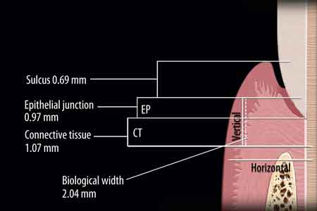
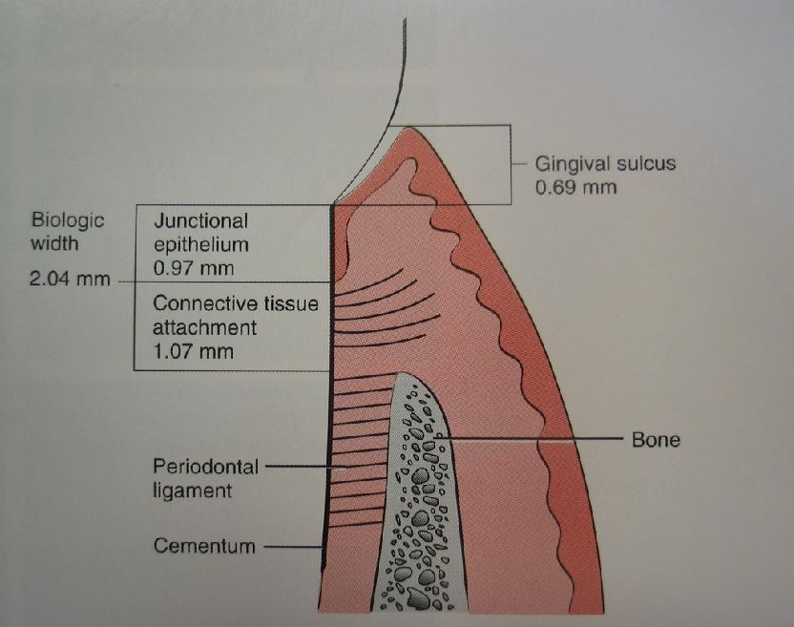
0.97 mm junctional epithelium, 1.07 mm connective tissue.

When we reduce the height of the gingiva, it must follow the contour of the underlying bone "parallel to the CEJ" for the following reasons:
- Because this relation creates the biological width.
Note: the sulcus depth which is considered the first line of defense.

- If the gingiva is not made parallel of the bone, there will be more re-population of the junctional epithelium at the expense of the connective tissue. Hence, deeper junctional epithelium and loss of the connective tissue.
Note: junctional epithelium repopulate much faster than the connective tissue, so the patient will end up having deep sulcus "pocket".

