بسم الله الرحمن الرحيم
Detecting Oral Cancer
PS: it's a short lecture all the slides included and what dr had focused on is in bored black, underlined. good luck seniors and let's START ;)
***********************************
Incidence and Survival
of Oral or Pharyngeal Cancer
- 30,000 new cases diagnosed yearly
- 8,000 deaths each year
- 5 year survival rate: 50%*
***in JORDAN ORAL CANCER NOT COMMEN 15-16%
Early Detection Saves Lives :( very important because 5-year survival rate and type of treatment depend on the stage and the progression of cancer at the time it had been detected )
- 5-year survival for localized disease is 76%*
- 5-year survival for metastatic disease is 19%*
ORAL CANCER VERY EASY to be early detectable cause ORAL CAVITY is EASY ACCESSIBLE to be examined .
Early Detection is Often Possible
- Tissue changes in the mouth that may signal cancer can often be seen and felt easily and simply .
Warning Signs (major one )
- Leukoplakia ( white lesion in oral mucosa )
- Erythroplakia
Other Possible Warning Signs
- Lump or thickening of oral soft tissue
- Soreness or “lump” in throat
- Difficulty chewing or swallowing*
- Ear pain
- Difficulty moving jaw or tongue
- Hoarseness
- Numbness of tongue or mouth
- Swelling of the jaw
**** when we see these signs we have to examine for ORAL CANCER ***

Risk Factors
- Tobacco use(main risk factor )
- Alcohol use( main risk factor )
- Exposure to sunlight ( lymph cancer )
- Age ( advanced age elderly people )
- Gender
- Race ( race itself not related as risk factor BUT ***HABITS *** related to it, it is like chewing habits in Malaysia )
Examination Overview
- Head and neck exam should be a routine part of dental and medical check-ups ( oral mucosa and lymph nodes )***.
- Take a history of alcohol and tobacco use.
- Follow up on suspicious signs.
Tools and Time
- Proper lighting
- Dental mouth mirror
- Gauze squares
- Gloves
- 5 minutes *( all the o examination should not take more than 5 min )
Extraoral Examination :1-( lymph nodes )
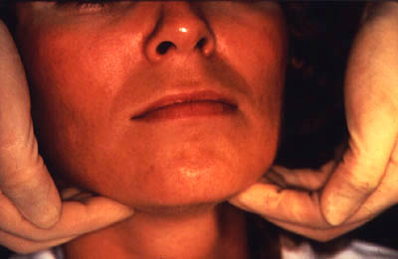

2-Perioral and Intraoral Soft
Tissue Examination: Lips
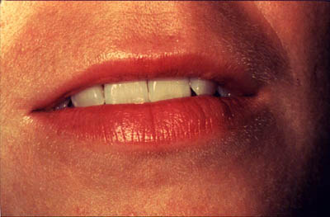
3-Perioral and Intraoral Soft
Tissue Examination: Labial Mucosa

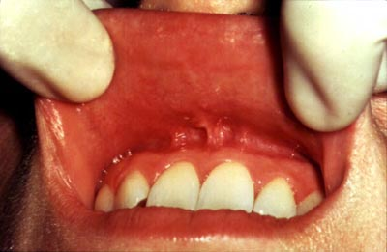
4-Perioral and Intraoral Soft
Tissue Examination: Labial Mucosa
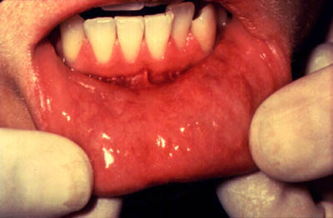
5-Perioral and Intraoral Soft
Tissue Examination: Buccal Mucosa
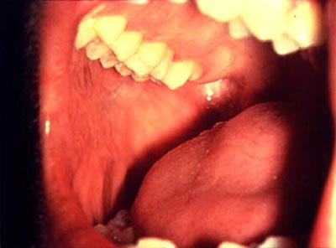
6-Perioral and Intraoral Soft
Tissue Examination: Buccal Mucosa
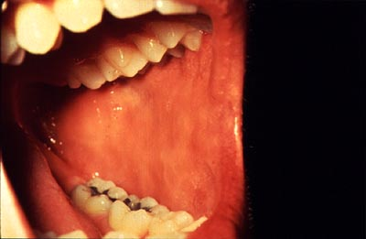

7-Perioral and Intraoral Soft
Tissue Examination: Gingiva
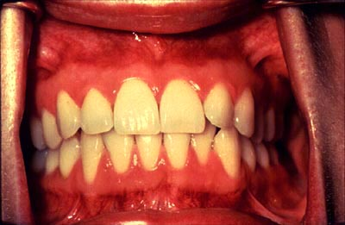
8-Perioral and Intraoral Soft
Tissue Examination: Dorsum of
the Tongue
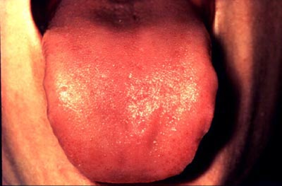
9-Perioral and Intraoral Soft
Tissue Examination: Left Margin of the Tongue
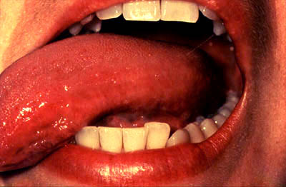
10-Perioral and Intraoral Soft
Tissue Examination: Right Margin of the Tongue

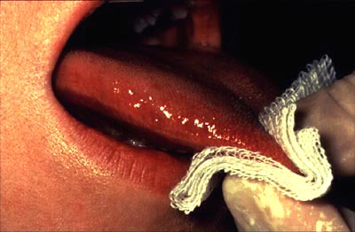
11-Perioral and Intraoral Soft
Tissue Examination: Ventral Surface of the Tongue
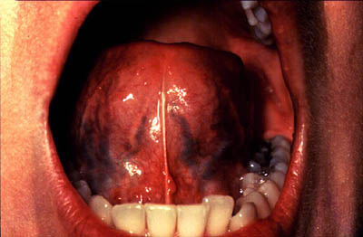
12-Perioral and Intraoral Soft
Tissue Examination: Floor of
the Mouth
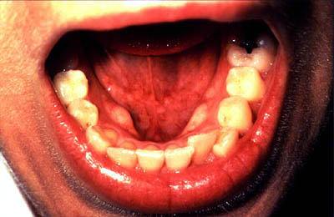
13-Perioral and Intraoral Soft
Tissue Examination: Hard Palate
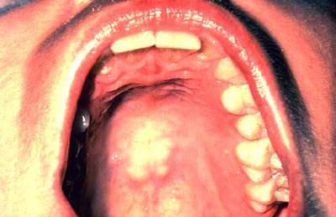
14-Perioral and Intraoral Soft
Tissue Examination: Oropharynx
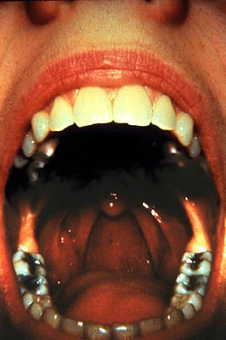
15-Perioral and Intraoral Soft
Tissue Examination
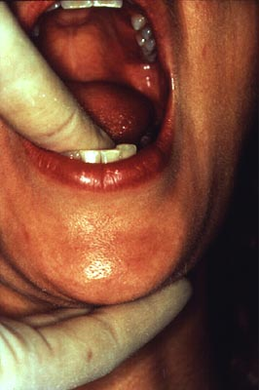
***Oral Lesions Suspicious***
for Oral Cancer
1-Homogenous leukoplakia
2-Leukoplakia with early squamous cell carcinoma
3-Nodular leukoplakia with severe epithelial dysplasia
4-Erythroleukoplakia with candida infection
Homogenous Leukoplakia****
Maybe lesion be small like this BUT show dysplasia or neoplastic changes SO if cancer detected at this satge chances of CURE will be the highest .***
Screening Tools for oral cancer:**
1-Visual inspection ( most important as palpation of oral mucosa )
2-Self Examination
3-Toluidine blue
4-Fluorescence imaging
5-Exfoliate cytology/Brush biopsy
6-Saliva Examination
***1-ORAL VISUAL INSPECTION : ( most important, accurate and the simplest )
Sensitivity 58 – 94 %
Specificity 76 - 98%
Most widely evaluated test

*** but there is lesions we can't visual inspection it because of limited access to it like post. Surface of the tongue .
2-Toludine Blue Test ( material that being uptake of nucleus of active cells with high proliferation rate so it's suitable for detecting early neoplastic lesions, SIMPLE LIKE MOUTHWASH * ):
Tested only in a few specified clinical settings
High false negative and false positive rates( NOT VERY SPESIFIC NOR SENSETIVE *)
3-Oral Cytology (brush biopsy ):
Lesion has to be seen before the sample collection
Yield is poor
Interpretation highly subjective
High false negative rates
4-Analysis of Saliva:( NOT ONLY for ORAL cancers and it use to detect the risk of having malignancy later on depend on specific markers that are not clinically applied yet and still under research )
MARKERS LIKE:
- 1-Increased levels 4 mRNA from the following genes
- 2-Interleukin1 beta
- 3-Ornithine decarboxylase antizyme1
- 4-Spermidine/spermine N1-acetyl transferase
- 5-Interleukin8
5-VELscope :
when the visual inspection is hardly detected and oral mucosa has changes such as thickninng or keratosis but limited access VEL scope is CONVENIANT it resemble light cure we use for composite .
- The VELscope hand piece emits a safe blue light into the oral cavity, causing tissue fluorescence from the surface of the epithelium through to the basal membrane – where pre-malignant changes typically start.
- By utilizing special optical filters in the VELscope hand piece the clinician is able to immediately view the different fluorescence signatures in the oral tissue to help differentiate between normal and abnormal cellular activity.
UNDER VEL scope : NORMAL TISSUE appers : GREEN.
UBNORMAL TISSUES : appear DARK .
**** ok the rest types have the same princeples in detecting cancer cells by color changes under light that it is become darker in cancer cells but by doctor opinion its all commercial just to sell that there is no pic as we see in patient but the MOST IMPORTANT TO KNOW VEL scope the rest the dr didn’t even read about it JUST mensioned it as names ***

6-Orascoptic DK (Diagnosis Kit ):
The DK oral lesion screening instrument works in conjunction with a mild acetic acid rinse to improve the visualization of oral lesions.
The DK exam enhances the ability to identify potentially cancerous tissue at its earliest stages.
Early detection of pre-cancerous tissue can minimize or eliminate the disfiguring effects of oral cancer and possibly save a life!

The oral lesion screening instrument works in conjunction with an acetic acid rinse to improve the visualization of lesions.
The device also includes a transillumination instrument and lighted mirror.
- Product Bief - Orascoptic DK uses a battery powered handheld LED light source and 3 interchangeable diagnostic instruments.
Special Features - Transillumination instrument, mirror
How it Works - Mild Acetic acid rinse for the visualization of oral lesions
7-Microlux Diagnostic Light (Microluax/DL)
With refractive light technology already proven to help save lives in the detection of pre-cancerous cervical abnormalities, the Microlux Diagnostic Light (Microlux/DL) makes this advance in patient care simple and inexpensive.
When used in conjunction with conventional oral mucosal exams, it improves identification, evaluation, and monitoring of soft tissue abnormalities and changes in all patients.
7After noting any acetowhite soft tissue lesions during a routine exam, simply have the patient rinse with the Microlux DL 1% acetic acid solution for 60 seconds.
Then, repeat the oral exam using the Microlux DL.
Since the acetic acid dehydrates the cytoplasm of acetowhite lesions, the lesion’s refractive properties are changed.
Under diffused light from the special Microlux/DL fiberoptic light guide, acetowhite or leukoplakic lesions become more visible.
The irregular cells take on a whitish hue which contrasts with surrounding tissue, helping to identify abnormalities which require further testing.
8-Identafi
3000 ultra
The Identafi uses white, violet and amber wavelengths of light to excite oral tissue in distinct and unique ways.
As a result, biochemical changes can be monitored with fluorescence, while morphological changes can be monitored with reflectance.
The combined system of fluorescence and reflectance uses the body's natural tissue properties as an adjunctive tool for oral mucosal examination.
The device minimizes false positives while disclosing abnormalities in oral tissue that otherwise would be missed by the naked eye.
9-ViziLite Plus with TBlue630
ViziLite Plus with TBlue630 is an oral lesion identification and marking system that is used as an adjunct to the conventional head and neck examination.
It is comprised of a chemiluminescent light source (ViziLite) to improve the identification of lesions and a blue phenothiazine dye to mark those lesions identified by ViziLite.
How ViziLite Plus Works
Similarly in the oral cavity, after rinsing with a dilute acetic acid solution, abnormal squamous epithelium tissue will appear acetowhite when viewed under ViziLite's diffuse low-energy wavelength light.
Normal epithelium will absorb the light and appear dark. ViziLite can assist a dentist or hygienist in identifying an abnormality in the oral cavity.
Detecting Oral Cancer: A Guide for Health Care Professionals was developed by the National Institute of Dental and Craniofacial Research, one of the federal National Institutes of Health. The program is not copyrighted and may be reproduced.
AYAT ALKAYED
كل التوفيق seniors

