Prostho - lec. 10 – 1/12
Dr.walaa

Anterior Hyperfunction Syndrome
(abbreviated as AHS)
Today we will start a new subject anterior hyper function syndrome or combination syndrome the reason why it called combination because of the upper complete denture and lower partial denture .
Signs and symptoms AHS :
The doctor show us a picture of missing maxillary teeth and in the mandible there is bilateral distal extension and only anterior teeth are there no posterior teeth this is a typical case of a combination syndrome >> because of the missing upper anterior >> the lower nothing opposing them >> They will be over eruptive>> nothing will stop the
also there will be a problem with the bone in the premaxilla >>it will be under continues cyclic hit from the lower teeth>>cause bone resorption
So resorption of bone anteriorly in the upper associated with development of fibrous ridge that is fibrous hyper mobility of the crest of the ridge because of the bone resorption>> this is first
second over eruption of the lower teeth accompanied by loss of bone in anterior maxilla
Now what’s happen here is the patient stay in this condition without any treatment >> the lower teeth will continue to over erupt and bone resorption in the maxilla >> exentuated the denture that will be place in the upper to sink anterior into the mouth>> which cause problem in the maxilla like development of denture associated granuloma in the sulcus >> this of course due to tipping the denture anteriorly upward it leads to drop posteriorly downward>> this continues suction of the tuberosity region>> make the maxillary to grow and descend down this is ( prolapsing tuberosity )
We have a problem here as it continuous the denture will continue to hit down because the over growth down of the maxillary tuberosity in the back>> it press against the lower partial denture ( bilateral distal extension end ) and what happen of course it is stays for a very long time and cause resorption of the mandibular ridge it self underneath the denture >> again this is because of sinking down of the lower partial denture because of the continues trauma against it by over prolapsing maxillary tuberosity >> so of course when we have a condition like this to continue so we have more vertical movement upward of the upper while it goes downwards in the back posteriorly cause by this kind of discrepancy in the level of the occlusal plane
Discrepancy of occlusal plane :Occlusal plane in normal situation it should incline up as we go backward. But herein Anterior Hyper function Syndrome the occlusal plane goes down as we go back .
Of course the denture is moving down all the way due to resorption in the maxilla and mandible or in the premaxilla we will have a problem in the vertical dimension is not be going to maintained probably, when the patient closes the upper denture with the lower partial the height of the lower face will reduce because the supporting structured will be resorbed in both jaws so when the vertical dimentsion is loss, the patient will over closing , which means that the tissue underneath the dentures are no more supportive and the denture will not have a proper adaptation inside the patient mouth .
Now clinically because of the resorbed of the premaxilla we see hyper mobile tissue and sharp bone underneath, so the whole support of the upper denture anteriorly is compromised and this make the labial flanges of the upper denture digging in the sulcular tissue and continues trauma to the sulcus causing repair by fibrous tissue and this which make the denture granulumas or Epulis fissuratum is developingin the sulcular tissue.
Because of this current of movement upward and downward and the tuberosity are enlarging and prolapsing down , this is make the base of denture itself rubbing against the roof of the mouth continuously, so when the patient bite it will hits against the maxilla it tips it up in the anterior and bring it down in the posterior, the continues friction in the middle this is what cause hyperplasia of the mucoperiosteum covering the roof of the mouth.
The papillary hyperplasia in the hard palate always an come in condition with resorbing anterior premaxilla and prolapsing tuberosity in the back.
So what happen to the lower when this condition is progress without any treatment, that the prolapsing tuberosity is pushing down the partial denture and sinking down with the saddle causing inefficient mastication because loss of the contact with the upper and the major connector digs into the sublingual tissue , and as result of continuous trauma at the lower border of the major connector against the sublingual areas the anterior teeth will developed a retrograde periodontitis (A periodontitis that start from the apex not from crown down but from the apex up) and if this retrograde periodontitis is progress without any treatment, the teeth will become loose and may lose the entire teeth .
Now we know how this patients are present with upper denture is not stable, digs in anteriorly and descend down posteriorly because the supporting structures are compromised. And the lower partial denture is seeking down in the back because there is trauma anteriorly. So most of the activities are taking place in the anterior part of the mouth like Epilus fissratum , fibrous ridge it self, problem with over erupting lower antirior teeth and resorping bone in the premaxilla . so for that reason it called anterior hyper function syndrom
To sum up the sighns and symptoms of AHS :
- Loss of bone from the anterior part of the maxillary ridge
- Overgrowth of the tuberosities
- Overeruption of lower anterior teeth
- Loss of bone under lower partial denture bases
- Loss of vertical dimension of occlusion\
- Discrepancy of occlusal plane
- Poor adaptation of the prostheses
- the denture granulumas or Epulis fissuratum is developingin the sulcular tissue
- hyperplasia of the mucoperiosteum covering the roof of the mouth.

MANGMENT
Now about the treatment
Most of the clinision make the same mistake , as soon the patien is attend to the clinic they immediatly think of relining the upper complete denture and they acualynever think that the problem start from havingover erupting the lower antirior teeth, they think that the lower should be stable because they had clasp around the canine or around the antirior teeth and they can never think that they are the one who creat this problem so they go ahead and realine or rebase the upper complete denture. and of course any rebasing or relining of the upper in case like this will run against the occlusal plane . where the occlusal plane is decending downward as we go back and the upper denture is continoue according to the inverted occlusal plane to hit the lower and the problem will exentuated and become more complex to treat .
So the treatment should start
first of all by correcting the tissue bed ( the tissue that support the prostesis)before coming to any prostatic treatment
so the treatment should be devided into : #1 pre prostatic preparation of the supporting structre, that is a surgical intervension. And after every thing will go to normal when epiulus fissratum hyperplasia and prelpsing tubirosity is corrected then we will think of #2 any prostatic traetment whether construction of new denture or rebaing or relining the upper denture and we should correct the both denture in the same time
first phase pre prostatic preparation of supporting structred:
First of all, we have to remove denture granuloma (excision of it). Then, we have to get rid of the hypermobile (flabby) tissues anteriorly that are fibrous tissues and have to be excised and removed and sutures are placed. The incision used is crestal incision.
These fibrous tissues will cause lack of support of the upper denture as we said. Of course do not forget to put the tissue conditioner after you excise the fibrous tissues and the epulis fissuratum. The patient should be provided with his complete denture relined with tissue conditioner which helps in heeling the tissue and prevent any trauma from the lower anterior teeth to hit agsinst the upper tissue then send the patient away and after a 10 days or two weeks the patient attends to remove the sutures and will show no more epulis fissuratum in the sulcus and no fibrous tissues on the premaxilla and the bone now is ready to support the denture.
Now, we should not forget about the hyperplasia of the palate (the area where the tissues are most subjected to pressure from the denture and rubbing effect against the tissues here which causes hyperplasia) so for this we give the patient a rest time so we will ask him to take of the denture and if we see that is heal gradually and take a lot of time and the patient cant live without his upper denture we put a conditionar and if it persist then we go to surgry so we use a cautery (e.g. loop diathermy) which is electrical cautery so by putting the patient under local anesthesia then we cauterize all the hyperplastic tissues shaving them away. Then after week epithelialization will start .. and after about two weeks everything will be cleared and this all should be done before any attempt to take impressions to get the tissues back to normal status of health and function.
Now, What about the prolapsed tuberosities??
Before making any surgical procedure on the tuberosities a radiograph is essential in order to check the proximity of the floor of the maxillary sinus (maxillary antrum), the maxillary antrum floor should be located exactly on the x-ray. And if we think there is a need of osseous surgery then we have to left the maxillary sinus up and if we are sure that the overgrowth is only soft tissues then put the patient under local anesthesia and take the soft tissues out.
In this photo the amount of excision needed is marked
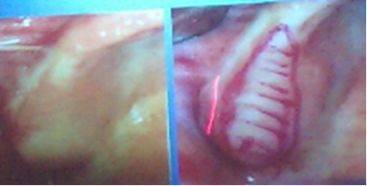

A crestal incision is made and the tissues are removed from the area of the tuberosity then a continuous suture is used to approximate the edges of the wound together after aweek of healing then we now ready for the second stage.

Second phase of treatment: prosthetic management:
Now the tissues on the upper and lower arches are ready to receive dentures after making the impression.
For a satisfactory prosthetic work we focus on maximizing the retentive forces ( stop the upper denture from push up anteriorly and descend down posteriorly) and minimizing the displacing forces.
How to maximizing the retentive forces??
Of course we have to have a proper technique for impression for the maxilla which is now normal and prevent further progression of hyperplastic tissue anteriorly. So we have to make a sepical tray ( of course after making a primary impression and developed a cast ) that is close fitting everyway and spaced in the anterior part where’s the lower teeth hit the upper
So we design the tray to be close-fitting everywhere except anteriorly (bluish area in the photo)
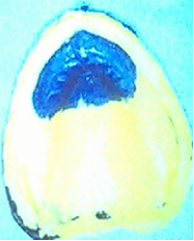

So we can either use medium body silicon all then light body in the anterior area or You can use the regular zinc-oxide eugenol impression paste all over except anterior alginate ( one tray two material) so it mucostatic in the anterior part of the maxilla and mucocompressive in the posterior part of the maxilla . so when you will end by having a functional model. So this functional modle will going to support the newly constructed denture

How to minimize the area that may cause displacement??
We have to think of how to provide the patient with a denture in top and partial in the mandible which articulated in balance way . so where ever the mandible move it must be harmoniously articulated against the maxilla , and this can only be done by having a proper occlusal harmony.
We have the maxilla which is the fix point in the human skull and the mandible which is moving.
So to transfer the exact location of the maxilla in the patient skull we have to transfer the same loction into the articulatorso we have to mounting the upper cast to the articulator hinge axis in the same way the patient’s maxilla is related to the patient’s TMJ which means that we have to take a facebow record and transfer it to the articulator.
*The facebow the doctor showed us is a Hanau face bow.which is the not the kinematic it is the other one ( arbirtrary) . the kinematic facebow is fitted to the lower not to the upper.
Facebow record the orination of the maxilla to the TMJ and transfer to the articulator
So what we do you heat the fork and inserted in the wax rim of the upper denture. Make sure that the midline of the patient face is with the midline of the fork.
Third point of referances fitted to almost the level of periorbital foramen
Anteriorly she bite in acotton roll to support maxilla.
Also there is a parallels the occlusal plane with pupillary line anteriorly
And posteriorly the occlusal plane had corrected as we go back ,it go up and parallel to the alo-tragus line this is the way it should be. Before we corrected the supporting structured the occlusal plane was inverted .
Then we fitted to the articulator where we can put our casts and, then we mounted to the articulator. then we do the mounting of the upper THEN the seconed part of the prostatic treatment how to correlate the mandible in relation to the maxilla

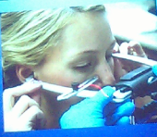
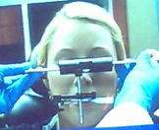

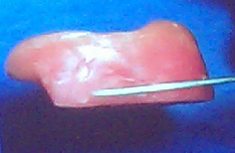
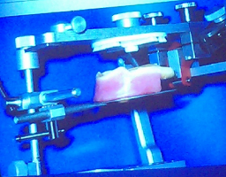

How to relate the mandible to the fixed maxilla ??
So you can do in the conventional way by determine vertical dimension of occlusal , then enough free way space, then put the mandible in the most rotruded contact position (centric relation position) and then we mount the lower accordingly .
All these step can be summarized by using a one device called central bearing device
Central bearing device is a two-piece device.. one piece is a plate that is mounted on the lower rim and has an adjustable screw in the middle.. the other part is a plane plate as a mounting of the upper rim (only plate).
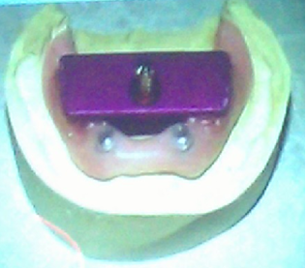
The lower part

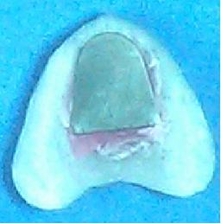
The upper part
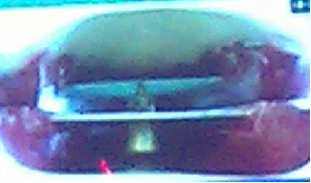
The two parts put together

Now we put them together.. the screw on the lower can be adjusted from outside the mouth to lift it up and down until it gives a contact with the maxillary plate and we adjust the vertical dimension until the patient is most comfortable (at the correct vertical dimension of occlusion)

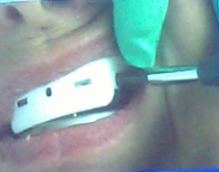
The picture above shows how the screw can be adjusted from sideways.. we increase the height of the screw until it reaches the top plate and we ask the patient to close down and we keep adjusting until the patient feels most comfortable (the patient is most comfortable when the condyle is in its correct position in the glenoid fossa.. that is when there is a correct degree of separation between the upper and lower)
So The central bearing device you can do all these relation in one step. If consist of plate that fit the mandibular rim and in the middle it has a screw that can be adjusted up and down so it adjusted to the height where it goes to fit against (or touch) another plate that fitted to the maxilla ( the maxilla has a plate but without a screw, plain plate )adjusted to the level of the occlusal plane. So we adjust the screw until the patient feels most comfortable. Usually the most comfortable position where in centric relation and the vertical dimension is exactly the same as the patient used to have contacted teeth also the condyle will be in the most correct position in the glenoid fossa
How to do it clinically you keep adjusting the screw up and the height of the lower face can adjusted until we got a proper lip seal .
Note: Centric relation position has to be done at an established vertical dimension of occlusion .
so first we determine the vertical dimension then after that we tell the patient to retrude to the mandible to the mast roturded position finally we record the centric relation.
We spray the maxillary plante with adhesive the with aligenate powder so the screw can draw a line there
Now if we ask the patient to move forward when the plate is attached to the screw from the bottom when the patient protrudes forward and goes backward the screw draws a line.. The center point is the centric relation position.. moving forward will be a protrusive line.. left and right lateral are as well drawn.. this procedure is called gothic arch tracing..
We can double check on the vertical dimension of occlusion whether it is correct or not (when there is a sharp arrowhead on the gothic arch tracing then this is the centric relation position)
So we should have a SHARP arrow head if not we keep repeat until it become sharp.
SHARP=CORRECT ARROW HEAD=CORRECT RECORDING
Centric relation is the only point from which all movements of the mandible start and to which they return and thus it is called CENTRIC relation position.
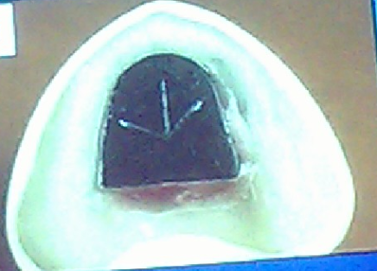
Now this is the diagrammatic presentation of the gothic arches
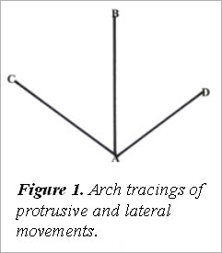

When the patient moves forward from the point A (centric relation i.e. the most retruded contact position of the mandible to the maxilla).. With protrusion the mandible will move anteriorly to point B which is the border position of the mandible anteriorly beyond which it does not go and it is a ligamentous position (ligaments prevent the mandible from moving more forward or beyond them) .. points B, D & C are the border positions of the mandible.
SO WHEN we come to articulator we can very easyly mount the lower when the screw at point A . so when you finish the mounting of the upper and lower to our articulator , it comes to the regular set up of upper posterior and anterior complete denture teeth finishing with the lower posterior teeth in partial denture.

Then in try stage just to check in tooth position and if every thing is fine just give your instruction to the lab to go ahead with the processing of partial denture. Then insertion of partial denture fitted with clasp around abutment thin we do selective grinding in the clinic. Even though we set the teeth and process them in adjustable articulator and record that have been taking by central bearing devise which are mechanical device and have some mechanical limitation then there will be some difference , so to over come all of these we let the TMJ to do by it self and do what we call it selective grinding.
So selective grinding marks the immature contact with one color and the eccentric with different color then we eliminated the colored points.
Notes :
The lower teeth will not be over eruptive if you correct the occlusal plane.
Always keep observation of these people they may just start to have the syndrome.
They also observe these people may have a class 5 carious lesion at the gingival third on the abutment around the clasp >> the clasp keep hitting the enamel>> and there nothing in the treatment can stop the mandible from shifting back and there is continuous rubbing of the clasp at the gingival third of the abutment . so the way to stop the mandibular partial denture from shifting back is to extent the retro molar pad slightly up and rest it against anterior ramus.

Done by :
Dina Ashraf

