Prosthodontics
Lecture 1 (2nd semester)
Date: 2/2/2015
Dr.Mahmood Al-Omairi
Occlusion
- The topic of occlusion will be covered in 2 lectures, today is part 1.
- This topic is very important; because we are going to be examined by an external examiner in the oral exams (viva) and he focuses in this topic, so be very well prepared.
- The lectures of the second semester are very important for the written exam (more important than the first semester) "عليهم ثلاث اضعاف من الفصل الأول"as the dr said.
- In the viva exams, we will pass through 2 committees one of them will contain an external examiner {named Damien Walmsley; you can search about him} and the other one will be the doctors of the department; so focus very well on RPDs, Occlusion and Implants. (However, this doesn’t mean that other topics are not important, you should study everything).
Now let’s start with our lecture:-
- Definitions:-
- Occlusion:-
It simply means contact between teeth.
- Static occlusion vs. Dynamic Occlusion:-
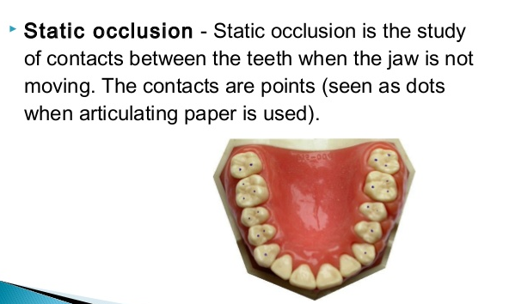
- Static Occlusion:
It is said when the contact between the teeth is static (no movement of the teeth when they are contacting each other regardless their position)
It is the static relationship between the incising or masticating surfaces of the upper and lower teeth {Natural dentition} or the artificial teeth {Ex: Bridge, Partial denture, Complete Denture, Crown…etc}

- Dynamic Occlusion:
- It is the occlusion during function (gliding), when chewing and the mandible is moving.
- Nowadays, when you see the word “Occlusion” in textbooks, it usually refers to “Static Occlusion” and the word “Articulation” refers to “Dynamic Occlusion; although this may seem not very accurate but it is generally used.
- So Occlusion ≈ Static Occluson
- Articulation ≈ Dynamic Occlusion

- Now we will start with Static Occlusion
- Centric Relation vs. Centric Occlusion:-
- In textbooks when you see “Retruded contact position (RCP)” this usually refers to Centric Relation.
- Centric Occlusion sometimes is expressed as “Intercuspal position”
- Balanced Centric occlusion usually means “Balanced Occlusion”

- Regarding Centric Occlusion:- {Important for Clinical Remount Competency}
Students often mistake between the term centric occlusion and Centric relation when asked in the clinical remount competency.
- You have to know the difference between centric occlusion and centric relation.

Centric Occlusion | Centric Relation
It is the relationship of the Teeth with each other when they are in the maximum intercuspation.  No teeth No centric Occlusion  Other synonyms:  - Intercuspal position  - Maximum intercuspation  - Habitual Bite  - Centric occlusion  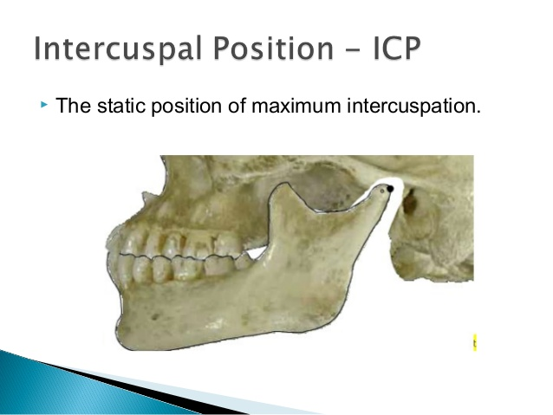 | It is a bony Relationship regardless I have teeth or not.  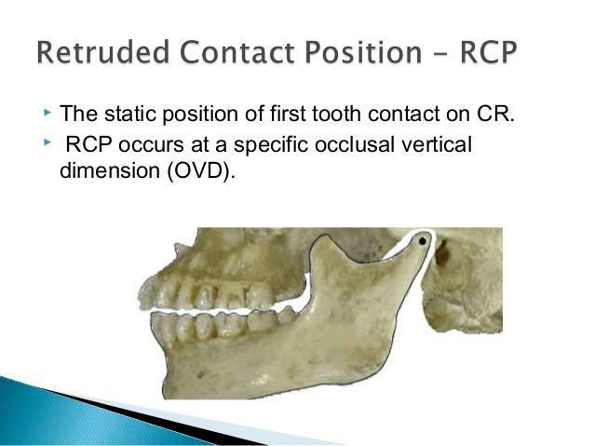  Continue the definition later

Usually the word “Centric” makes some confusion to the students in exams so pay attention and know the difference between Centric Occlusion (occlusion=teeth) and Centric relation.
- In completely edentulous patients there is no centric occlusion (you can call it “artificial centric occlusion”)
- Each patient with normal natural dentition has his own centric occlusion; you may see deviation or shift, but the teeth are still in maximum intercuspation {We still call it centric occlusion for this particular patient}
- Thus, centric occlusion does not have to be in the centric position, it can have deviation or shift but the teeth can still reach maximum intercuspation.
- So don’t be confused by the word centric.
- As you know, in the natural dentition only 5-10% of the population has their centric occlusion coincident with the centric relation.
- In Artificial dentition (Complete Denture patients) we have the artificial centric occlusion that we made it coincident with the centric relation; since it is the reproducible position in edentulous patients.
- Regarding Centric Relation:-
- We will define it from Anatomical, conceptual and Geometrical perspectives (3 perspectives):-
From the Anatomic Perspective:-
- It is the condyle in its most superior position in the glenoid fossa.
- And the most superior position of the condyle is divided into 3 parts:-
- Anterior
- Middle
- Posterior
According to anatomical studies, they found that the anterior part of the superior part of the condyle have the most dense bone; so they concluded that the condyle is located in this location more than any other location (more than the middle and more than the posterior).
- Thus, they defined it as the most superior anterior position of the condyle in the glenoid fossa.
- However, some people may say that it is the superior middle or the superior posterior (we can’t say they are wrong because they are still mentioning the superior part of the condyle) However, the more accurate and supported by studies is the anterior superior position.
From the Conceptual Perspective:-
- We have what is so-called “Least strained position of muscles”; in where the muscles are relaxed in general and the fibers are in least strain (in this position when the muscle fibers contract they contract faster and easier than any other position)
- So we add what is mentioned to our definition and the definition will be:-
It is the most superior anterior position of the condyle in the glenoid fossa and the muscles are in the least strained or relaxed position.
From Geometric Perspective:-
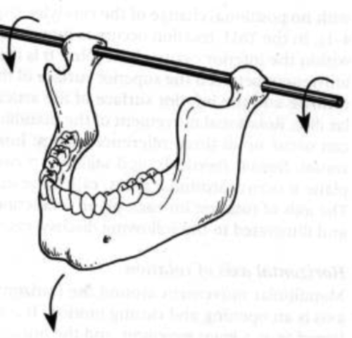
- When the condyle in three dimensional space is located in a position that allows an imaginary line called “Hinge axis” or “Terminal Hinge axis” to pass through it.
- In this imaginary line “hinge axis”, the condyle is in pure rotation.
- Imagine it as a swing; in which the condyle is static in its position and the mandible is rotating around this static position (pure rotation)
The dr focused a lot on this point
So the final Definition of the centric relation will be:-
{It is the position in which the condyle is in its most superior anterior position in the glenoid fossa, the muscles are relaxed (in the least strained position) and the condyle is able to do a pure rotational movement around an imaginary line called “Hinge Axis”}
This is the Centric Relation

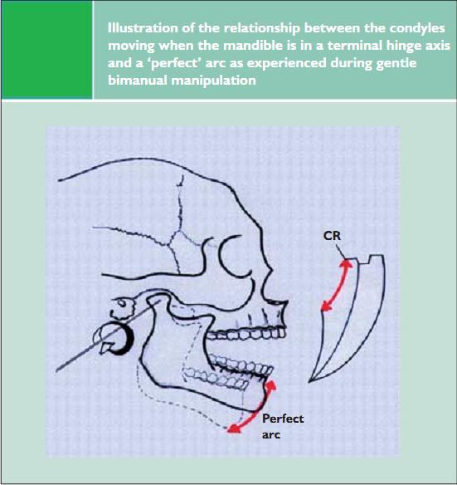
The pure rotation done by the condyle around the terminal hinge axis in the centric relation gives a distance about 20-25 mm of pure rotational movement and we are still in the centric relation This is called “The Perfect arc”
(Notice the red line in the picture of posselt's envelope of motion)
After that we will have translational movement.
{Note: 20-25 mm may seem to be a high number for us and may seem a little bit not logical; but it is based on many studies}.

Why the centric relation is important to us?
- Because it is a reproducible position
- It has no relation to the teeth, despite it is reproducible.
- Even though, when there is no teeth (Ex: CD patients) we can still have a centric relation when constructing our occlusion we still have a reference point that we can refer to it.
So it is reproducible without the need for the presence of teeth.

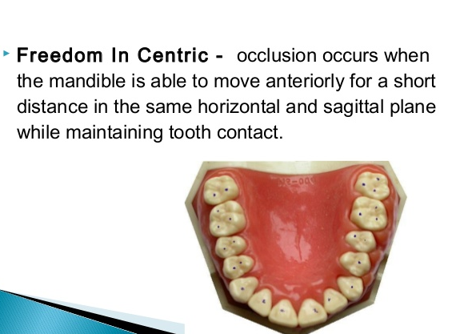
- Freedom in Centric occlusion:-
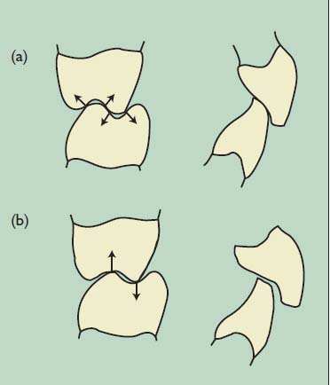
- It is when the teeth are in centric occlusion (maximum intercuspation) and the teeth can do a movement of 0.5-1.5 mm in any desired direction while still maintaining their contact in maximum intercuspation (without disocclusion).
(a): No freedom in centric occlusion
(b): Freedom in cenric occlusion
- As you can see, when we have a tall molar cusps occluding on a point and making a lock, when we try to move them from each other; we will have immediate disocclusion (separation); we don’t have maximum intercuspation anymore. If this occurs in a complete denture we will have loss of stability.
- Similarly, in the anterior teeth when the upper and lower teeth are overlapping each other (deep bite); any anterior movement of the mandible will lead to disocclusion of the posterior teeth and I will lose the contacts on the posterior teeth.
- So in these 2 cases you don’t have freedom in centric occlusion:-
- In deep bites and reduced overjet.
- The cusps are completely interlocking each other (similar to a triangle matching another triangle)
When moving these teeth we will have sliding and immediate disocclusion, and we are no longer having a centric occlusion (maximum intercuspation).
- Thus, to have a freedom in centric occlusion; you have to make the fossa wide (area) instead of an angle; so that when the cusp occlude on the fossa it has some freedom to move (maneuver) while still maintaining the contacts in maximum intercuspation.
- Similarly, in the anterior teeth, to have freedom in centric occlusion; you should reduce the overbite (vertical overlap) {not to be a deep bite} and slightly increase the overjet (horizontal overlap); so when the mandible moves a little bit anteriorly (protrusion) the posterior teeth will not slide on each other and will maintain their maximum intercuspation (will not disocclude). {Remember, we are not talking about 1 or 2 cm of movement; it is just 0.5-1.5 mm of movement of the mandible while maintaining maximum intercuspation).
- Thus, the clinical significance of freedom in centric occlusion is that when you are setting the artificial teeth of CD and you have some recently extracted teeth, we will have some bone resorption and the denture may have a slight settling or leaning by 0.5mm or 1mm or 1.5mm (el 6a8m braye7 shway) so by taking this issue in consideration when setting the teeth, we will have our denture stable if any sudden change in bone levels occurred and the artificial teeth have some freedom to move without affecting denture stability or cause displacement of the denture.
- So our denture will have some freedom to move while still maintaining maximum intercuspation.
- If I set the artificial teeth to a perfect occlusion and the cusps are interlocking on each other perfectly, any sudden change that may occur will lead us to lose our occlusion in the denture; so take in consideration to have some freedom in centric occlusion when setting the teeth to overcome any sudden changes that may occur to the denture and maintain a good and stable occlusion to the patient.
- Freedom in centric occlusion can also overcome some inaccuracies in bite registration if the patient was not biting perfectly in the centric relation position; we still have 0.5-1.5mm of free movement (Remember: in complete denture our centric occlusion is coincident with centric relation)

- Now we will talk about Dynamic Occlusion (Articulation):-
- We have systems that control the movements of the mandible; these systems are called guidance systems.
- We have 2 systems:-
- Posterior guidance Areas
- Anterior guidance Areas
- The posterior guidance is controlled by the condyle.
- The anterior guidance is controlled by the teeth (Anterior AND Posterior teeth).
- To simplify it, in the most posterior part of the masticatory system we have the condyle; and in the anterior part of masticatory system we have the teeth (anterior and posterior).
- So molar teeth have a function in Anterior Guidance

- The posterior Guidance:-
- We have what is known as “The Working side” and the “Non-working side”, the working side was so-called because it is the side in which we chew the food so we are working there; the other side is called the Non- working side (Ex: suppose you are chewing food on the left side, so the left side will be considered as the working side and the right side is the Non-working side).
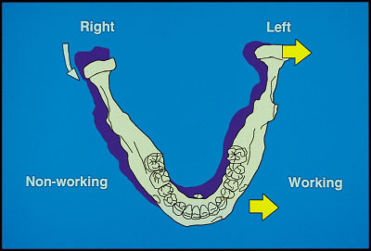
- The movement of the condyle in the working side is less than the movement in the Non-working side.
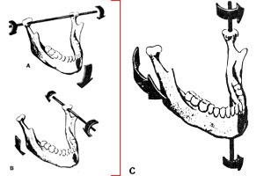
- On the Non-working side, the condyle is moving more; it should go downward, forward and medially in order to let the other side (working side) to move properly and chew the food, by moving the mandible toward that side.
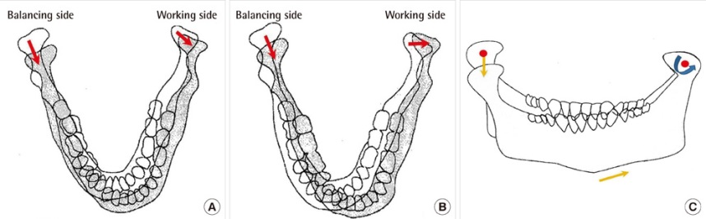

- So the side that has more movement is the Non-working side.

- We also have 2 terms in posterior guidance (important for competency)
- Condylar Guidance Angle
- Bennett Angle (Mediolateral condylar guidance Angle)
- Condylar guidance angle: it includes anterior and posterior condylar guidance angles (اطلقت اصطلاحا)
- Bennett angle is called to the mediolateral condylar guidance angle of the mandible.
- The condylar guidance angle ranges from 30⁰-45⁰ and the average is 33⁰.
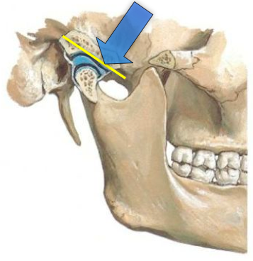
- The Bennett Angle ranges from 15⁰-22⁰ and the average is 16⁰-18⁰.
- The values are very important to know (very imp questions)

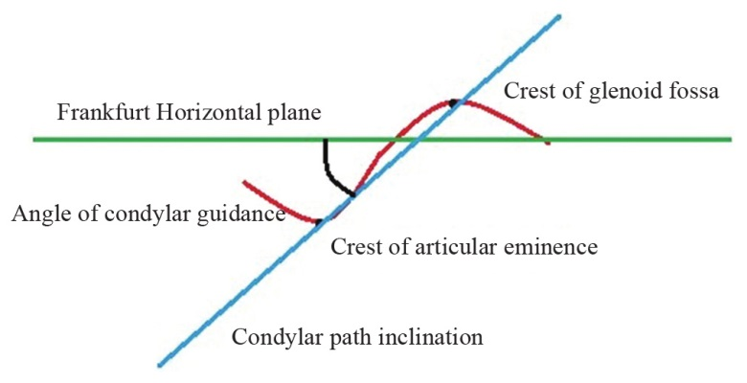
- (Look at the figure) Here you are seeing from the side when the condyle is moving downward forward, the angle that is formed with the horizontal plane as a result of the downward forward movement of the condyle is called “Anteroposterior condylar guidance angle” or simply “Condylar guidance angle”

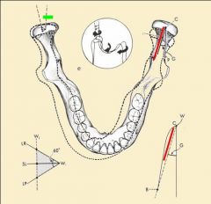
- Regarding the Bennett Angle:-
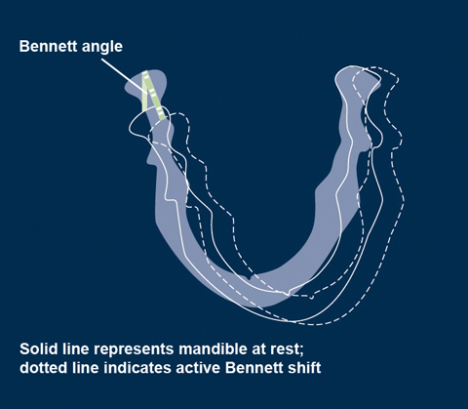
- When seeing from the front, the condyle is moving downward, forward AND Medially.
- The angle that is formed with the sagittal plane as a result of this movement is called Bennett Angle.
- Bennett angle can be measured at the same time for both condyles (right and left). How?
- When you move the mandible to the left side (The working side); the left condyle will have a sort of rotational movement and will form an angle with the sagittal plane; similarly, the left condyle (in the non-working side) will move downward, forward and medially and will also from an angle with the sagittal plane. The angle formed from the 2 condyles (left and right) with the sagittal plane is Bennett angle. (So it is the same for both condyles)
- The Anterior Guidance:-
- As we have mentioned the anterior guidance is controlled by both Anterior and Posterior Teeth
- We have 3 major types of anterior guidance:-
- Canine Guidance
- Incisal Guidance
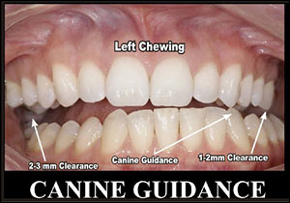
- Group Function Guidance

- Canine Guidance: It occurs when sliding the mandible in lateral movements; the canine opens the occlusion (disocclude the teeth) and guide the mandible.
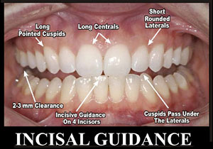
- Incisal Guidance: It occurs when the anterior teeth touch each other on protrusive mandibular movements and the posterior teeth disocclude.
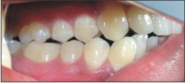
- Group function: it is the multiple contacts of posterior teeth when moving the mandible laterally.
Group Function

- Occlusal Interference:-
- It is anything that interrupt our guidance systems that we mentioned above (Canine guidance, incisal guidance, group function).
- Ex (1): I am moving my mandible to the right side and I have a canine guidance; Normally the left side should be disoccluded, if I have any contacts on the left side this is called interference and this interference can be called “Non-working side interference”.
- Ex (2): If I moved my mandible to the right side and I have a canine guidance but the wisdoms on the same side (right side) contacted each other This is called “Working side interference”
- Ex (3) : I am protruding my mandible and the anterior teeth are sliding on each other smoothly (Normally the posterior teeth should disocclude); if I had a posterior contact during this movement This is called “Protrusive Interference”.
- We can also have interferences in centric occlusion; Ex: if you made a class 1 Amalgam filling and it was high and the teeth cannot occlude completely; this is called occlusal interference in centric occlusion (premature contact).
- In complete denture; it is the opposite; the non-working side is called “the balancing side”, we aim to have contacts in this side to get a stable denture.
- So in the natural dentition, it is bad to have bilateral contact on both sides (interference); while in artificial teeth such as CD it is an excellent thing to have bilateral contacts (For denture stability)
This is a major difference between the complete denture and the Natural dentition.
- Another major difference between CD and natural dentition is the proprioception; which is almost absent in artificial dentition or if found it is too weak.
- In natural dentition, each tooth acts as a single unit and independent ((كل سن وحدة مستقلة , while in complete denture all the teeth act as a single unit; Thus they require balanced occlusion (if it is not balanced; the denture will fall out and is not stable).
- The malocclusion in natural dentition can be easy to adapt (majority of us have a sort of malocclusion) even though if there is displacement or cross bite, we can adapt to it. While any displacement or occlusal error in complete denture is intolerable by the patient.
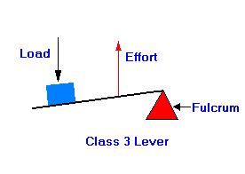
- The non-vertical forces can be well tolerated by the natural teeth than artificial teeth (So the lateral displasive forces have more effect on the artificial dentition; because there is nothing that can hold them to the bone).
- The force of biting in the natural dentition is definitely higher than the artificial teeth.
- In the natural dentition, the center of the maximum force is in the second molar (7) (this is a v.imp point).
It acts as a lever type 3 action; as you go near the center of action the force gets higher and here our center of action is the second molar and the force is generated by the muscles; so the second molar is considered to be the nearest to the muscles. {The third molar is excluded because it may be partially erupted}.
(Note: Type 1 lever ≈Seesaw as you go more far from the center the force increases)
- So in the natural dentition the center of action of the forces is in the second molar (7).
- In Artificial teeth, the center of action is on the 5 and 6 bilaterlally (why)? Because the 5 and 6 come on a flat horizontal surface in complete denture; while the 7 in the denture comes on an inclined surface so if any force comes to it the denture will slide and will dislodge anteriorly.
- So we should make the force on the 7 to a minimum in the artificial teeth and maximize it between the 5 and 6, so when the patient bites on his teeth the force will be concentrated on the 5 and 6.
- To sum up: In the natural dentition the center of force is concentrated on the 7, while in the Artificial dentition the center of force is concentrated on the 5 and 6. (The dr focused a lot on this point).
- So in complete dentures you should reduce the bite force on the 7 (make the contact appear lighter in the articulating paper).

- Occlusal Schemes of Complete denture:-
- First let’s define stability
It can be defined as the resultant (محصلة) of function of all other functions; it means that we should have adequate retention with adequate support and excellent fitting and occlusion without discomfort. So it is not only the resistance to horizontal movements (it’s the sum of all these factors) and resistance to horizontal movements is part of its definition.

- We have 3 main occlusal schemes in CD:-
- Balanced Occlusion
- Monoplane (linear) occlusion
- Lingualized occlusion
- Minimally we should Have balanced occlusion in CD (The minimum requirement).
- The artificial occlusion should be in the centric relation.
- To get a balanced occlusion ; I should have:-
- Face-bow transfer
- Semi-adjustable articulator
- Adequate teeth shape and size
- These are the basic requirements to get an adequate occlusal scheme in CD; whatever its type.
- We all know the basic information of teeth setting (from 3rd year lab):-
- The cusp fossa relationship
- ML cusp of 6 is only touching the occlusal plane.
- 2nd premolar (5) has the 2 cusps touching the occlusal plane, while the 1st premolar (4) has only the buccal cusp is touching the occlusal plane.
- The canine tip is touching the occlusal plane while the lateral incisor is out of occlusion and the central incisor is touching the occlusal plane.
- The 7 and 8 are not contacting the occlusal plane.
- The compensating curves (we will talk about them shortly).
- If you don’t have a balanced occlusion, when the patient occlude anteriorly, the posterior teeth will disocclude this disocclusion of posterior teeth is known as “Christensen’s Phenomenon”
(It is very imp to know it for exams especially viva)

Christensen’s Phenomenon: -
- It means that there is no balanced occlusion when protruding or in lateral movements and the teeth separate from each other on the posterior area or on the balancing side, this will lead to instability of the denture.
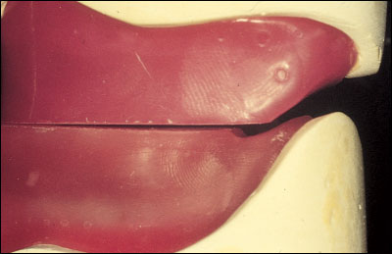
- To overcome Christensen’s phenomenon in complete dentures, we should set the teeth in a way that we can achieve contact posteriorly and laterally when the patient bites on any side.
- You can examine Christensen’s phenomena in the bite registration stage.
- Christensen’s phenomenon is desired and ideal in the Natural dentition and unwanted in the artificial dentition.
- Christensen’s phenomenon is eliminated in the artificial dentition by the use of Compensating Curves.
Compensating Curves:-
- The compensating curves are done in the teeth setting stage.
- The purpose of the compensating curves in CD is to overcome Christensen’s phenomenon.
- As we know in the Natural dentiton we have 2 curves:-
- Curve of spee
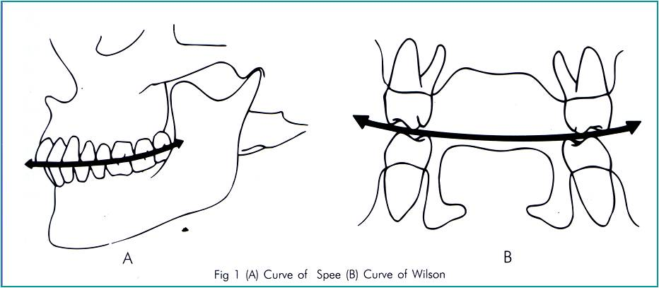
- Curve of Wilson (or Monson)

- Curve of Spee is coincident with the buccal cusps or the tip of the canine anterioposteriorly (See the figure above)
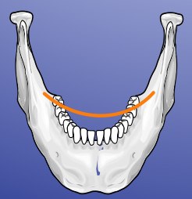
- Curve of Wilson (or Monson) is from the right to the left (From premolar on one side to the premolar on the other side)
- So in Complete denture we have:
- Anterioposterior compensating Curve ≈ Curve of spee
- Mediolateral Compensating curve ≈ Curve of wilson
Hanau Quint:-
- We have 5 main factors that affect the balanced occlusion (this is very very important) {Note: Hanau=five}:-
- Condylar Guidance
- Incisal Guidance
- Plane of Occlusion
- Angulation of Teeth
- Compensating Curves
- One of these factors cannot be changed at all which is Condylar guidance {Except if we do jaw surgery}.
- So we have 4 factors left:-
- Incisal Guidance:-
- It can be changed up to a limit (10⁰-15 ⁰)
- In this factor you are controlled by the Function (Ex: Phonetics) and Esthetics (appearance).
- The overjet is usually set to 1-1.5 mm.
- The overbite is usually set to 0.5-1 mm.
- Plane of occlusion:-
- It is also adjusted to a limit (5⁰-10⁰) not more than 10⁰.
- If more than 10⁰ the patient will appear as if he don’t have any teeth (only the central incisors may be seen, rabbit appearance)

- Teeth Angulation:-
You can use teeth of 0⁰ cusps (Non Anatomic) or 15-20⁰ (Semi-anatomic) or 30-33⁰ (Full Anatomic); they can be used according to the case.
- Compensating Curves:-
- We usually set the teeth on a curve (arc) instead of a straight line to simulate the natural dentition. (upper teeth are slightly inclined labially and bucally and lower teeth are slightly inclined lingually)
- The upper 6 has its ML cusp touching the occlusal plane only and the rest of the cusps are out of occlusion.
The most 2 factors that I can control are:-
- Teeth Angulation
- Compensating curves

- Occlusal plane can be controlled up to 10⁰ only
- Incisal guidance Controlled by function and esthetics
Thielman’s Formula:- (Viva and Competency Questions):-

Balanced Occlusion= $\frac{Condylar Guidance×Incisal guidance}{Occlusal Plane×Cusp height×Compensating curves}$
- It is an equation, according to mathematics laws; if the denominator (المقام) is increased, you should increase the numerator (البسط) to keep the same value and vice versa.
- This equation does not have any numerical value; it is imaginery just to explain how you should balance the factors to get a balanced occlusion.
- As you know from what is mentioned previously:-
- The condylar guidance cannot be changed at all.
- The incisal guidance can be changed to a certain limit.
- So you have to keep those in mind when viewing the formula; meaning that you can change the cusp angle, compensating curves to keep everything balanced.
- The condylar guidance ,which is created by Allah, is controlled by certain factors, however I can do some things to decrease its effect in the occlusion as follows:-

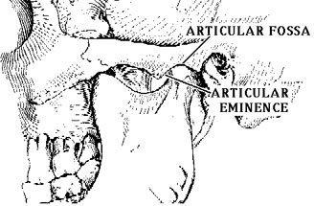
Slope of the Glenoid Fossa:-
- When you view the condyle from the side, you will find the condyle resting in the glenoid fossa and ends by the articular eminence.
- When the slope is steep (نازل لتحت بقوة ), this means that with any minimal movement of the mandible to the anterior will be accompanied by a huge downward movement, so the teeth will disocclude faster
- To keep the teeth in occlusion and not to lose their contact; I should use teeth with taller cusps; so that if the mandible moves suddenly; the tall teeth can compensate for this movement and keep the contact (so we don’t lose the balanced occlusion) so the denture will not dislodge from its place.
- So, if the slope of the condyle was (Steep, sharp…etc); you need taller cusps, because the vertical movements are more. {Note: you may need a narrow fossa, but it does not have that much effect, we are more concerned with vertical movements in this case}.
- On the other hand, if the slope of the glenoid fossa was shallow (it means that I have more horizontal movements); this horizontal movement requires a wide fossa (Freedom in centric) and short cusps; if I have tall cusps, they will interlock in each other and as the mandible moves the lower denture will dislodge from its place.
- So to sum up:-
      - If the medial wall of the glenoid fossa is steep more Vertical movement (faster downward movement) Tall cusps and narrow fossa are needed.
      - If the medial wall of the glenoid fossa is shallow more horizontal movement Wide Fossa and short cusps are needed.
Last thing in the lecture: {Intercondylar distance}:-
- It is the opposite of everything.
- As the intercondylar distance increases; you will need shorter cusps and wider fossa.
- As the intercondylar distance decreases; you will need taller cusps and narrow fossa.
Further Explanation:- (see the 2 pictures)
- When you move the small mandible (Decreased intercondylar distance); it will make a high angle with the horizontal plane; so you will need taller cusps to prevent teeth disocclusion during the movement.
- And when you move the Large mandible (increased intercondylar distance); it will make a smaller angle with the horizontal plane; so you will need shorter cusps (because tall cusps will interlock with each other and during the movement the denture will dislodge suddenly).
Note: the distance of movement is the same for both mandibles, the only difference is the size (intercondylar distance); so as the mandible’s size increases, the angle formed with the horizontal plane is smaller.

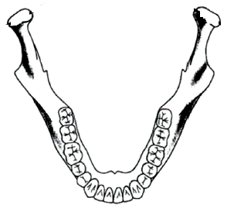
Horizontal Plane
Notice the small mandible forms a higher angle with the horizontal plane, than the large mandible for the same amount of movement.

(In this case, taller cusps are needed)

Notice the Large mandible forms a smaller angle with the horizontal plane, than the small mandible for the same amount of movement.

(In this case, shorter cusps are needed)

Horizontal Plane

So to sum up:-
For the same amount of movement:-
- Large Mandible = Large intercondylar distance = Less Angle (With horizontal plane) = Shorter cusps
- Small Mandible = Small intercondylar Distance = High Angle (with horizontal plane) = Taller cusps.

{Sorry for any mistakes or misunderstood points}
Good Luck seniors in the last semester
Done by:
Khaldoon AlQaddumi

