Occlusion part 2
In previous lecture we talked about hanaue quaint ( five factors), we talked about condyler factor and its effect …etc
Second important factor :
2- Incisal guidance :
Dayman feeh moshkle m3 el Student b5arb6o been el incisal guidance in dentate and edentulous patient

usually Incisal guidance in dentate is fixed for the patient ( unless we do orthodontic or fixed prosthdontic treatment for the patient ) ,
-in natural dentition incisal guidance angle usually steep and conformative with condyle ( condyler angle
approximately 33-45 degree)
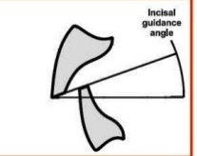
Figure #1
some people have incisal angle 45 degree ( deep -
overbite and the overjet reduced )

If we need to decrease incisal guidance angle we have
Either : 1- increase over jet or 2- decrease overbite

Incisal guidance angle is the angle between tip
of upper incisor and tips of lower incisal
We draw line from tip of upper incisor to the tip of
Lower incisars with horizontal plane this make the angle( figure 1)

for complete denture ( artificial teeth) we make a shallow angle (5-15 degree)
how ? during the setting we set anterior teeth with overjet 1-2 mm maximum and over bite 0.5-1 mm
we shouldn't make deep over bite in artificial teeth because that will increase incisal guidance angle>>
- if inciasal guidance is steep , steep cusp or occlusal plane or compensatory curve is needed to balance occlusion >>
for occlusal plane we can do a limited change 5-10 degree , so we mainly can increased the cusp height….

if incisal angle is acute this means we have deep bite >> here
any movement for the mandible forward >> lower teeth will hit upper ant teeth and the mandible opened spontaneously and with any horizontal movement >> separation of post teeth occur>> to prevent separation of post teeth we need to increase cusp height ( this important for balance occlusion )
in natural dentition :
we need Christensen's phenomena ( dis occlusion in post teeth during protrusive movement ) to prevent protrusive interference

when we increased the over jet, we should use teeth with wider fossa and shorter cusps.
in increased overjet >> the mandible has a long distance to move until ant teeth hit each other (m3o masafh 6welh yt7arak 2bl ma el asnan yo5bo6o bba3ad)
when the overjet increased >> we must use wide fossa we cant use narrow fossa -
(we need to increase fossa width and decresed cusp height)
In deep bite we need to decrease fossa width and increase cusp height -

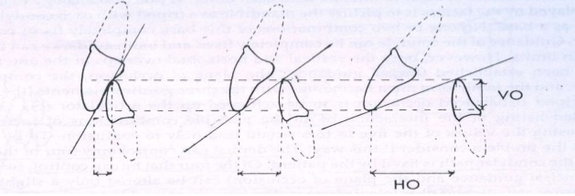

fig 2 : here the overbit is constant and when overjet increased the angle changed……

so for complete denture we need to increase horizontal overlap and decrease vertical overlap.

Plane of occlusion , occlusal plane ( camper's line , ala-tragus line) :

About ala tragus line dr said: for me elli shofto thabet akthar >> basta3mlha mn Mid ala to mid tragus
- some doctor use it from sup ala to sup tragus
- Other from inferior tragus to sup ala >> but this wrong and there is no any support for that ( ma 2lo ay marje3 aw tafseer) !!
So >> from middle to middle , sup to sup or inf to inf ,,, but not superior to inferior

Plane of occlusion less imp than other factor>> because it can be altered to minimal amount only 10 degree
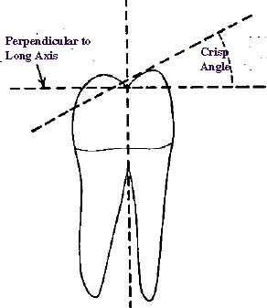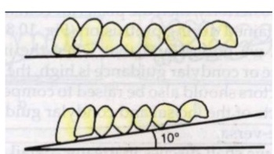

Figure#3 figure# 4

Cusp angles and effective cusp angle :
Cusp angle it is angle between cusp slope and horizontal plane ( fe mnha mn jehat el buccal , lingual , mesial and distal ……. ) figure # 4
it vary ( zero, 15-20 and 33 ( anatomical teeth) maximum 33 degree )

if a patient has deep incisal guidance and steep condyler angle 45 degree and he has natural teeth in anterior area and need to replace missing 4,5 &6 ( partial denture) >> here we need to use high cusp angle (45 degree) ,
How we increase the cusp angle from 33 to 45 ??
By tilting the tooth according to compensating curve or occlusal plane ( bnrfa3 el occlusal plan 10 degree ) we set the teeth vertically on the occlusal plane but tilted in horozintal plane

We set the cusps vertically on occlusal plane or on
comansating curve (
عموديا عال curve المقابلهم بالضبط في هديك النقطه )

cusp angle with occlusal plane 33 degree , with horizontal plane( ba3ed ma rafa3na el occlusion) the angle increased 10 degree = 43 degree ( figure #3) <<<< this this named effective cusp angle !!!

note : compensating curve is the curve we make with artificial teeth
but in natural dentitions is named CURVE OF SPEE or curve of Wilson
why our teeth arranged on curve ? because the condyle is fixed and move as a maf9al 3a curve
زي البندول .. مكان ثابت عالعمود

Why we set the artificial teeth in a curve :
To mimic incisal angle and condyler guidance (to reach BALANCE OCCLUSION)

An answer of student question :
1- is cusp angle in post area more than anteriorly ??
Dr saide 7asab el makan ,, bs 7asab el compensating curve yse posteriorly is more

Also we can change effective cusp angle by trimming , if I have cusp 33 degree and I need one with 27>> I can trim the tooth to change the angle

We need a touch between cusps when the mandible moves ( in artificial teeth )-
this is not imp. In natural dentition

occlusal plane guide line :
1- ala tragus line
2- with corner of the mouth
3-with the two third of retro molar pad area ( in some book ,center of the retromolar pad area) but not less than center
El a9a7 two third bs lw eja bl emte7an center msh 3'ala6

4-tongue covers lower lingual cusps
5- tounge tip on cervical area of lower ant. Teeth
6- occlusal plane 3.3 mm below parotid gland orifis ( stensen's duct):
** If the occlusal plan bnrefe3 zyadh >> pt will bites on the ducts that’s why some pt. had a scar around the duct
If occlusal plane wa6i kteer >> tongue above occlusaion (on buccal cusp of lower teeth ) >> tounge biting**

Compensating curve:
Used to prevent Christensen's phenomena ( disocclusion of posterior teeth during mandibular protrusion which is very important w ma6loob in natural dentition

But this cause loss of stability in artificial dentition )

Wilson or monson curve :

بتغير شكله حسب الاماكن اللي واصل بيناتها

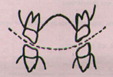 figure #5

Have 3 shaped :

1- between 1st premolars ( right and left ) مقعر للاسفل ومحدب للاعلى fig#5

In Upper 1st premolar buccal cusp touchs occlusal plane but palatal cusp is above occlusal plane

2- between 2nd premolars >>

straight line (Both cusps of premolars touch occlusal plane)

3- between 1st molars >> محدب للاسفل مقعر للاعلى

( mesiolingual cusp touch occlusal plane others cusp not in touch )

Curve of spee
El Mandible bt7arak 3a kora 2.5 inch ( approximately 10 cm)
Axis of this curve lies at level of mid horizontal orbital plane

Fig ure#6 If u draw imaginary line in mid orbit
curve
و مشيت عمود زي البندول بمر بالاسنان الاماميه للخلفيه فهاد هو ال ( )

Figure #6 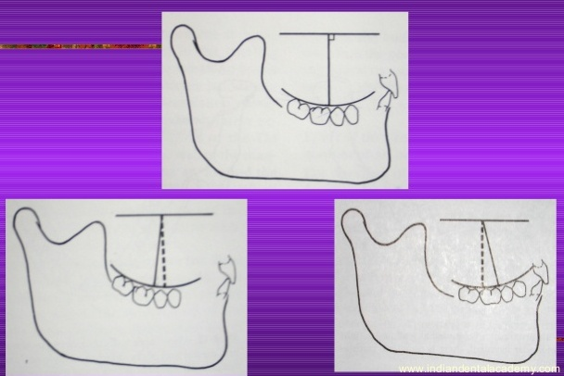

For balance occlusion we need interaction between five factor
- one factor we cant do any change on it which is condyler angle
- another factor we can altered up to certain limit >> incisal angle
- occlusal plane can alterd up to 5-10 degree
Other two factor ( bn2dar n3adel 3aleehom aktar eshi ) cusp angle and compensating curve.

for balance occlusion >> in all guiding movement there is must a contact in ant and post teeth bilaterally ( to prevent loss of stability )

Clinical remount :
Two types of remount laboratory and clinical
1- laboratory remount :
the dentures are returned to the articulator after deflasking ( during de flasking ma bnkaser el model bn6l3h el 6a2em 263a wa7dh ) .The casts are repositioned on the original plaster mountings using the key (index) in the base of the cast
we close the articulator and adjust any occlusion error
laboratory remount adjusts any error during packing and flasking

after that we remove the denture ( bnfek el model ) and we check it in the clinic
after insertion and fitting we check the occlusion
if minimal interferences 0.5mm or less >> intra oral simple grinding
if more 1-1.5 mm we cant adjust it orally we need clinical remount

clinical remount : we ask the pt to bite to pre-centric record ( not centric relation)
1-2 mm before centric relation ( wax filled the space)
>> new mounting ( we use fast setting plaster) >> we use articulator paper >> adjust the teeth until we reach even contact bilaterally

Rules :
- bull role ,
we can remove from opposing fossa if high spot on the cusp tip -
if high spot on cusp incline we remove from cusp incline -

-Why in pre-centric not centric record ?? because when the pt bites on centric relation the deflective contact btjber el mandible to bite wrongly so our record will be wrong , the mounting and adjustment ra7 ykoono 3'ala6
For that we need pre centric record 1-2 mm before centric relation
-ma3na majal for condyle movement ( Rotation in hing axis) around 20 mm !! bs 1-2-3 mm mnee7

for balance occlusion we should avoid:
any prematurity-
very wide occlusal table ,, -
- using huge number of teeth (snan zaydh 3n el 7d) , no need to 7 or 8 tooth placed in retromolar pad area
Usually the patient did not use 2nd molar efficiently they mostly use 6 or 5 in artificial dentition
- too large occlusal table (ma bdna asnan 6ale3lha 6a2em bdna 6a2em 6ale3lo asnan)

Occlusal scheme :
1- balance occlusion
For Complete denture :
Bilateral balanced occlusion
For Natural dentition:
Uni lateral balance.
Mutually protected occlusion:
anterior teeth protect the mandible and posterior teeth during eccentric movement and the post teeth protect ant teeth in centric position.

when u bite on molars >> forces are huge , all mastacatory muscles are working in both areas and they close to the center of function , very heavy forces so during centric position if ant teeth touch each other >> the force will be very huge and off center , off vertical oblique not horizontal and that will damage periodontal ligament
so because presence of overjet and overbite of ant teeth in centric postion and post teeth only that have touch ( carry the force ) >> this protect anterior teeth from any damage (

eccentric movement, when pt moves mandible forward ant teeth touch each othor and post teeth separated
here the number of functional muscle will decreased ( more than half of muscles)
forces decreased also ( posterior teeth out f occlusion)
anterior teeth protect posterior teeth from vertical forces) )
and reflex of ant teeth is open not close reflex

-y3ni during eating if u bites on a hard object (stone) in posterior teeth bel 3adh you will continue the bite until your tooth fractured (close reflex)
-in anterior teeth if you biting a stone ,the ant teeth 3ala6ool bf9lo 3an ba3ad (open reflex)

note:
-the forces in anterior teeth is small cant damaging ant teeth
-during function if molars touch each other >>number of muscle increased , forces increased, forces of center >> the teeth will damaged
2- mono plane occlusion
no compensating curve or cusps
على سطح واحد
Indication :
1-Used in pt with sever resorped ridge
2-class II or class III skeletal relation

-Non anatomic teeth used here
- metal plate used to set the teeth in straight line

3-Mono plane with balancing ramps:
Mono plane teeth had no any cusp (flat) , so during movement post teeth will separated
>> no balance occlusion >> denture fall
They add acryl in post. area as a ramp to solve this problem
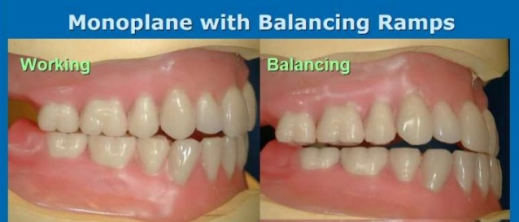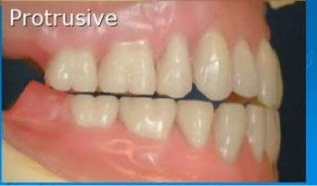

When teeth move forward , post teeth separated but last molar touchs the ramp >>
Or 3 points contacts , in ant area & in Both right and left ramps

4- Lingualized occlusion :
-We use large lingual cusp and rudimentary buccal cusp >> anatomic teeth occlude on wide fossa in semi anatomic or non anatomic teeth.
Buccal cusp are rudimentary only for esthetic ( -
(منظر جمالي اكثر من كونه اي شي اخر
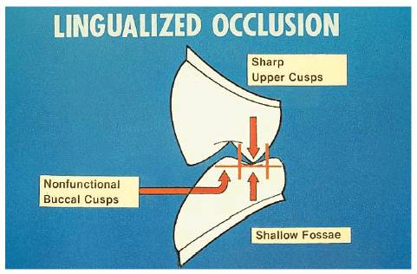
Indication:
1- flabby or resorbed ridge
زي مبدا الهاون(Mortar and pestle )..لما ندق فيه ما بوقع منا
2- in Parkinson patient and
who lack manual dexterity or lack of oral awarnece
3- immediate denture patient ( after bone resorption , denture settling >> in anatomic teeth we lose maximum intercuspatin ( loss of occlusion) but in lingualaized we don’t lose occlusion and here we permit the denture to move withen long centric occlusion position )

Advantage:
1- high forces during funtion
2- decreased lateral forces ( no cusp lock)
3- prevent cheek biting
4- esthetic (buccal cusp)
It is more esthetically than mono plane but not more than anatomic teeth

Note :
In lingualized occlusion teeth>> we set the teeth with same technique used in anatomic teeth
-not as monoplane we use compensating curve in lingualized occlusion
>> -mono plane انقرضت ما بنستعملها بس لازم تعرفو عنها

types of teeth used to achieve lingualized occlusion
1- modification of teeth with large lingual cusps
2- teeth with metal alloy in lingual cusp
3- anatomic teeth 3adyh w n3mllh trimming in buccal cusps
4- special set of teeth (with special occlusal morphology)

Mono plane occlusion | In balance occlusion | Lingualized occlusion
We us mono plane teeth in upper and lower  Two types :  -balanced (ramps)  -un-balance | Free anatomic teeh ar anatomic teeth in both upper and lwer teeth | We use upper special teeth with large lingual cusp and the opposing either mono plane or semi anatomical teeth

Ideal occlusion :
مش شرط يكون موجود بكل انسان
But we have clinically and functionally occlusion , we have normal occlusion not ideal
Only 4-5% have ideal occlusion ( centric relation coincide 100% with centric occlusion)>> rarely presents.

Conformative versus reorganized occlusion:
-Either you conform the present occlusion like pt with class one caries, one missing tooth , simple crown
Reorganized : we have to change the occlusion according to centric relation examples: -
1- complete denture patient
2- pt have for example upper ant teeth and lower posterior teeth >> here there is no occlusion, teeth not in contact >> for that patient we prepare partial denture in centric relation

We don’t use conformative in >>>
TMJ problem, wrong vertical dimension ( for each vertical dimension we have a unique centric relation , if u record vertical dimension wrongly definitely your centric relation will be wrong also ) , if all teeth are over erupted , problem in appearance , gum recession , problem in occlusion (many bridge failed and fractured)

If reorganized occlusion not tolerable ( 3amalnah 3'ala6 ) it will cause :
Tmj problem , occlusal trauma , periodontal disease , tooth wear , loss of restoration and fracture

Example :
Patient with Tooth wear >> as a treatment we do temporary restoration or we give the pt occlusal splint with tooth colored acrylic or composit >> ba3d ma yt3awad el pt 3ala el vertical dimention el jded bn3mal permenant restoration ( bridge,crown,partial denture …etc ) ..
also reorganizes called rehabilitation prosthesis

Important lal final w el Viva :

Tooth-supported dentures
Should the conformative or re-organised approach be used?
7asab , depends on the case :
1- in case of tooth supported with huge number of teeth missing we use reorganized:
Patient have upper two central and two 4s and lower two 6sand two canines >> no teeth contact , no centric occlusion >> we go for re-organized

2- patient with two missing teeth only >> confirmative approach used

Usually we use conformative approach for tooth supported denture except if we have remeaning teeth that not In centric occlusion

Stabilizing splint >> to increase the vertical diminsion >> and according to new vertical dimention we make a new occlusion in centric relation

Hybrid prosthesis >>
- pt with wear in partial denture teeth >> we add acrylic and restore vertical dimension then we make anew denture
- patient has partial denture in posterior teeth and old bridge from canine to canine ( the teeth are carious and need extraction ) >> for temporary restoration we can use the bridge>> we fix the bridge with partial denture by acrylic ( we fill th inner surface of bridge by anything acrylic , composit … )

tooth and mucosa supported denture : bilateral free end saddle
also depends on the case :
-patient had teeth from 5 to 5 in upper and lower teeth >> conformative
pt with teeth from canine to canine >> reorganized (centric relation )-

note : alterd cast technique used in tooth and mucosa supported denture ( refer ti impression lecture )

mucosa supported denture:
two types complete or partial
partial denture :
اسوا اشي ممكن تعمله بحياتك .. they damaging the bone
it used for transitional period

Complete denture patient :
All patient >> reorganized ( balance occlusion)
Note: if you have pt who had an old denture ( for 20 years) and wants denture like old one ( denture duplication) >> We add acryl in the denture to increae vertical dimention and after that we make a new denture
Here We Conform Old Denture ( conformative occlusion according to artificial teeth occlusion)
in over denture >> we go for reorganized approach

for partial over denture >> 7asab el case .

------------------------------------------------------------------------------------

sorry for any mistake or unclear points


Best of luck
Haneen Kamal Al-Laithi.

