Dental implantology
The goal of dental implantology is not just to place an implant , but to do a prosthesis after that (prosthetic treatment ) , so the implant –the fixture- will mimic the root on which we will attach some parts that will serve an abutment and it looks like a prepared crown , so now you will have something that looks like a tooth and over that you can do what ever you need a denture , over denture , fixed bridge,crown,,,etc.
so we are trying to make a foundation on which we can build our prosthesis on and this prosthesis can be done intra-oral or extra-oral .
In dental implantology you need to take the medically history and look at the patient in general not only his oral cavity , because as we know there are contraindications in some patients that will prevent you from placing an implant then you will have to search for another option.
We have things that determine if my implant is success or there is a failure, you have to:
1- know what type of loading will be on the implant
2- the techniques available for the prosthodontic treatment
3- the type of prosthesis that I might use
4-how to achieve adequate occlusion .
Implant loading
Loading protocol or Loading period : is the duration of time between placing the fixture in the bone and placing the prosthesis above it (the abutment and over it the prosthesis )
يعني الفتره ما بين اني احط الزرعه ,ونحط عليها التركيبه والمريض يستعملها ويسير ياكل عليها
This loading can be :
1-Delayed ,, you place the fixture and you close the tissue over it –suturing - , and if we wait from 3-6 months until osteointegration happens then this is delayed loading , this is the conventional or the one that most of the drs use .
--each company manufacture the implant and tell you how much to wait some companies say wait 4 months for the maxilla and 3 for mandible other might say 2 months , so it's different and this depends on the surface characteristics of the implant , some have titanium plasma spray , some have hydroxyappatite some have H+ on it surface ,,so we have many many types ,, so follow the loading protocol that is written in the manufacturer instruction .
2-Early loading ,, within 6 weeks ( and time after the 1st week till the 6th week )
3-Immidiate loading ,within the 1st week, , you can place your implant now and load it right away or any time within the 1st week .
*Note : Don't mix immediate loading with immediate placement , the immediate placement means that you place your implant directly after extraction ( in the extraction socket ).
(اذا خلعنا سن هسه وحطينا الزرعه هسه وحمَلناها هسه فا اذا (immediate placement and immediate loading
-Pay attention that any thing in implant that is done immediately have a higher failure rate , like the immediate placement we will have problems with the blood clotting and fibrous tissue,,etc.
- If we place the implant and over it the abutment but still out of occlusion then we didn't load the implant yet , we consider it as single stage surgery where we place the fixture and we don't suture the tissue over it but we place the gingival former or the healing abutment over it and we leave it out of occlusion .
-If you did early loading- zyadeh 3n el lozoom- with immediate placement and high occlusal load then you will end up with failure .
- What is the reason that makes the implant fail if we placed high load on it –but the normal teeth as we know can stand up high loads - ?
Because we have the PDL in normal teeth which contain the nerves and can dissipate the forces , for example a pt will feel that he has a high on a natural tooth even if it caused minimal interference and will come back to you until you reduce it, but in implants since we don't have a PDL then the proprioception will depend on the bone which is much less that that of the PDL so the pt will not feel the occlusal interference as he does in natural dentition and this might lead to occlusal trauma that will affect the bone surrounding the implant and so it might fail.
* Basic principles to do the implant loading :
1-Reduce the occlusal force,,we can do that by making it out of occlusion but this will be for temporary period because the pt eventually will use the implant – w beddo yakol 3alaiha- ,, so do reduce the occlusal load we reduce the occlusal surface so the pt can do penetration for the food more efficiently with less force to crush food ,, and when we reduce the forces then the bone will have better healing and less bone resorption .
2- Correct direction of the forces , we try to make it vertical forces and try to avoid the off-vertical forces (horizaontal and the oblique) .
3-Improve the support area , we can do that by
a) increasing the size of the implant so we will have more surface area ,
b) place the implant in a good quality bone
c) or simply increase the number of implants , for example a pt has missing from canine to the eight we don't put 2 implants only instead we place 3-4 implants ,, some companies manufacture their implant 4 mm but the make it threaded implant so this increases the surface area so better support , other companies they do threading and on the same thread the do microabrasion so again a more increase in the surface area for the same implant size(4mm).
-What if we do over loading for the implant or early loading-zyadeh 3n el lozoom-?
1-we might have fracture for the screws or loosing of the screws ( el fixture elli bel bone bterkab 3alaih parts benthabet-ha bel screws elli momken yenkaser we yseerlo loosing fa betseer el tarkeebeh tet7arrak 2- fracture in the prosthesis it self .
3- fracture of the implant it self – we used to see this in older generations of implant but nowadays its very hard for an implant to fracture.
4-if we have an opposing natural dentition then they might wear ,,or even the prosthesis it self might wear .
When we want to do a treatment planning for a pt with an implant we have to think prosthso wise:
1-how many missing and remaining teeth are there
2- what is the position of the implant ,,, it's angulation ,,,the distances between the implants
3-amount and quality of bone ,,, the longer the edentulous span require more implants
4-also you have to think about the esthetics and amount of esthetic appearance –high and low lip line - because if high lip line then any gingival recession will appear and that would be un pleasing , but the pts with low lip line are more giving ( feehom masa7et sama7 aktar shway ,ennu 7atta law sar shwayyet recession momken nerda) the color of the teeth ,,, is the pt really concerned about the esthetics or not.
5-assesment of the surrounding dentition around the implant –for example if we have a missing lateral and upon examination there might be enough space but when you take an x-ray the root of the canine for example might be tilted mesially so when you place the implant you will perforate the root or you might get very close to it and cause endo problem in it and later on a lesion might appear and affect the implant.
6-finally the occlusal analysis so you have to check if we have occlusal interferences before we start working and check the parafuntional habits.
-Think Esthetics wise (esthetics determinants) :
1-The health, type , contour of the gingiva, the biotype of the gum is important because in thin biotype the metal will show through the implant (gray-out appearance) .
2- Interdental closure , the size, shape ,anuglation of the teeth .
3-Occlusal plane , my implant should go with the occlusal plane in the conformative approach but in the reorganized approach then I decide where and how my occlusal plane will be.
4-The ridge contour, if it was irregular then I have to think in bone trimming (alveoloplasty) or bone grafting.
5- The type of implant , there are implants made out of zircon material – white in color- so if the pt has thin biotype gingiva we can place the zircon implant but it is more expensive , also the part the we attach to the implant – abutment- can also be made of titanium or zircon or ceramic material .
- The dr talked about an example of spacing between implants , there were two implants very close to each other here it will be very difficult to place the prosthesis and very difficult to take an impression and the result is esthetically not acceptable .
So for an implant to be successful form and esthetic and prostho wise ,we should have good implant treatment plan, and planning should involve the wax up and radiographical imaging whether 2D or 3D and the use of diagnostic models and surgical stents , maybe mounting and face bow to transfer the orientation relation of the maxilla to the cranium.
Now moving to impression making
In order to take an impression for an implant we need certain components
1-Impression coping
2-Implant analog the company the manufacture the implant also makes this implant analog that is an exact copy of the implant but made from different material(usually stainless steel ) just for the sake of impression making, and it will be incorporated in the model later on as if you have the same pt's mouth in the lab .
3- abutment ,,, placed it inside the pt mouth on the fixture , it looks like a prepared tooth .
1- first of all we remove the abutment or the healing screw or what ever is attached to the implant inside the pt's mouth before taking the impression and we put instead of it the impression coping which also looks like a prepared tooth(beeji ma3a bor'3i menthabto fe 3ala el fixture ) then we take the impression .
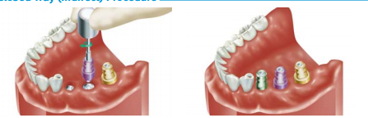
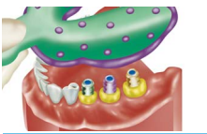

2-now remove the impression coping from the pt mouth and attach it to the implant analog now they become as a one piece and then put it back to it's place in the impression. ( elli dakhel jowwa el 6ab3a howweh el coping welli 6ale3 mnha howweh el implant analog )
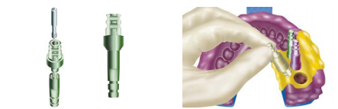
3- pour the model now ( elli ra7 yseer jowwa el model howweh el impant analog welle 6ale3 mennu howeh el impression coping )
4-now remove the impression coping along with it's screw from the poured model you will end up with model and the implant analog inside it exactly like what's inside the pt's mouth.
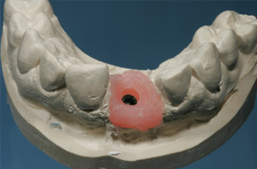
5-now we put the abutment on the model w adjust it the way we want we can even do wax up on it and then do the metal and adjust it the way we want and then put ceramic on the metal as if I'm working on a crown or a bridge .
6- we remove the abutment from the model and bring the crown that we fabricated in the lab and we go back to the pt's mouth we attach the abutment to the implant and place the crown on top of it we check the occlusion and everything .
Treatment sequences of prosthesis :
- remember that the removable prosthesis is our last option and the fixed prosthodontic ( howeh el 5o6weh 8abel el a5eera)
1-we start with OHI ,2- perio treatment ,3- surgery ,,, last thing prosthodontic
we do the history and examination ,, primary impression ,, study model ,,special tray ,,seconday impression ,, master cast , metal try in,,follow up,, every thing as we took in the fixed- fixed before .
Impression techniques used for implants ( hadool aham eshi be kol mo7adarat el implants xD)
1-Close-tray impression technique
2-Open-tray impression technique
Or another classification
1-Implant-level impression technique
2-Abutment –level impression technique
1-Close-tray impression technique , it's a normal tray you load the impression material and take the impression .
2-Open-tray impression technique , we perforate the tray in the place opposite to the implant site so we make like windows opposing the implants
3- Implant-level impression technique , it's the same technique we prescribes above the one where you end up with a model containing the implant analog.
4-Abutment –level impression technique ,Some dr's when the pt come with a fixture in his mouth they go and choose an abutment for the pt inside the clinic and attach the abutment in the pt's mouth directly and prepare and adjust the abutment as if it is a natural tooth using burs and the metal will go into the mouth ( zy ka2ennak 3m bensheel amalgam beseer el tom aswad el mohem betnaddef mnee7 w momken n7o6 retraction cord lal gingiva bs mu zy ma mn3mal bl Cr&Br ) and then we take an impression as if it is a natural prepared tooth, then you take it to the lab , you pour it and here you don't have to remove or attach anything since the model will be only stone no implant analog inside it , the technician now do the wax up , metal casting , ceramic , then you cement the crown .
Clinical scenario :
1-knowing that a pt has come to your clinic and you constructed a tray and did the steps that we mentioned before ( coping and analog wel gesas hay ) ,,the technique is named Close-tray implant –level technique .
2- a pt came to your clinic and you prepared the impression inside his mouth and took an impression with a normal tray without perforating or do anything to it ,, then the technique is Close-tray abutment-level impression technique .
*On the model that contains the implant analog you will notice a material that can be pink in color or any other color this material represents the gum it is important for the technician when he make the crown to pay attention for the gum and so the esthetics , and when you place this material you don't have to do detching as in the Cr&Br (bte3'neek 4an el detching,w bte2dar t2eem hay el qet3a w tshoof deeper areas) .Before you pour the stone in 2-3 min there is a material called Gingifast used for gingival mask it is made out of rubber material and usually pink in color , you inject it is small amount (as you can see in the photos below) as if you are injecting light body silicon and then wait 2-3 min until it dries and then pour your stone model now around the analog there will be this material that allows you to check the esthetics and how the abutment looks and also you can remove it and reach deeper areas and expose the implant analog without the need of detching and you can make sure that the abutment is well fitted on the analog .
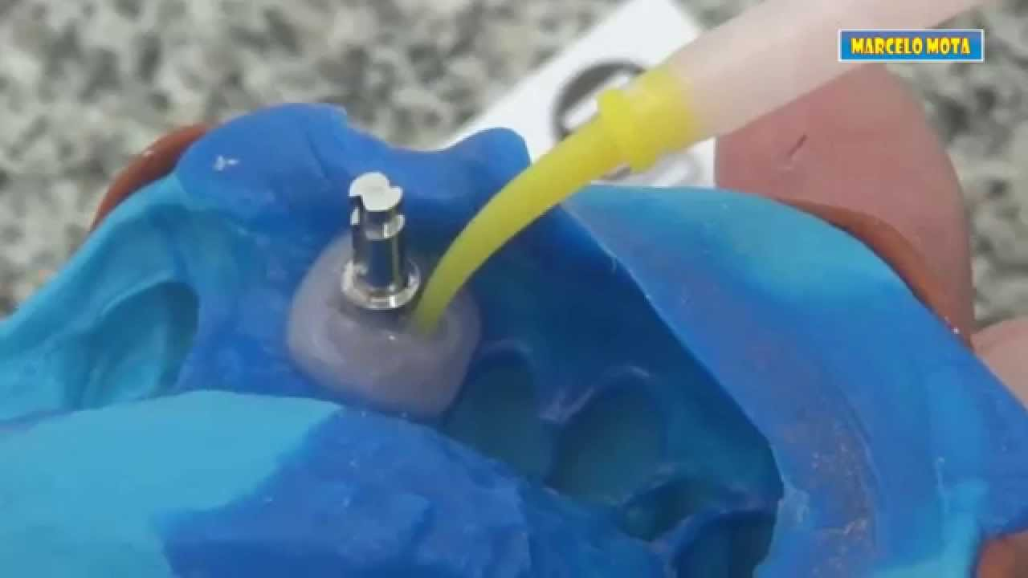
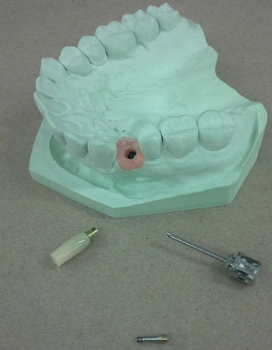

When to use the close tray technique and when to use open-tray ?
-The Close tray can be used when the pt has sort of limited mouth opening , also when we have an impression coping that can be removed from the mouth and placed inside the impression in a precise position ,also in some pt's with posterior implants we prefer to use close tray
-The Open-tray impression technique : when the tray is placed in side the pt's mouth and since it has perforations in the places opposing the implant site so it will appear as tray with perforations and from these holes the screws – el bara3í – of the impression coping are coming out of these holes , the difference here is that the impression coping that is used here is long but the copings of the close-tray are shorter than these , of course we need them to be tall in open tray so that they can come out from the holes of the tray
-We place the impression coping ,and then perforate the tray in the area opposing to it ,, do border molding then we take the impression, now when we try to remove the impression you will notice the impression coping have a large under cuts , so here if you tried to take the impression it will tear so you can't do what we do in the close tray (remove the impression then remove the coping and attach it to the implant analog and place it back in the impression )what we do here is that we remove the screw of the impression coping 1st ( elli hommeh 6al3een mn barra el holes elli bel tray momken bs nra5i el bor3í mn doon ma n2eemo bl kamel ) then we remove the tray so now the coping will come out with the impression.
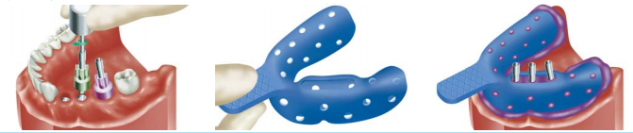
_The impression now has the impression coping inside it and no we attach the implant analog to the coping ( w bnerja3 benshed el bor3í taba3 el coping 3ashan ytahbto ma3 el implant analog )
Implant analog
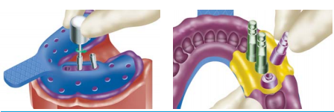
Now lets talk about the difference between the two technique open and close ?
In open tray technique , you don't have to try to put the impression coping back to it's place in the impression and as you know you might place it back but in a wrong direction ( ma3 ennu e7temaleyyet hal 3ála6 qaleeleh la2enu aslant shakel el coping bekoon ma9ammam ennu ykoon mathakan mn jeha flat w mn jeha round so that ma bye2dar yerja3 ella be makan wa7ad 3al impression) .
so one of the disadvantages of the close tray is that we might place the coping in a wrong way inside the impression .
Although the coping comes out with impression in open tray technique but when you attach it to the implant analog and tighten the screw, the coping might rotate while it is inside the impression since the impression material is a rubber material .To avoid that you have to hold the implant analog with one hand while tighten the screw of the coping with another hand.
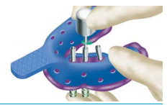
Another difference between the two techniques ,if a dr placed a very deep implant and you wanted to use the close tray technique but as we said their impression coping are shorter that those of the open tray and since the implant is deep it will be below the gingival level so if you took an impression and tried to place the coping back on it you will not find a place for the coping , but if we used t=here the open-tray technique their copings are long so even if the implant is deep the copings are also long and can reach the implant and also the coping as we know in the open tray will come out with the impression it self so no need to search for it's place in the impression as in the close tray technique.
So to summarize that :
- If a pt came with a deep implant use the Open-tray technique
- If a pt came with an implant in the posterior area or a limited mouth opening we will have to use short impression coping so use the Close-tray technique .
-If we have non-parallel implants if we used the close then when we will try to remove the impression it will tear so we use the Open –tray because it will remove the impression coping as a whole with the impression
-If a pt came with a severe gag reflex we use the Close tray technique because if strated to have the gaging i can remove the impression rapidly unlike the Open tray where I still have to remove the screws of the coping while they are still inside the pt's mouth .
-The faster and conventional way is the Close tray .
-The face bow register the Oriantartion relation between the maxilla and the cranium .
Done by: Shatha Abzakh

