Public Health
Sheet5
4\3\2015

Univariant Descriptive Statistics
Univariate analysis is the simplest form of quantitative (statistical) analysis. The analysis is carried out by picking one variable and analyzing it by looking at the mean, mode, etc....

Once we want to present data, we tend to use “tables” instead of charts, as they are the best way to represent data.
Other ways of presenting data:
- Bar charts, which are used only when we are dealing with ordinal or nominal data, we can’t display continuous data in bar charts.
- Cluster Bar Charts, when we want to describe two variables together, for example “there was a chart in the slides, which I cannot find” in this population we are displaying type of the job and the bachelor degree.
- Pie Chart, another descriptive way to describe data
Bar charts, Cluster bar charts, and pie charts can only be used with ordinal or nominal data.
- Histogram: used in health statistics in general, ordinal data are mainly described using histogram, and sometimes continuous data can be used when they can be converted into ordinal data.
- Polygon, same as the histogram but with less bars.
There is some differences between the histogram and bar chart, one of them is the histogram containing more bars “up to 30 bars’’ , whereas bar charts can have up to 5-10 bars, so we get more flexibility while using the histogram.
The most important difference between them is that we can get the “standard curve’’ while using histograms, the standard curve can give us an idea whether the data is skewed or not, that means we can know if the data are distributed within the normal distribution or not.
In the perfect world the data should be normally distributed, without being skewed or deviated, but this cannot be found in the real world, so we tend to standardize our data buy applying “transformation”. To understand what do we mean by transformation here is an example:
Let’s say in this class there is 100 student, and in the exam the highest mark was 60\100, range of the marks was 10-60, we can see that these marks are negatively skewed “skewed down” to apply transformation or standardization to these marks, we need to calculate how much skewness we have “let’s say it is 10” and we add it to all the students marks, so the highest mark would be 70 instead of 60. We are not changing the raw data itself “the marks in our example”, we are doing what so called “معالجة للبيانات” for statistical purposes.
One of the most important ways of representing data is boxplot or whisker plot, boxplot can be used in comparative studies for ordinal data.
You can find more about boxplot in chapter 2 page 55, it is very important and we need to know about it.
A boxplot, sometimes called a box and whisker plot, is a type of graph used to display patterns of quantitative data.
A boxplot splits the data set into quartiles. The body of the boxplot consists of a "box" (hence, the name).
A picture of how a boxplot looks like:

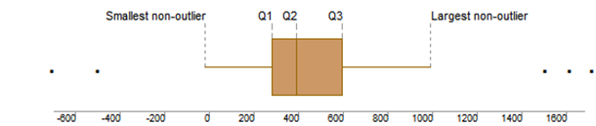
Within the box, a vertical line is drawn at the Q2, the median of the data set. Two horizontal lines, called whiskers, extend from the front and back of the box. The front whisker goes from Q1 to the smallest non-outlier in the data set, and the back whisker goes from Q3 to the largest non-outlier.
If the data set includes one or more outliers, they are plotted separately as points on the chart. In the boxplot above, two outliers precede the first whisker; and three outliers follow the second whisker.

Descriptive measures:
We have two types of descriptive measures:
- Central tendency
- Variability
We use them to describe properties of the sample or population we are working on. And we can’t use them to compare between samples of populations.
Once we want to describe the difference between samples we ought to use differential statistics not descriptive ones.

*Measures of Central Tendency:
A) The Mean “Average”: It is the best average for symmetrical frequency distributions that have a single peak, (normal distribution).
M = ∑ X/N
Notes:
- The sum of deviations of the values from the mean always = Zero.
- ∑ (X – M) ² (THE SUM OF SQUARES) is smaller than the sum of squares around any other value. (Least squares).
- We can add means of different groups together, A mean of total group (M total = M1n1 + M2n2 + ……..)
- Mean is intended mainly for interval and ratio variables “continuous values” and sometimes in ordinal variables, but not in nominal ones. We cannot say, for instance, the mean of gender = 0.75
- The mean is sensitive to extreme values.
B) Median: The middle value of a set of ordered numbers “50th percentile”.
- The median is not sensitive to extreme scores.
- Used in symmetrical and a symmetrical distributions
- It is useful when the data are skewed
- Appropriate in ratio, interval and ordinal variables, but not for nominal data.
- It is useful when giving grades “A,B,C,D” in the university
C) Mode: The most frequent value or category in a distribution.
- Nominal data are best described using mode
- Not calculated, but spotted
- It is appropriate for all variables including the nominal ones.
Ex: 8, 10, 10, 18, 24, 36, 48, 60 the mode is 10.
-----------------------------------------------------------------------------------------
- In a perfect world, the mean, median & mode would be the same. However, the world is not perfect & very often, the mean, median and mode are not the same, and this results in skeweness.
- If the mean is greater than median, the distribution is positively skewed.
- If the mean is less than median, the distribution is negatively skewed.

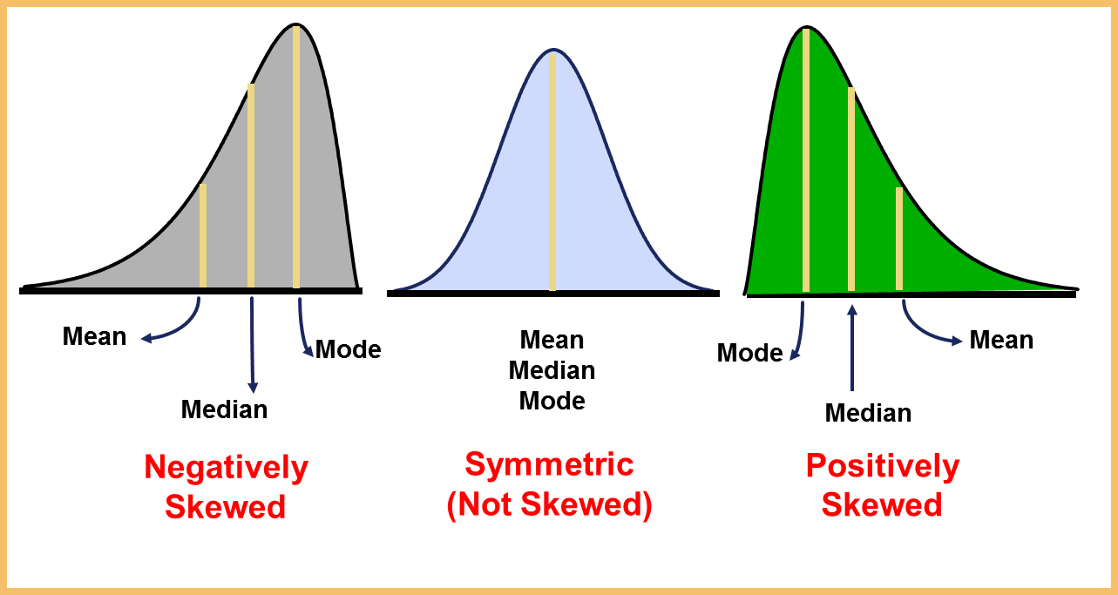

*Comparison of Central Tendency Measures:
- Use mean as more frequent unless the distribution is badly skewed (median)
- Use mode for nominal variables
- Use Mean when distribution is reasonably symmetrical, with few extreme scores and has one mode.
- Use Median with nonsymmetrical distributions because it is not sensitive to skewness.
- Use Mode when dealing with frequency distribution for nominal data

Measures of variability Scatter or dispersion:
Every central tendency measure has an analogue from the measures of variability, as an example the mean always accompany the SD.
- Standard deviation:
- SD = square root of ∑ (X – M)² /n – 1
- Every value in the distribution entered in calculation of SD.
- SD is a measure of variability around the mean.
- It is sensitive to extreme values
- It serves best in normally distributed populations
- Used for the main dependent value
- The most widely used measure of variability
- Most reliable estimate of population variability
- Best with symmetrical distributions with only one mode

- Range:
- The difference between the maximum and the minimum values in a distribution
- Sensitive to extreme values
- Mainly used to call attention to the two extreme values of a distribution
- Quick, rough estimate of variability
- Greatly influenced by sample size: the larger the sample, the larger the range

- Percentile:
- Is a score value above which and below which a certain percentage of values in a distribution fall.
Ex: P60 = 30 this means that 60% of the values in the distribution fall below the score 30.
- It allows to describe a score in relation to other scores in the distribution.
25th. percentile = first quartile
50th.percentile = second quartile= (Median)
75th. percentile= third quartile
-------------------------------------------------------------------------------
Summary of variability measures:
- SD the most frequently used measure (normal curve = one mode)
- Range is a rough estimate of variability (influenced by sample size)
- Range and percentiles are useful in skewed distributions.
- There are no measures of variability for nominal variables.

Best wishes
Majed A. Sharayha

