Radiology Sheet 12
Date: Thursday 18/12/2014
Malignant Diseases of the Jaws
- The dr wants for the sake of our future career and more importantly for the sake of final exam to think in pairs and comparatively; and to categorize the diseases and know how each category differs from the other one in terms of specific radiographic signs, and to be able to compare and contrast the radiographic signs between two different diseases or two categories.
- The bulk of the final exam is similar to that in the midterm; however it may include a minority of MCQ questions.
- When starting this lecture you may feel some confusion between the benign and malignant lesions.
- We will follow the same structure of what we took in benign tumors, but I will point out to the differences in the radiographic signs.
Just to remind you about radiographic signs (We all know them by now) and the MUST be mentioned when describing any lesion:-
- Radiographic Density (Radiolucent, Radiopaque, mixed)
- Margin characteristics (ill-defned, well defined…etc)
- Shape
- Location and Distribution
- Size
- Internal Architecture
- Effect on surrounding structures.

- In the previous lecture, we talked about benign lesions; we talked about purely radiolucent, mixed radiolucent and radiopaque and they have septations or loculations.

Now we will start talking about the general characteristics of malignant lesions:-
- Density Wise:-
- The malignancies we are going to talk about today are more radiolucent as far their internal architecture EXCEPT for metastases from Breast and prostate or osteogenic sarcoma (related to osteocytes).
- Margin Wise:-
- The margins in malignant lesions will be ill-defined, moth eaten, radiant appearance, this basically means that in the border you CAN’T tell where the lesion stops and where normal things stop.
- Usually they appear as having irregular margin due to the infiltrative nature of the lesion.
{This is opposed to the well-defined margins and sometimes corticated that is usually seen in benign lesions.}
- Effect on surrounding structures:-
- We will have interrupted cortex.
- As you know from the beginning of the semester; if you have a sharp, intact cortex then by definition this is an effect of benign lesion.
- However, if you have an interrupted cortex, then by definition this is a malignant effect.
- Thus, erosion or destruction means malignancy.
The cortex may be:-
- Inferior border of the mandible
- Floor of the maxillary sinus
As you know, when you look at a maxillary premolar or molar projection you should always expect that you are going to see the floor of the sinus.
(You can’t graduate without knowing the shape of the sinus XD)
So if you cannot see the floor of the sinus or you see interruption of the floor of the sinus, then this is something bad, we have something that is abnormal.
Normally, if the sinus is going to do anything it is just going pneumatize and will expand (it never gets smaller with age).
So, if you used to see the floor of the sinus and then you didn’t see it; you should ask yourself “where did it disappear!!” this is usually indicates that there is a disease process. {{Keep this in mind}}
As you remember, we talked about periosteal reactions and Garre’s osteomyelitis (proliferative periostitis) we said that in this disease there is a push in the periosteum and this push is due to a low grade apical inflammation around the lower 6 with an open apex, it is pushing the periosteum gradually and gently and we have parallel layering of bone; if this occurred then this is more benign {Less aggressive}.
If we saw something that is pushing the periosteum very fast and with severe stripping so that the bone instead of being layered in a parallel way (horizontal) it is layered in a vertical (perpendicular way) against the bone appearance (Sunray appearance).
This form {Sunray appearance} of periosteal reaction is a bad sign.
- Inferior Alveolar Nerve canal:-
- We all know the canal’s normal position; if you see displacement in the canal then this is benign.
- On the other hand, the malignant lesions may pass through the canal (any process that happened above the canal will occur below the canal also and for sure it will include the canal {will pass through the canal} as well.
- However, upon clinical examination the patient will be complaining of anesthesia or paresthesia in that part of the mouth.
- So if you find something abnormal (ex: radiolucent bone above and below the canal, and the canal is not displaced this indicates that something aggressive is happening.
- By aggressive, we may either mean malignancy or acute osteomyelitis.
- Do you think that if acute osteomyelitis was above and below the canal will be as subtle as a malignant lesion? Actually in acute osteomyelitis we will have more destruction.
- However, from a radiograph, you just have to know that this lesion is aggressive and this aggressiveness may be malignancy or osteomyelitis. {You CAN’T put Ameloblastoma (which is benign) as a differential diagnosis when you see such a lesion}
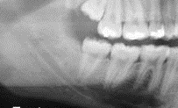
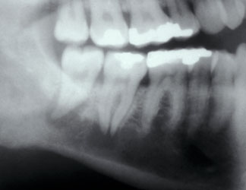
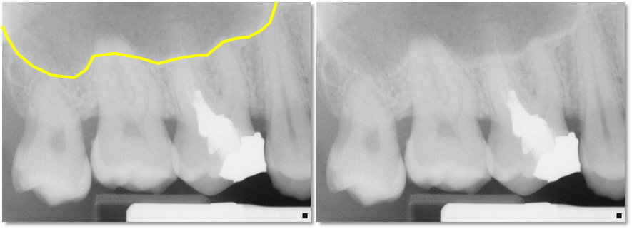
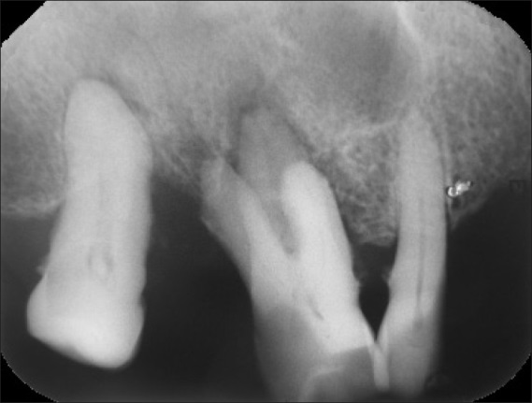
{As you can see the picture on the right hand side is a normal anatomic appearance of the inferior alveolar nerve canal, and the picture on the left hand side we can’t see the canal this indicates that something aggressive is happening}

{As you can see, the picture on the right hand side is the normal anatomic expected appearance of the floor of the sinus, in the picture on the left hand side we can’t see the floor of the sinus this indicates that there is something aggressive is happening}

- And to know exactly if it is malignancy or osteomyelitis, you have to take a biopsy, you can’t tell from a radiograph, you just will know that this disease is aggressive in its nature from its radiographic appearance.
{When you see such aggressive lesion and say that this is ameloblastoma, you probably have done a misdiagnosis and killed your patient and GOT A ZERO in the exam XD}
- As long as you are mixing in the same category of diseases (all are acceptable differential diagnoses) however, you can’t mix up between different categories (you can’t put a radicular cyst and Squamous cell carcinoma (SCC) in the same differential diagnosis Doesn’t make sense.
- Why can’t we say that this is just normal (not even a lesion)?
As you all know, when viewing a lot of radiographs you already know what is expected to see in normal conditions in any location (the normal anatomy ex: cortex of the lower border of the mandible, floor of the sinus…etc) if you can’t see them in a radiograph, then this is an indication that a bad thing is happening.
Also, if the trabecular pattern of bone is more lucent than usual also an indication.
Most importantly the patient is having a specific complaint (Ex: Anesthesia, paresthesia, exophytic mass inside the mouth, lymphadenopathy …etc) this is more important than the radiographs.

Now moving to orthodontics , we know that orthodontists move teeth by exerting low continuous forces on them , and we know this would cause bone resorption , but it is benign and will look benign , but if the lesion is more aggressive than a benign odontogenic lesion , it will eat bone very fast , there's no way the teeth had the time to have any forces to stimulate osteoclasts, it will be aggressive , generalized resorption across the bone .
Root resorption , in slow manner , it will be horizontal and sharp as if cut by a blade
But here in malignancy, it will look more vertical , because these indivisual cells surround the root as if they're munching the surface everywhere and all around.
Another very important sign is aseptic widening of the periodontal ligament , and the reason is that they're individual cells that travel to least resistant sites, so chondrosarcomas, osteosarcomas and lymphomas are one of the most common candidates to reside in the PDL space and start there.
Differential diagnosis of that is vertical root fracture , orthodontic movement , and if it was symmetrical widening and everywhere , then scleroderma is a good differential diagnosis.
Malignant odontogenic tumors :
1)Malignant ameloblastoma
2)Ameloblastic carcinoma
3)Ameloblastic fibrosarcoma
Malignant ameloblastoma has a malignant histologic feature but a bening behavior as opposed to ameloblastic carcinoma which has a benign histologic features and a malignant behavior
These three diseases are very rare entities , I don’t use them with any of the differential diagnosis , but they are there as malignant odontogenic tumors.

Malignant non- odontogenic tumors
Those are the ones that I deal with on daily basis and use in differential diagnosis
Ectodermal :
Squamous cell carcinoma
Central mucoepidermoid carcinoma
Metastatic carcinoma
Mesodermal :
Either bone related or vessels related just like their benign counterparts
Osteosarcoma
Chondrosarcoma
Ewing sarcoma
Fibrosarcoma
Rahbdymyosarcoma

Metastasis
It is a big one , don’t forget that metastasis are the second most common malignancies , breast , lung , kidney , colon , rectum
Hematopoetic diseases
Lymphomas
Multiple myeloma
Leukemias
Now the most common one that we want to spend more time discussing is squamous cell carcinoma :
1)radiolucent
2)ill-defined
3) irregular
The doctor asked about a radiograph that if we don’t know we are discussing malignant diseases , what would you think of it ?
Periodontitis , but , is periodontitis usually localized only to one tooth ??
No , one sextant maybe , but one tooth only with other healthy periodontiom elsewhere , this is not periodontitis , so we consider SSC.
Now , another radiograph for a female who presented to clinic for her last tooth , it was tender and a bit mobile with food accumulation , after one year and a half , another radiograph was taken for the lady , the tooth has been lost , floor of the sinus cant be seen , bone loss is severe
So shall we continue the perio trx for this lady after 1.5 year ?!
NO!this is an alarming radiograph.
So now, after we confirm the SCC diagnosis we should go for staging to determine the prognosis and then do a trx plan including the surgery and the follow up clinics.
Another patient , presented with a posterior SCC lesion on the lateral right tongue and they want to make sure if there's bony invasion of the mandible , and as we can see , there's a difference between right and left sides of the mandible with no anatomical explanation, this stage of disease is 4 and this dictates a different type of prognosis and different type of surgical and follow up management.

Metastasis
1)Just like any other malignancy it is radiolucent , except SOME of the prostate and breast cancers.
2)ill-defined borders
3)irregular cortical structure
In this radiograph ,if we look at the lateral of canine,we should be looking for the floor of the nose meeting the sinus, here we can see that this is not the normal place of the floor of the nose , so when I see this picture I don’t go for endo trx because of radiolucency and a periapical lesion , this picture is for a metastasis of breast cancer , and it is radiolucent , because radiopacity appears in SOME of breast or prostate metastasis as we said.

the dr. showed us a case of young patient with good oral hygiene not complaining from anything and he is regular attendant to the clinic for check up , his Bitewings showed no caries except small incipient caries distal of upper right 5 , after 5 years he came complaining from paresthesia with huge ill-defined lesion+ widening of periodontal ligaments .
if we look back to the same bitewings again( the one was taken 5 years before the lesion start ) we might notice widening in periodontal ligaments mesial and distal to 4 , if this sign wasn't missed that day and the lesion was detected in this stage we would end up with better prognosis of treatment , if they took periapical radiographs that time the rest of asymmetrical widening of periodontal ligament will be seen and it will be more suspicion .
signs of malignancy this patient had :
- parasthesia.
- ill-defined lesion .
- asymmetrical widening in periodontal ligament.
- dr. said that he also had periosteal rxn ( in other radiograph not included in the slides ) .
teeth are displaced ( not malignant sign ) ,however patient was diagnosed with malignancy because there is 4 signs of malignancy out of 5.
But why teeth are displaced ( which happen in benign lesions )
the reason behind that is this malignant took long time to develop ( 5 years ) that why teeth were displaced .
he was diagnosed with osteosarcoma .
note: osteosarcoma is a disease of young people affect late teens and early twenties .
another case ..
there is sun-ray appearance indicate periosteal rxn .
if there is interruption of the cortex and we can't see the sinus this mean we are dealing with malignancy , but what type of malignancy ? it's hard know the exact type of malignancy from radiograph unless we use histopathology , but still we can put a list of differential diagnosis from most common to least common .
example if we have malignant in maxilla how we can give the differential diagnose ?
Malignant in maxilla might be originated from the sinus and the most common malignant originated from maxillary sinus is squamous cell carcinoma¹ (SCC) so it's on the top of the list and the second most type is lymphoma² (lymphoma originated from the vessels found inside the sinus btenzel 3ala sinus floor then the floor will lost in radiograph).

the dr. showed to radiographs with time interval 7 months :
a 7 months after radiograph showing :
- roots are irregularly resorbed .
- bone is resorbed all the way.
- floor of the sinus is lost.

chondrosarcoma
- is mixed density lesion.
- show widening of periodontal ligaments .
- most commonly happen in posterior mandible ( condyle lesion ) but can happen in maxilla.

the dr. showed two radiographs with two years interval the first one was healthy with clear sinus floor the second showed lost of sinus floor it was diagnosed as lymphoma .

CRC
case 1
it's CT scan
dr start pointing on anatomical landmarks :
left radiograph: she pointed on maxilla .
right radiograph : it was brain tissue and falx cerebri in the meddle .

- falx cerebri was calcified ....... this is the first clue.
- well-defined multiple radiolucencies in mandible and maxilla.
this happen in syndrome called basal cell nevus syndrome also known as ( Gorlin-goltz syndrom ).
Basal cell nevus syndrome characterized by:
- calcification in falx cerebri .
- multiple KOCT lesions in multiple quadrants .
Q:a student asked why it's not ameloblastic fibroma ?
A: dr answered that ameloblastic fibroma as most of odontogenic tumors are note multiple lesions ( they arise on single side on single jaw )

case 2
it's a panoramic radiograph has large well defined multilocular radiolocencies on the left side of the mandible also there is root resoepion and displacment of the 8 .
this is a typical case of benign locally aggressive odontogenic tumor that is ameloblastoma
for differential diagnosis :
- ameloblastoma.
- myxoma
- Anuerysmal bony csyt
- KCOT
- CGCG
note : usually KCOT not multilocular , that why it wasn't on the top of the list .

Case 3:
Here we see asymmetrical widening in the PDL space of the distal aspect of lower right canine( well defined radiolucency)... No lamina dura is seen.
It is hard to say that it is periodontal pocketing because of intact crestal bone.
This is typical for.... 42:26 (sorry it wasn't clear )
Case 4:
This is a CBCT, not MRI since we cannot detect soft tissua details.
In comparing right side and Left one... we can at one side no sinus space! As if it filled or obliterated by something that has destructed the walls as well. This is more probably due to soft tissue mass.
This behavior is followed by malignancy, SCC and lymphomas are the differential diagnosis.
Case 5:
This is a reconstructed panoramic radiograph, showing a lesion at lower right mandibular part, particularly at parasymphyseal and premolar area. The lesion is ill defined, destructive, pass through the canal.
It cannot be cyst, benign, cementosseos lesion or ameloblastoma.
It could be osteomylitis (acute) and it is more likely to be malignancy (osteo/chondro-sarcoma or SCC..)
NOTE:
ALWAYS ALWAYS ALWAYS write osteomylitis and malignancy together esp. if the radiograph is the only give information.
In question with more details about pt history and the clinical pic( sudden painful swelling with abscess through fistula...) here we can exclude malignancy.

Done by :
Khaldoon Qaddoumi
Ruba Mughrabi
Fahd Al.aswad
Areej Qubbaj

