Inflammatory lesions of the jaw

In the oral cavity we have multiple reasons why we would get infection, we have different sources of infection like :
- Infection of pulpal tissue that would come from caries
- Fractures , as compound fracture (that has a communication with the outside)
- periodontal disease
- tooth extraction wounds
- haematogenous spread (when someone has infection somewhere else in the body it can actually spread through the blood and cause osteomyelitis in the jaw)
- sterile trauma (there is lots of tissue necrosis and non-vital debris that cause inflammatory reaction without the need for different types of bacteria).

- the mediators of inflammation would tip the normal bone metabolism in either bone resorption or bone formation.
radiographically ; we will see inflammatory lesions that are radiolucent because of bone resorption and others are radiopaque because of bone deposition, and there are lesions that would have pieces of those two.
And this is based on : time , dispersion and the balance between the virulence of the pathogen and the immunity of the host .
- the inflammation from clinical perspective can be divided according to :
- time : the inflammation is either acute or chronic , as far as when the lesion start ( differ in time ) .
- dispersion: either localized or generalized. If it is well confined we call it osteitis but if it is widespread we call it osteomyelitis and those two also differ in the management.
- Pathogenicity :When we have Strong virulent agent, or weak body or combination of those two acute process take place , but when we have a weak agent and a competent immune system then chronicity occur .

Clinical presentation of inflammation according to time
- Acute inflammation:
What do you expect to see in a radiograph with acute inflammation?
- Regardless it’s osteitis or osteomyelitis ; in general the majority of those have no radiographic evidence .
- When the inflammation occur too early , there is no enough time for bone resorption or deposition . so there is no radiographic evidence in acute inflammation . as we remember , the lesion may take 10 days to allow the early signs to appear as in osteomyelitis for example.

- When we don’t have a radiograph we depend on the clinical signs and symptoms ( the prodromal signs of inflammation ) ;redness, heat, swelling, pain, loss of function) . later on , you may see little widening in the periodontal ligament .
So acute inflammation not always impressive from radiographic point of view.
- Chronic inflammation :
we will see the tipping that we’ve talked about either bone formation or bone resorption . you may see every thing in radiograph :
- Increased in radiolucency
- Increased in radiopacity
- Mixture of both
- If you reach the stage of osteomyelitis , you may see sequestration , a fistula or pathological fractures.

Location of the inflammation is very important because it will affect the management , is it a localize thing around the apices of the teeth, or is it a more generalized .
Margins: Periphery of inflammation in some how make you a little bit confused ; it could be :
- Well defined very localized lesion . all the way to ill defined
- “ ill define border means that you are dealing with aggressive disease forming wide zone of transition that make u unable to distinguish between normal and diseased bone “ .So it Depends on how acute the inflammation is.
- Osteomyelitis and malignancy mostly are ill-defined
- Apical granuloma mostly well defined not corticated but well defined.

- Infection \ inflammation could be superimposed on old malignancy.
patient came with major abscesses and cellulites every where (fulminant pic of inflammatory diseases ) . incisional drainage to the abscess was done , culture and sensitivity test to prescribe Ab to the patient . he is not getting any better then they took a biopsy and they discovered that the patient had non-Hodgkin lymphoma .
Internal structure , it could be :
- Radiolucent
- Radiopaque
- Mix of both
Effects on the adjacent structures
- The First thing that we have to look for is Widening of PDL , as it is the earliest sign of inflammation
- root resorption which is a sign for the chronicity . “ presence of inflammation wirh root resorption is a sign that the inflammation have been present for awhile "
- If osteomyelitis occur then periosteal reaction take place . and depending on the type of osteomyelitis we have different shapes of periosteal reaction.

Clinical presentation of inflammation according to dispersion :
1-Periapical diseases:

- Apical periodontistis (widening of the periodontal ligament space)
- Apical rarifying osteitis (bigger lesions of apical periodontitis ), apical because it is around the apex of a tooth , rarefying because it is radiolucent, osteitis because it is inflammation in the bone surrounding the apex of the offending tooth ( so it is not wide spread inflammation in the bone as in osteomyelitis) .
Histo-pathological point of view , this means that it could be either:
- Abscess
- Cyst
- Granuloma
How to differentiate?
- All of them are non-vital teeth.
- Between cyst and granuloma ;
Size criteria. The larger it is more risky to have a cyst
Margin criteria, corticated then mainly it is cyst .
- Between granuloma and abscess ;
Clinically, if there is fistula then it is an abscess
No fistula then it is granuloma.
- Apical sclerosing osteitis.
around the apex of Non vital tooth and bone deposition took place
- All of them are radiographic terms

2- Extensive infections
- Osteomyelitis is the most common example, could be acute and chronic
- Diffuse sclerosing osteomyelitis
- Proliferative periosteitis
- Specific chronic infections, associated with atypical infectious agents like actinomycosis, tuberculosis, syphilis, osteoradionecrosis
- Periodontitis, pericoronitis, soft tissue inflammation.

- Periapical disease in details :

- Apical periodontitis
- Radiographic feature : just a little widening in the PDL
- Clinical presentation : the patient come with very sever Spontaneous throbbing pain and the tooth is very tender to palpation and percussion .
- Associated with oedema
- Associated with irreversible pulpities or Non-vital tooth .
- You may see thickening in lamina dura but this doesn’t occur in the acute phase , as thickening of LD need long time to occur .

- Apical rarifying osteitis
- the inflammatory process become more chronic ,because either we have a low virulent microorganism or strong immunity of the host that cause a bigger radiolucent lesions to develop .
- Radiographic feature:
- a big radiolucent lesion and loss of lamina dura
- Size varies depending how chronic the lesion is .
- Blunting external root resorption

- halo sign radiograph :
remodeling to the cortical bony floor of the sinus due to inflammatory lesion at the root apices of max. molars .

in this radiograph ; the upper 7 has big carious lesion with root caries , the tooth become non-vital . apical disease is formed pushing up the floor of the sinus and remodeling occur . the apex of the tooth appear as it is surrounded by a halo .

differential diagnosis for a radiolucent area around the apices :
- PCOD (occur in ant. teeth that are vital)
- Periapical scar : due to over instrumentation through RCT of non vital tooth , then heals by fibrosis forming a scare which appear black
- Surgical defect (apicectomy, heal by fibrosis )
- How to know?
- Time is the judge, you have to follow them up. apical scar and Surgical defect are constant do not grow whereas PCOD and apical disease do so .
- Signs and symptoms

3-Apical Sclerosing osteitis
If the virulent of the bug become much lower in grade , the immunity of the host become much higher or the patient doesn’t seek treatment then the process went more in chronicity but rather than having bone resoption , bone deposition occur ( proliferation of periapical bone ).
- More in mandible as it is low in vascularity .
- Upon saying Sclerosing osteitis ; it does not always mean perfectly white lesion . it usually appears to have a radiolucent component “ maybe widening of PDL “ and radioopaque component, so you can call it apical rarefying/sclerosing osteitis .

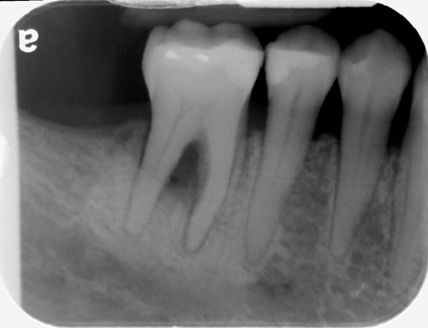

This radiograph shows lower 6 has a radiolucent area around the apex surrounded with radioopaque area .

Differential diagnosis:
- PCOD : in the beginning it appears radiolucent then goes to mixed density then goes to completely radioopaque .
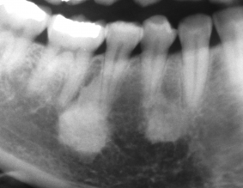
- Sclerotic bony island (idiopathic osteosclerosis ) :
the lamina dura is intact and PDL is not affected here .

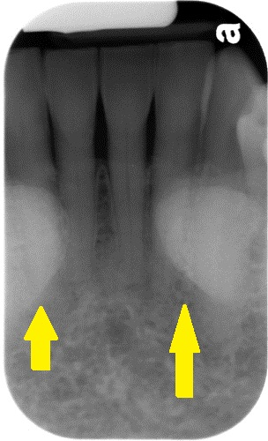

- Tori :
mandibular tori super imposition ; Typical bilateral well defined cortical white mass
- exostosis

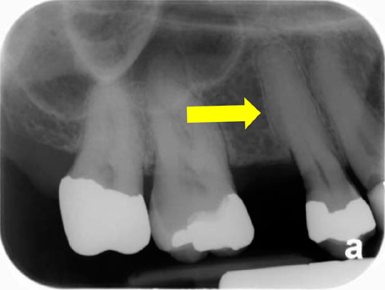
- Hypercementosis:
- the normal sequence of the structures surrounding the root is : cementum , PDL space then the lamina dura .

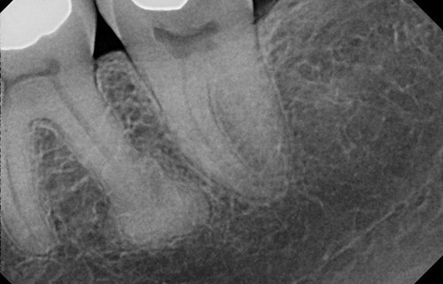
- in hypecementosis :
radiopaque mass of cementum then PDL space then lamina dura.

- as opposed to what occur in PCOD ; PDL space then lamina Dura then the radiopacity .

- Notes :
- After endo treatment of apical rarefying/sclerosing osteitis , healing occur for the rarefying area by bone deposition . but the sclerosing area need a very long time to disappear as the bone is already formed and most of patient doesn’t get rid off it . “ you may see edentulous patient still having sclerotic lesion as a remnant of apical rarefying/sclerosing osteitis after extraction “
- Doing extraction of sclerosing osteitis tooth doesn’t cause osteomyelitis.

2-jumping to Extensive infections

- Osteomyelitis

- it is an inflammation that is more widespread Involving the bone and bone marrow spaces
- Is not an easy form of inflammation
- Usually there is a predisposing factor (extreme of age, leukemic patients, uncontrolled diabetes, alcoholism, malnutrition , anemia , Hypovascularity : which means Osteoradionecrosis , osteopetrosis , paget’s disease and floride cement-osseous dysplasia as they are major risk factor for osteomyelitis as a result of hypovascularity .
- Mandible more than max. due to low vascularity .
- Molar area more than premolar area
- Men more than women as they have more predisposing factor
- Ladies in bisphosphonate are in more risk to get osteomyelitis
- Has all the clinical features of inflammation (severe pain, redness, fever, purulent, and discharge)

- Acute phase : we don’t see any radiographic sign
- after 10 days you are going to see decrease in density of trabecular pattern and enter in the radiolucent stage .
- Then it becomes chronic with milder symptoms ( because the virulent agent is low and the host resistant become more effective ) . sequestra and sinus tract will develop . if it is left for a while then acute intermittent exacerbation occur.

Radiographic feature :
- Mostly osteomyelitis has ill-defined borders (ill defined borders mean aggressiveness and not giving a chance for the bone to form a well-defined border)
-When you see an ill-defined border, think about the signs, when all of them are signs of inflammation then mostly it is an osteomyelitis.
- Irregular radiolucencies
- You may find radiolucency and radio-opacity . most imp. Radio-obacity that you have to look for in osteomyelitis is sequestration
- Sequestration
Means dead bone, but how can I recognize it on the radiograph?
it is a floating piece of bone ( separated from the bone , no connection with haversian system ) .
Normally bone gets nutrition from the Haversian system and the periosteum, when a piece of bone separated from this system it will die ( sequestra )
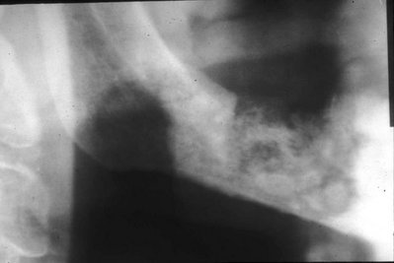
Radiograph showing border of the mandible that’s interrupted, this area is radiolucent and ill defined

- Fistula formation : sinus opening in the skin to discharge the pus outside .
radiolucent band traversing the body of the jaw penetrate the cortical border of the mandible

- The dr shows a panoramic Radiograph with bone loss around the teeth , very radio-opaque bone of the jaws and radiolucent ID canal . it is similar to florid cement osseous dysplasia .
- the other thought is extreme periodontal bone loss which gives you an alarm for more inflammatory process and risk of osteomyelitis..There is flying piece of bone, it is a sequestrum because it is not attached to anything .
- It is not impossible to florid cement osseous dysplasia with the bad periodontal disease to become a serious inflammatory process ( osteomyelitis )

- The dr shows another CBCT \ axial cut and reconstructed panorama of completely edentulous max . for a patient on bisphosphonate therapy who came to clinic with tenderness and pain in the pre-maxilla . in the radiograph , pieces of floating bone are apparent.

Differential diagnosis (think in every thing that could cause ill define borders)
- Malignancy : the only way to differentiate between malignancy and osteomyelities is by taking a biopsy .
- Paget’s disease
Cotton wool appearance, sclerotic and bilateral .
- Fibrous dysplasia

- Diffuse Sclerosing ostemyelitis :
is a more chronic process with very very low virulence causing more bone deposition ( very thick white bone ) . it appears as cotton wool but rare to be bilaterally .
differential diagnosis :
- Paget’s disease : occur bilaterally ,, osteomyelitis it is really very rare to be bilaterally .
- Fibrous dysplasia :it appears radio-opaque and unilateral at young age . but if a radio-opaque lesion appear suddenly at 60 yrs old with large painful swelling then it is not FD it is osteomyelitis

- Proliferative periostitis :
- Another type of osteomyelitis ,which occur at young children as they have good immunity with very good reparative potential.
- Stripping of the periosteum will occur which will induce the formation of new bone . and so on , until onion appearance develop ( layers of cortex ) .
- Occur in lower 6’s area , more with open apex .

Differential diagnosis :
- Infantile cortical hyperostosis
- Congenital
- Not only in mandible but widely spread
- Osteoradionecrosis
- typical to post radiation therapy
- Radiographically ; you cant tell the difference between the types of osteomyelitis ( is this osteomyelitis occur because of bisphosphonate intake , radio-therapy or even uncontrolled diabetes) . just know that this lesion is osteomyelitis , and if it is acute or chronic .
- Widespread according to the field of the radiotherapy ; if the whole mandible is radiated you can get the disease bilaterally.
- Statistically more in mandible and men .
- A complication of osteomyelitis is pathological fracture associated with cyst , inflammation or tumor

4-Periodontal disease.
- It is NOT radiographic diagnosis , you can’t assess the periodontuim without a probe .
- when you look to radiograph you can assess the bone only .
you can determine the history of bone loss and the risk of having furcation involvement in 2D radiograph.
- Search for a factor that cause a localize periodontal problem . e.g perforation in the root surface due to wrong placement of a pin causing vertical bone defect .

5-Pericoronitis
Mainly no radiographic signs because it is soft tissue problem , but when it is recurrent a periosteitis may occur around that partially impacted tooth and we can see radiolucency or radiolucency/radiopacity as the underlying bone is inflamed .

6-Mucosities

- Healthy mucosa of the sinus should not be seen in radiograph because it is very thin. But once it is thickened it will be obvious in radiograph which means sinusitis .
- A sinusitis maybe generalized allergies , viral , bacterial or fungal or odontogenic in origin
- Odontogenic origin , apical inflammation around a tooth causing remodeling of the bony floor of the sinus and interruption occur . then inflammatory mediator spill inside the sinus causing sinusitis .

Special thanks to Tawba Nemer .
Haneen Qandil .
Best of luck

